Plenty River crossing to Willis Vale.

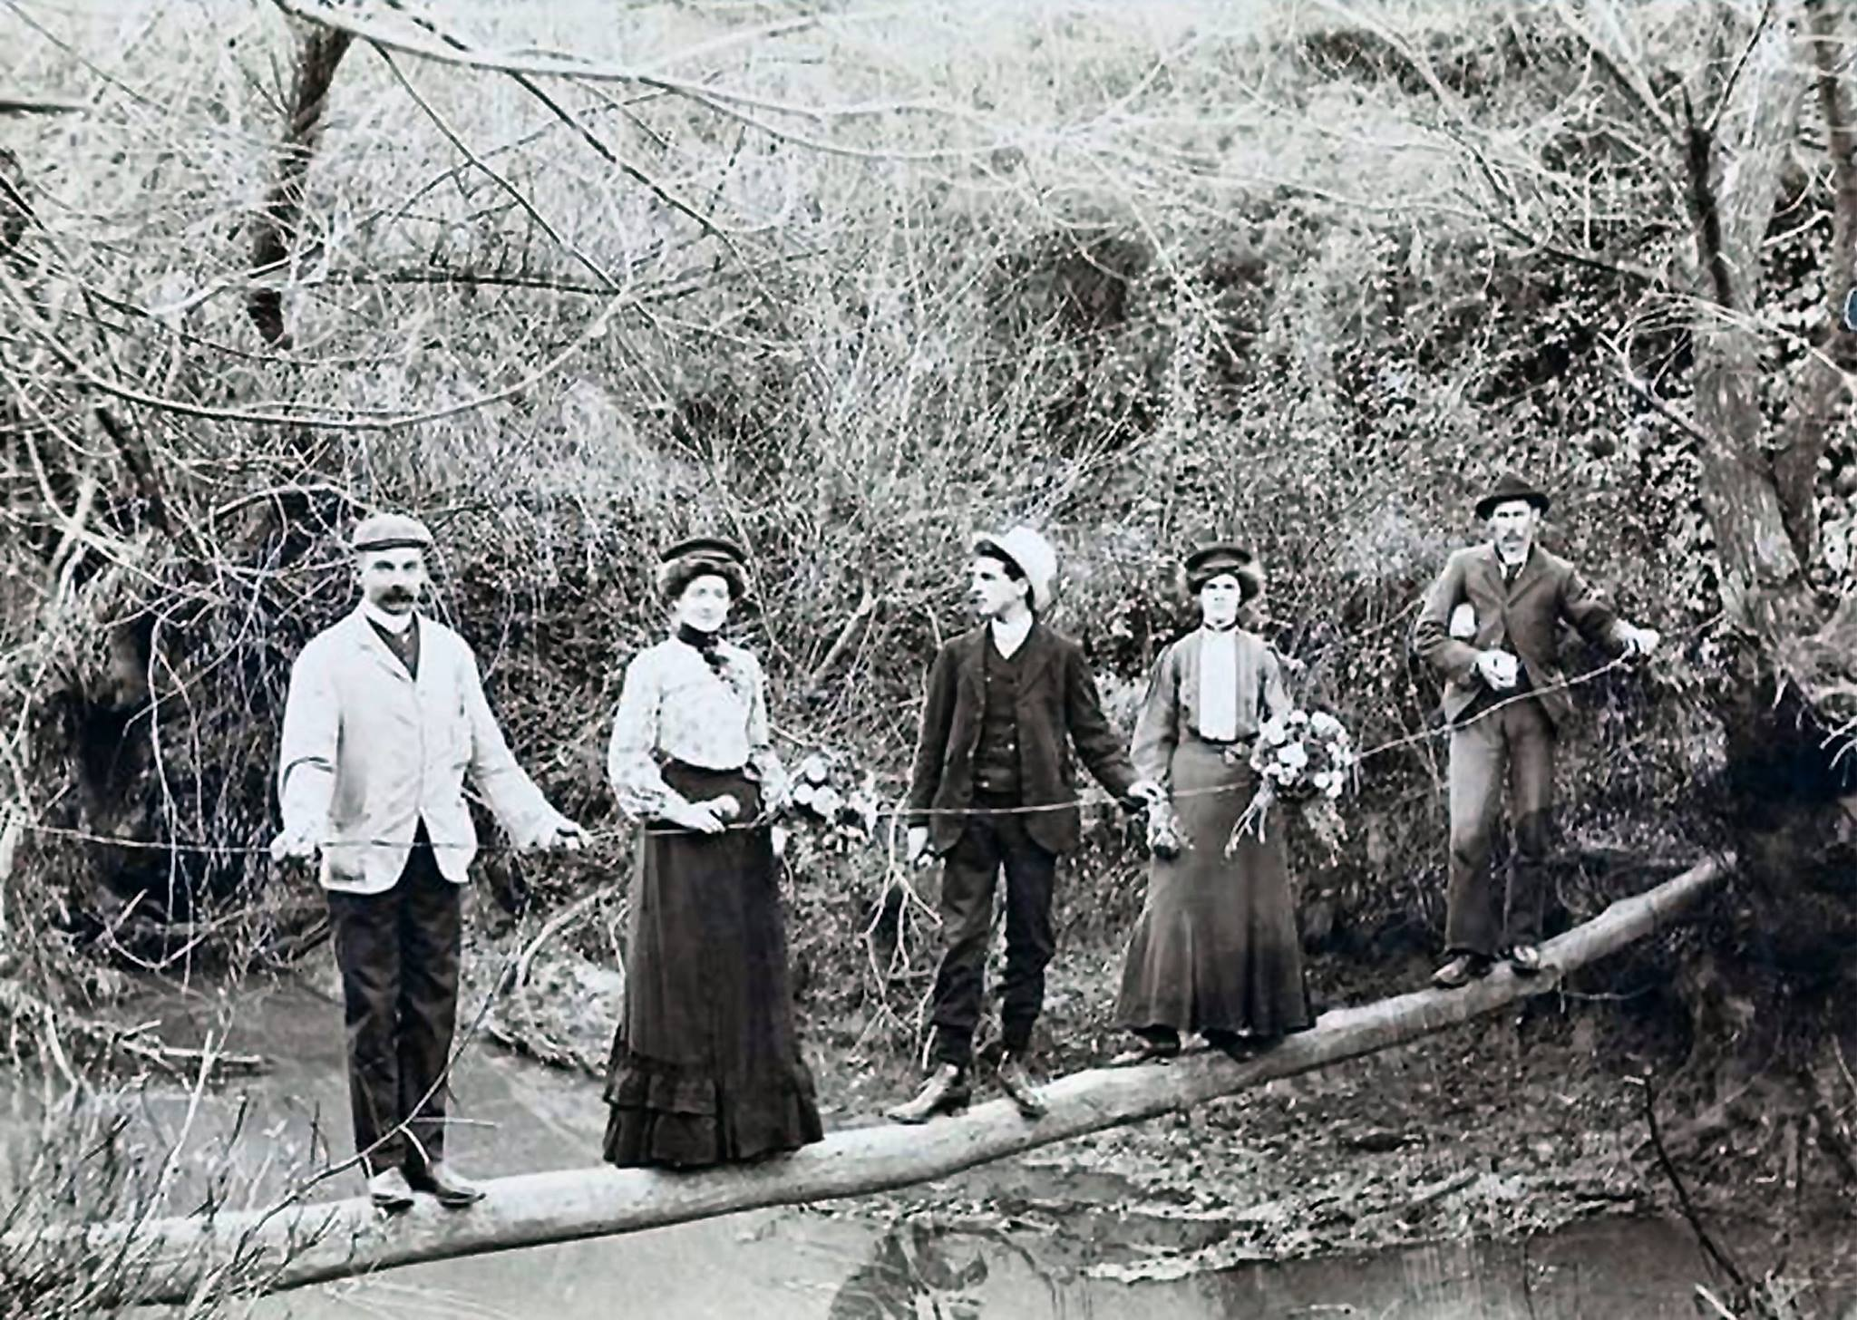

FACEBOOK Faye Fort‎ Greensborough & Diamond Valley forgotten memories.... what’s your story ?

Faye Fort Log just below the Mitchell House the only entrance by foot to get to Willis Vale

Faye Fort Mr Coghill (Bee keeper) Prudence Partington (Miss) unknown bloke Miss Maria Partington, and their brother William Partington. Willis Vale is up to Will’s left

Faye Fort Not a very big log and have a look at the wire ?

Faye Fort I would like to see all you new mums having to carry your baby across a log like this or in a buggy across the ford ( and not like it is today all built up ) it was just through the water and when the river was in flood you had to go up the steep hill then down to the Diamond Creek Rd ( about where Plenty River Dr is today then up to the town.

Faye Fort Our own log which Dad had to put across the river below Whatmough Park ( when they were forbidden to use this one in 1943 ) Was a bit thicker and us Kids almost used to run across it when we went over to Nana’s place at Willis Vale. There were a few logs because when there was a big flood the log would be washed down further. My brother Gary remembers one flood when he had to take Robbie our horse to try and pull the log back in place but the water was so strong, it took the horse as well but he was retrieved down further, the same horse as us 4 kids are on at Willis Vale

Steven Jacobs Not sure Faye - electoral rolls indicate that the first Roberts (William & Myrtle) moved from East Caulfield to Greensborough somewhere between 1919 and 1924.

Faye Fort Steven Nana had functions over there to raise money to build the new hall out the back of the church. It opened in 1930 the ladies guild ( of which your family were members ) was founded in 1925 the proceeds of their work were used to build a vestry at the end of the church 300 pounds, a kindergarten in the back hall 500 pounds, it also contributed to trust funds they all worked very hard

Steven Jacobs That's what I love about you Faye Fort You have all this wonderful knowledge about the area and those who lived here. We have very little information about the activities that my Nanna, Aunty Olive & Aunty Dorothy may have contributed towards as members of the Ladies Guild so thank you very much for the information - a worthy addition to my family history records.

