Sherbourne Road Briar Hill
Matt Craig
Greensborough & Diamond Valley forgotten memories.... what’s your story?

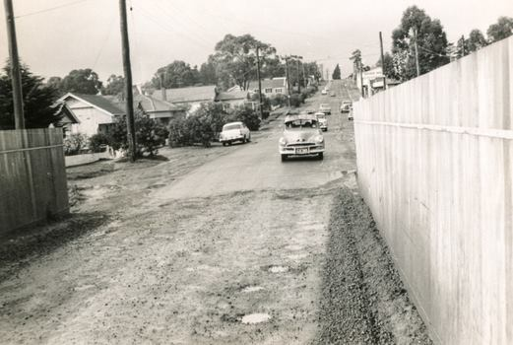
Sherbourne Road

Sylvia Tupper I have the notice of acquisition of land from the Eltham Council when they took 11 feet off the front of our property in order to widen the road. This is dated 1954. I also have photos of the front of the house before and after. One is called "Our new wall" and is dated 1958 so that should help date the photos shown here.
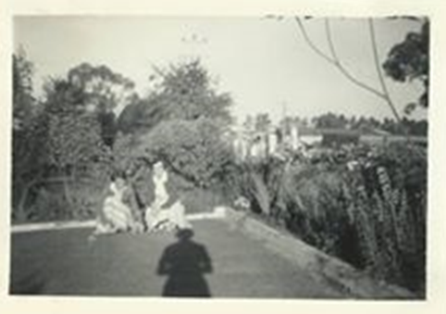

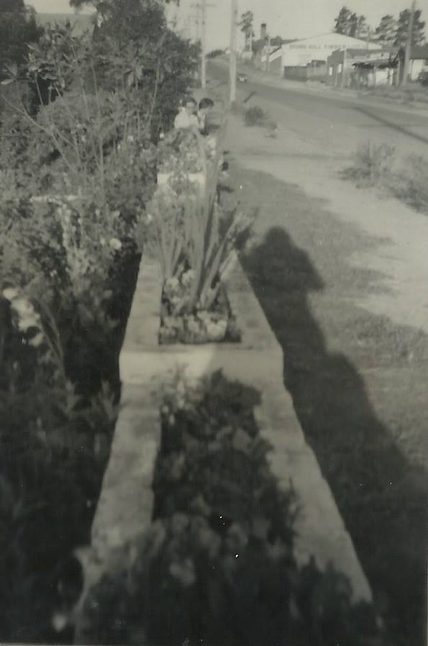

Sylvia Tupper Our new wall
Sandy Anton Yes looking up the hill Sylvia Tuppers house is on the left. Timber yard on right
Paul de Sauty Looking at the Holden parked on the left, it would be 1962/63.
Sandy Anton When you look at all the Holdens in the old photos Watsons did a roaring trade
Paul de Sauty Falcons didn’t make an appearance until 1961. There Customlines etc were available but they were “Yank Tanks”!
Matt Craig Fred Squires who owned the Timber Mill drove some big Yank Tank. Can't recall the name of the car but someone will remember.
Debra Bruning My hubby says the FJ was built 1952-56. The car parked on the left is an FE or FC, built 1957,58
He’s a Holden man
Paul de Sauty He could be right. At first glance the car on the left looked as though it had the tail light fins of the EK and the other similar model. Was it FB?
Matt Craig Good stuff! The Timber Mill in the background with some of the tall pine trees behind
Matt Craig As Sandy has mentioned. It is becoming increasingly hard and difficult to find new material. Unless members rummage through old boxes, ask family members for any memorabilia such as old black and white photos or have contact with old neighbors, friends, siblings from the bygone era then all this will be lost. At least sites like this can only try to preserve those memories and it takes all of us to share even the smallest of memories in the stories and recollections we have.

