3 St Helena Road
(For Sale October 2017)
Mason Taplin - Ray White Greensborough
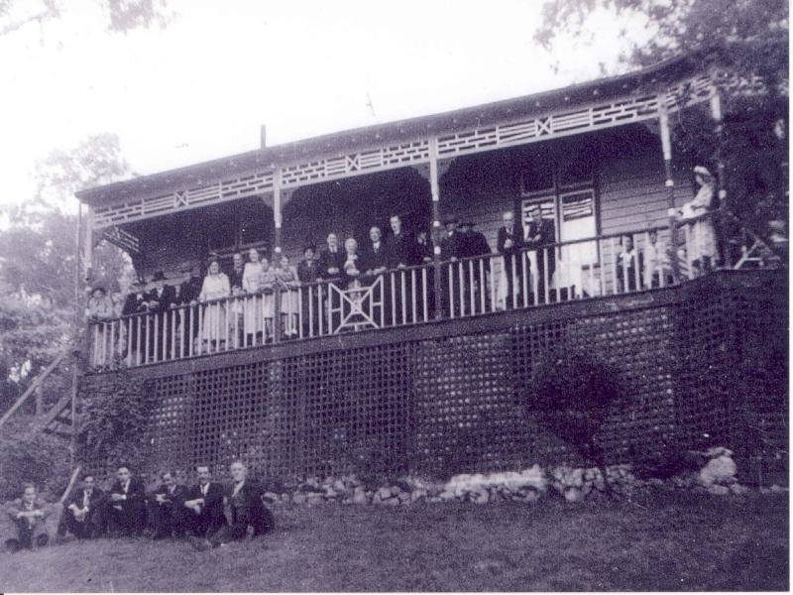

FACEBOOK: Greensborough & Diamond Valley forgotten memories.... what’s your story?
Noelleen Bourke That’s the old Nurse’s house on the corner Diamond Creek Road and St Helena
Kevin Biaggini Is it Heritage listed?
Mason Taplin - Ray White Greensborough Hi Kevin, yes, this home is heritage listed. If you have any further questions, please do not hesitate to ask!

Faye Fort This house on the corner of St Helena and Diamond Creek Road was built in the 1920 s
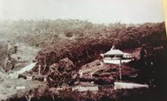

Faye Fort Same house today
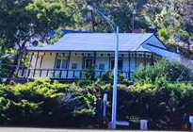
Sandy Anton Let’s hope this one stays

Faye Fort It's been sold a few times over the years. Surely this won't be pulled down like so many other old homes in Burra

Faye Fort Yes seeing it has survived this long It was built about the same time as the old kiosk opposite (now the Diamond Valley Learning Centre )

Faye Fort It certainly must be well built

