All Saints’ Greensborough
Greensborough & Diamond Valley forgotten memories.... what’s your story?
Sandy Anton
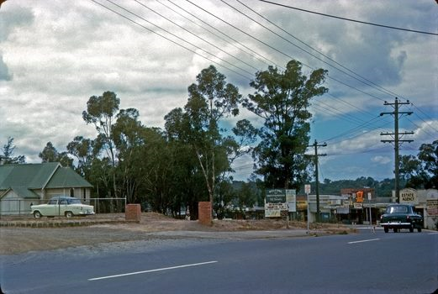

Sandy Anton Church Street still unmade. Row of cypress trees down Church St already gone

Debra Bruning My Uncle Fred told me about this little wooden church. Did they pull it down for the existing church?

Sandy Anton no the new Church is in a different spot. They sold the land to Coles so the Church, Hall and old vicarage went

Sandy Anton Your Uncle Fred’s butcher shop was just near here

Debra Bruning Yes Sandy, he was in Grimshaw, pretty much at the head of the “T” with Church St. He spoke of a wooden church on the corner. Was it actually further down into Main St?

Sandy Anton it faced Main St but it was set way back

Terry Leaford Church was moved next to hospital

Sandy Anton No I don’t think so, this was Church of England. The one next to Hospital was the Methodist, and they built a new church there

Terry Leaford Did that replace Main St church to near hospital then

Sandy Anton Yes Terry it did.....a new church got built here, right on the corner of Church St.

Sandy Anton These old photos bring back so many memories

Terry Leaford Not wrong used cut church to school; church bell up tree
Sandy Anton yes ring the bell and run lol

Terry Leaford I never rung bell wanted to

Sandy Anton There were huge cypress trees each side of those brick pillars that was the driveway to the hall and Sunday School. Driveway to the Church was in Main St and it had stone pillars

Dorothy Mudd That is nothing like the Methodist church. All Saints C of E is just as Sandy said the old church, hall and house was sold to Coles in early 1970's and was then called New World... the 1970's version is set around a circular alter and the end you see on RH side has or had a pipe organ.

Dorothy Mudd 1965 the old church was still there. Rev Charles Maning was the minister at time that I was confirmed at St Paul’s Cathedral... Rev Appleby before him

Sandy Anton Rev Appleby was fantastic. .Rev Maling was a grump didn’t like him. I stopped going to church

