All Saints Anglican Church Greensborough
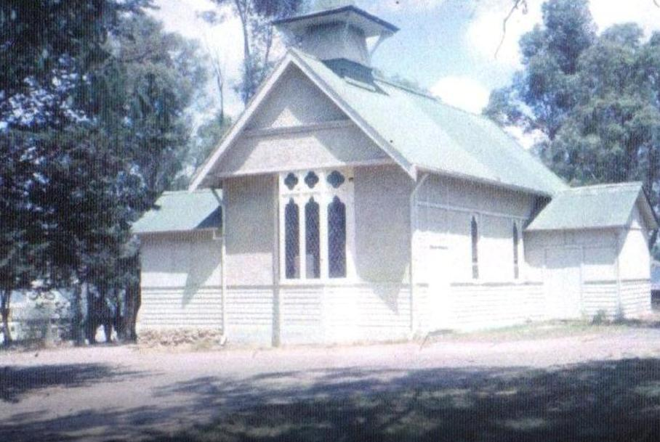
Faye Fort‎ I GREW UP IN THE GREENSBOROUGH DISTRICT

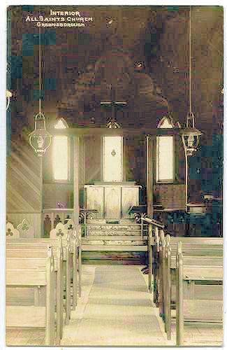
Marilyn Smith ‎I GREW UP IN THE GREENSBOROUGH DISTRICT

