AMIET Family

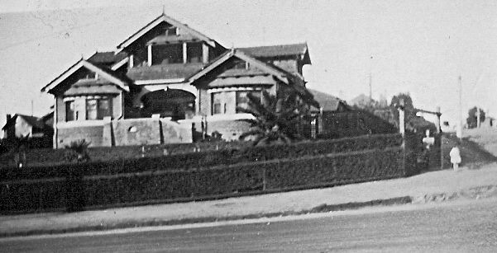
David Shane Amiet‎ Greensborough & Diamond Valley forgotten memories.... what’s your story ?
Louis and Helen Amiet eventually moved from their house in Grimshaw St and lived at a lovely house at 20 Lower Heidelberg Rd Ivanhoe. Two photos attached, don't know the date for the B&W one but the colour photo was taken in 2009.
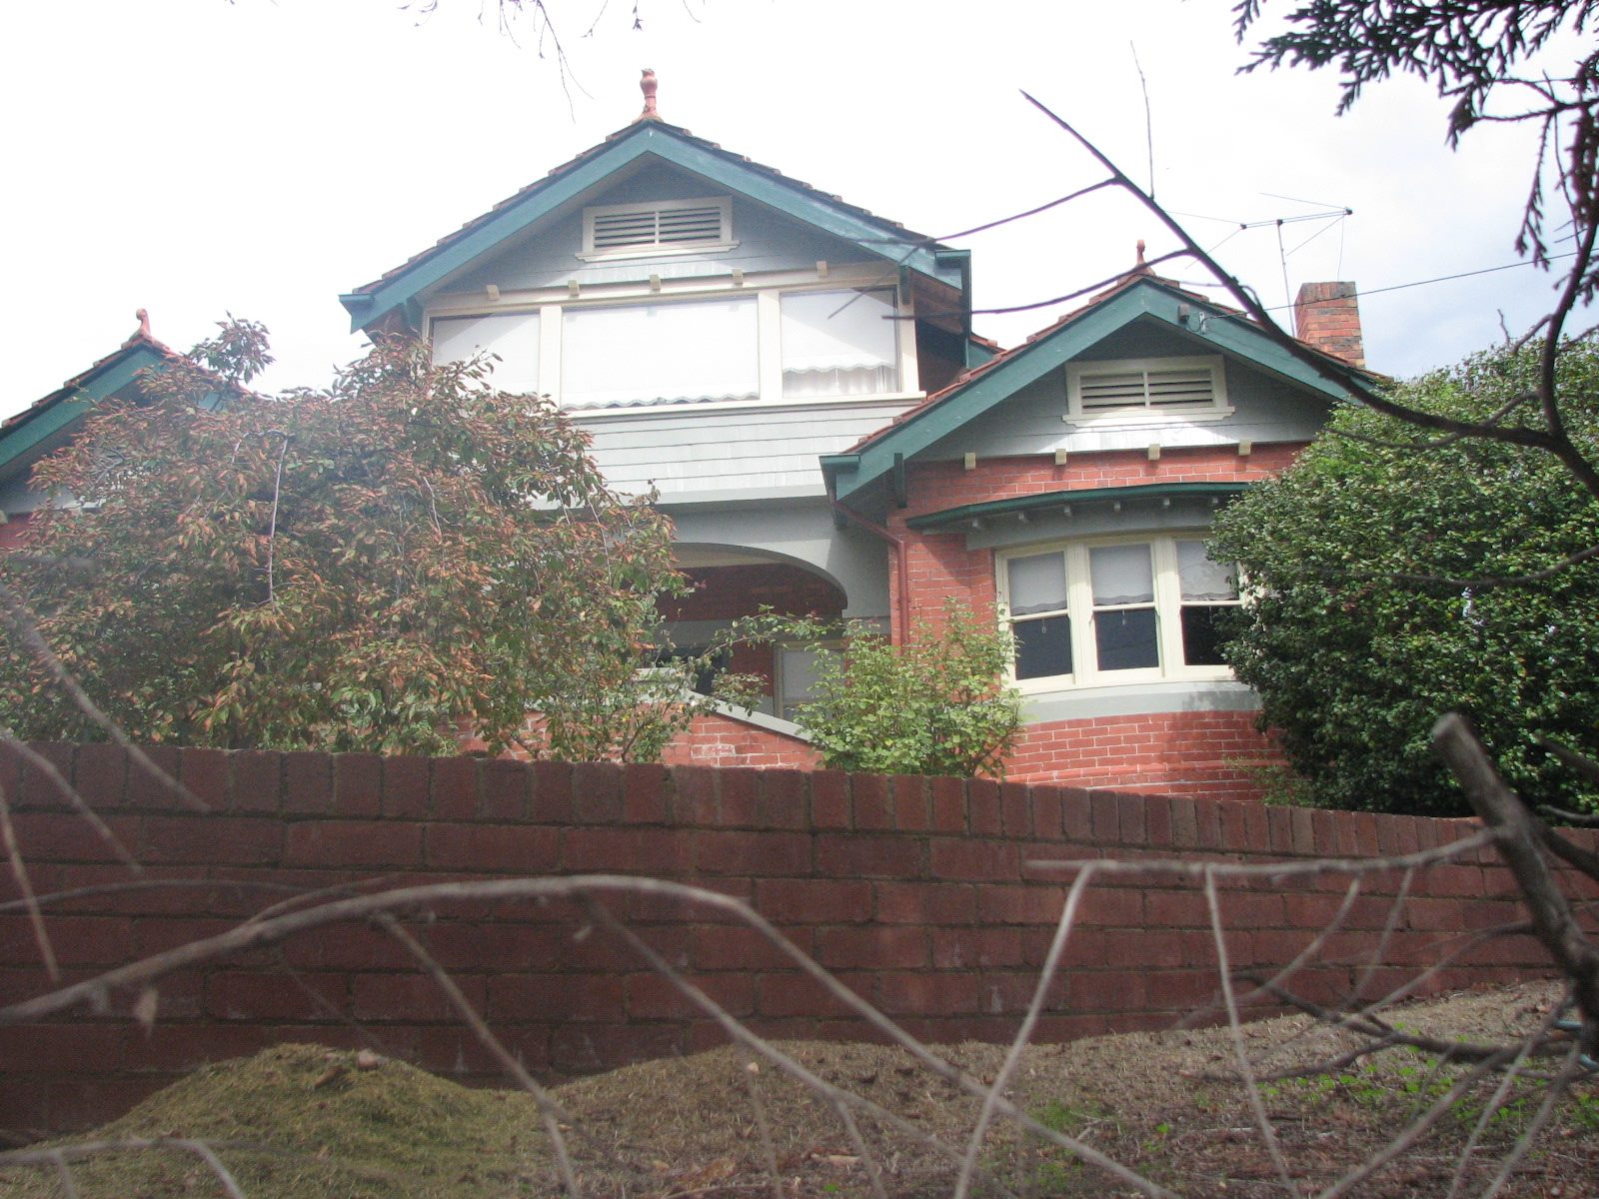 2009
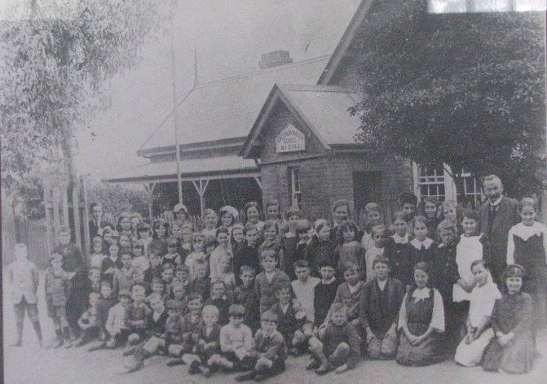
Greensborough School 1918
David Shane Amiet
Amiet Street names:
Oliver Lane – after Louis Abram Amiet’s son Oliver Leslie Amiet
Pellet St – after Rose Amiet nee Pellet, Louis Abram’s mother

David Shane Amiet
Oliver Lane, Greensborough. Tucked in off Kell St, this short lane was named after my Grandfather Oliver Leslie Amiet (son of Louis Abram Amiet). He left Greensborough about 1909, departing for Qld and the small town of Juandah (later renamed Wandoan), a small pastoral town located on the western Darling Downs and about 450 kms west of Brisbane. He made the move as he was seeking to purchase land for the purpose of dairying. At that time the Qld Govt had opened up large pastoral leases and thus cheap land was available. He was joined in this exodus by a number of other Victorians who settled in the area drawn by the prospect of starting a new life and opportunities. He was unfortunate to only get a lane named after him and not a street like most of the other members of his family !!! Maybe because he left to become a Queenslander !!

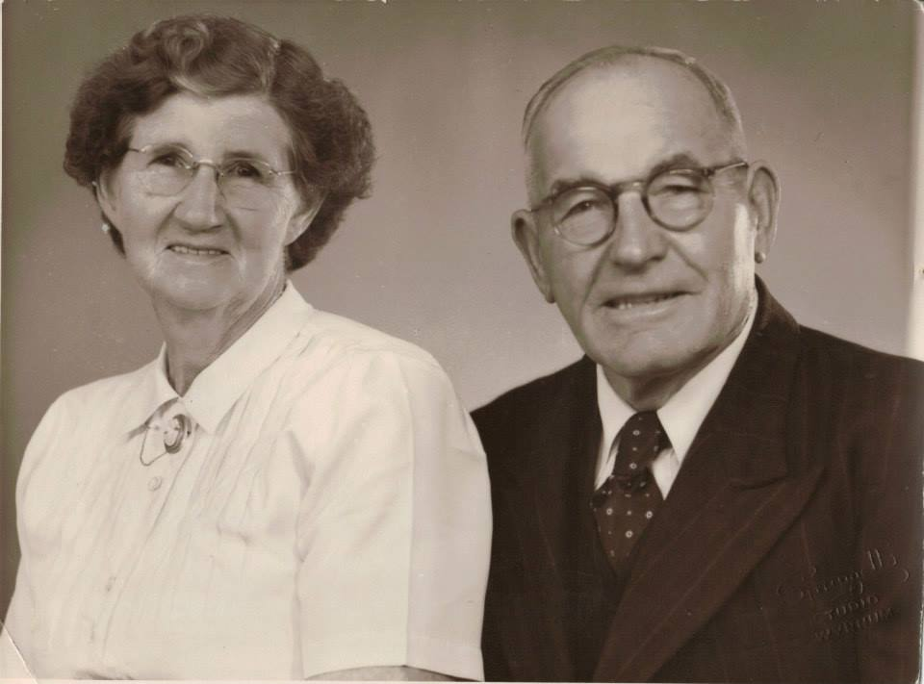

Edith and Oliver Amiet in their later years. They retired and moved to Tingalpa in Brisbane in about 1954. This photo was taken about 1960 and this is how I remember them

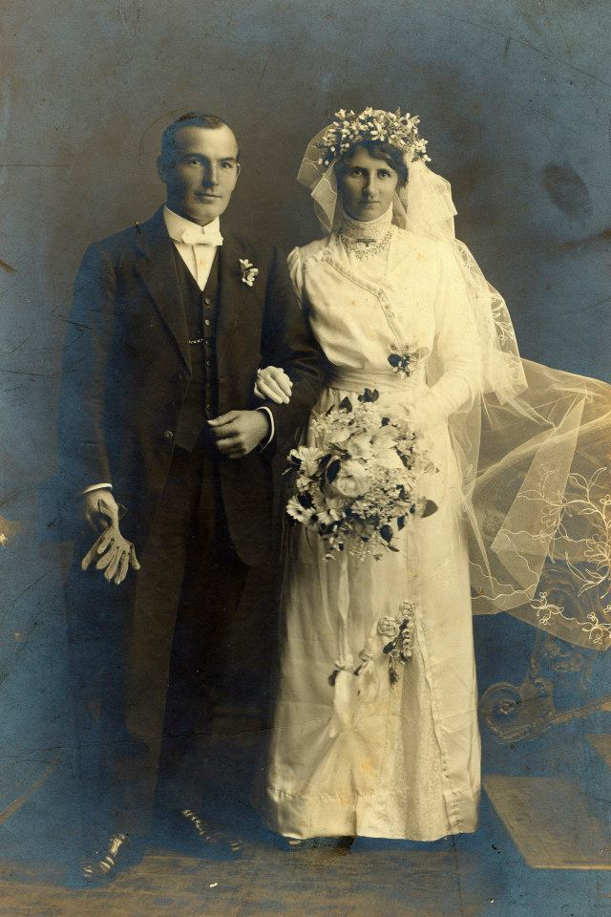

Wedding photo of Oliver Leslie Amiet to Edith Maria Parish (1891-1964). The wedding was held on the 23 Jun 1914 in Juandah. Edith's family came from Kilmore.

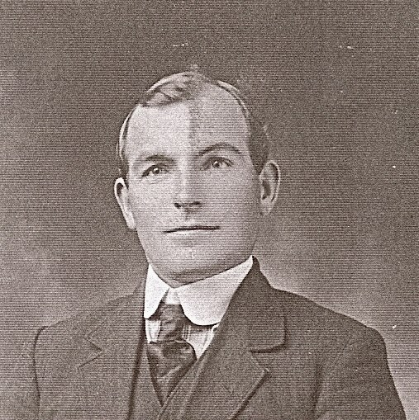

Oliver Leslie Amiet as a young man, probably about the time when he left Greensborough.

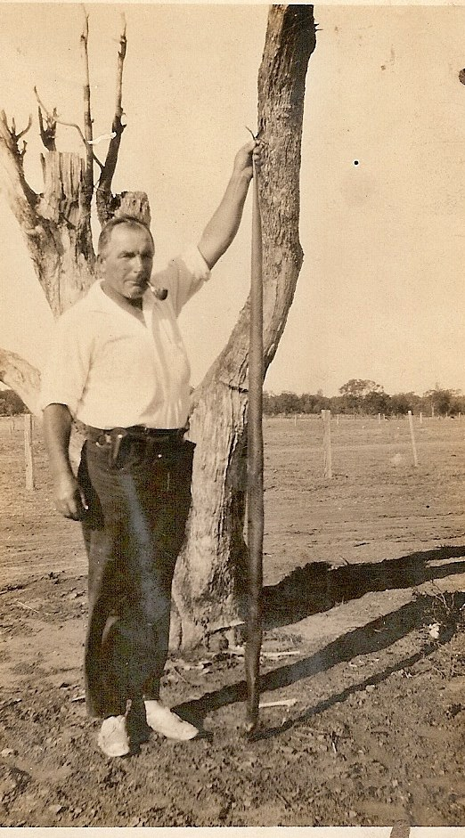

The joys of living in Qld !! Oliver Amiet on his farm in Juandah with a large black snake.

David Shane Amiet
The passing of Louis Abram Amiet
From: The Advertiser (Hurstbridge, Vic. : 1922-1939) Friday 4 November 1932
Obituary: " The death of Mr. Louis A. Amiet, at the age of 75 years, at Ivanhoe on the 1st inst., has severed another link with Greensborough history. Prior to his retirement from the Education Department, the late Mr. Amiet was head teacher at the "Greensborough State" school for 33 years, and was endeared to at least three generations of past scholars by his kindly and tactful interpretation of discipline. Many of his former pupils gratefully remembered his subsequent interest oversight and encouragement in their studies to fit themselves for positions in the professional or commercial world. For many years the deceased gentleman energetically identified himself with every forward movement of earlier days, such as obtaining a train service, sanitation, street lighting. etc.
He was also always in close touch with every charitable movement, and was a familiar figure at the then few and far between public social functions. Old identities will also agree that the old Progress Society was indebted to the late Mr. Amiet for his readiness to place at their disposal his active and trained mind in connection with its problems regarding the advancement of the district. The body was interred in Greensborough cemetery in the presence of a large number of his former pupils and friends, and a number of his former associates of the Ivanhoe Bowling Club. As a further mark of respect the Greensborough school flag was flown at half mast, and the whole school and staff were ranged in respectful silence outside the school as the cortege passed on its way to the cemetery. The Rev. Forster conducted the burial service at the grave side."
From: " The Advertiser" (Hurstbridge, Vic Friday 17 October 1930 <http://trove.nla.gov.au/ndp/del/page/5871327>
Re Monty St, Greensborough. A relatively short street that links Cam St to Nepean St was named after the eldest son of Louis Abram: Louis Montrose Montgomery Amiet....quite a mouthful and probably why he was always known as Monty...hence the street name. Monty. Monty was born on Nov 4 1881 in Fentons Creek and died in 1961 in Williamstown, Melbourne. He married Gertrude Arthurs in 1907 and following her death in 1942 he married Lily Agnes Ogleby in 1946. He was employed as a leading hand fitter at the Newport Railway Workshops. As a young man he was an excellent cricketer and in 1897-1898 he won trophies for batting and for taking the most catches during the season. Photos of Monty and his family posted in photos.

David Shane Amiet
Around 1900, Louise Abram built a house on Grimshaw Street, this location is now the site of the Diamond Valley Hospital. Louis had an orchard, a vegetable garden as well as a few acres of bush up towards St Helena.
He was one of the first owners of an automobile in the area and in 1918 he owned a single cylinder De Dion Bouton Model D.
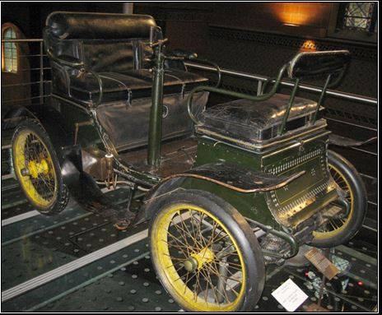
If you examine the attached photograph it was a classic example of an early motor vehicle and one can clearly see the obvious links to its predecessor, the horse drawn carriage. The vehicle was steered by a handle rather than a steering wheel and if there was more than one passenger they sat on the seat facing the driver. Even the step into the vehicle closely resembles what used to be used in horse drawn carriages.
Notice also that the vehicle shown above had no head lights, other vehicles of this type that had headlights were of the brass and glass carriage type.
Ownership of motor vehicles was not particularly common at this time and Louis must have been one of the earliest motor vehicle owners in the Greensborough area.
However it was rarely used as a mode of transport as the hilly nature of Greensborough caused the single cylinder car to struggle. Remember at this time the single cylinder engine was widely used as a tricycle engine!!
I certainly wished the family had kept it and passed it down to me !!!
From: " The Advertiser" (Hurstbridge, Vic Friday 17 October 1930 <http://trove.nla.gov.au/ndp/del/page/5871327>
GREENSBOROUGH...... The Podargus Club
The monthly evening was held in the Methodist school hall on Tuesday night. The chief item was a "Back to Childhood" celebration. Sedate citizens, mostly parents burdened with the responsibilities of families, put aside the worry and anxiety of the present hard times, aided by imagination went back to the carefree period of school days. Fathers, some of them over six feet in height, appeared in knickerbockers, socks, blouses with sailor collars, caps, etc. Mothers, clad in short print dresses, with sashes of coloured ribbon around what possibly were once slender waists, tied in a bow at the back, and with hair in plaits also tied up with coloured ribbon, assembled under the control once more of their old schoolmaster, long since retired (Mr. L. Amiet). After falling into line and marching into school, and before lessons were started, Mr. Amiet feelingly referred to the fact that many of the old boys' names were on the schools honour roll, many of whom had made the supreme sacrifice, and he asked that the entire company stand in silence for one minute to honour their memory. When school began, we regret to state that discipline was very hard to enforce. Girls kept on giggling or talking, and boys, quite old enough to know better, were frequently copying and making eyes at them. Lessons in geography, grammar and arithmetic rather hung fire, owing, perhaps, to the fact that the one-time bright schoolboys and girls have for many years since been chiefly concerned with the every day problem of making both ends meet. The master, however, was very lenient, and none were "kept in" at playtime. As a matter of fact, quite a novel method of punishment was adopted. Instead of using cane or strap, or writing 100 times "I must not talk in school" for errors in sums or bad behaviour, the culprit was compelled in most cases to sing an old-time song. This method had the two-fold effect in many in stances of punishing the vocalist and the audience also.
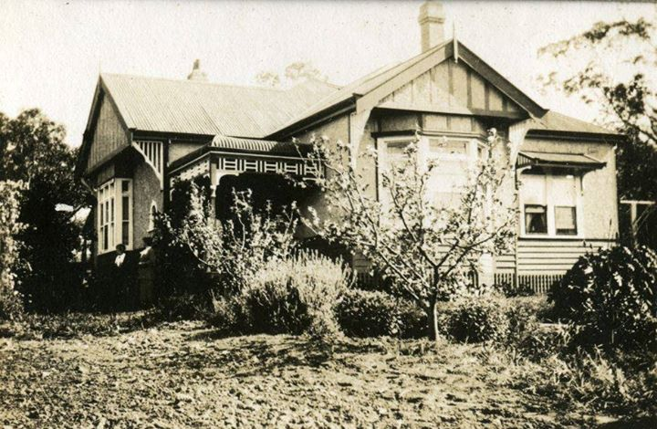
David Shane Amiet‎ Greensborough & Diamond Valley forgotten memories.... whats your story ?
Louis Amiet's house in Grimshaw St... I believe one of the ladies standing at the foot of the stairs is Helen Amiet
