Briar Hill Hall
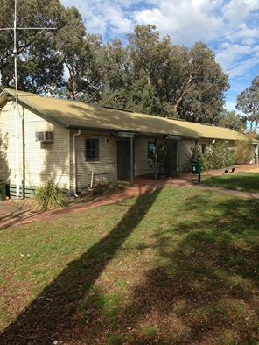
Matt Craig ‎I GREW UP IN THE GREENSBOROUGH DISTRICT

It's on Mountain View Road left hand side just before you get to the Briar Hill Shops coming from the St Helena Road end
This is one building that has changed very little over the years and has avoided demolition. It may have changed colour every so often but exactly the same exterior for over 60 years or longer.
Used to do self defense there in the 70s
I did marching there and sometimes we would have fetes there too

