Leech Street Briar Hill
Matt Craig‎
Greensborough & Diamond Valley forgotten memories.... what’s your story?

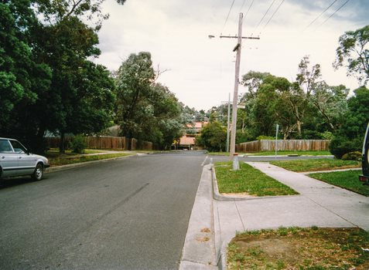

Sylvia Tupper Philip Adams used to live in Leech Street. I was in the same class as Philip at Eltham High.
Matt Craig Haha 😂 I wouldn't be owning up to that one Sylvia
Sylvia Tupper Made life interesting even if we didn't agree with him.
Jo Petrovic I seem to remember it being mostly paddocks back there Sylvia. We lived on Britnells Road which later changed its name to Mountain View Rd. In the mid 50s dad carved up our acreage and put in Glendale Road, Flodden Way and Bonnie Doon St. We used to cut across the paddocks at the back, and walk down a little concrete pathway that now runs off Essex Street, which took us to the corner of Fernside Ave and Campbell St. That was our walk to the little store on the opposite corner of Sherbourne and Mountain View Road. No doubt your street was always there, but I don't remember a whole lot of housing back then.
Matt Craig Thanks for the story Jo Petrovic. I know over the period of time that we reconnected through this site you had some wonderful stories to tell and when we caught up last year in Toowoomba we had a good laugh. Do pray continue reminiscing and telling us a few more stories. It is so wonderful to hear them time and time again.
Sylvia Tupper If it helps to date it Philip Adams was at Eltham High 1951 to 1955 so his house in Leech Street must have been built prior to 1951. It was weatherboard but I'm not sure whether it is still there.

