Briar Hill Shops 1984
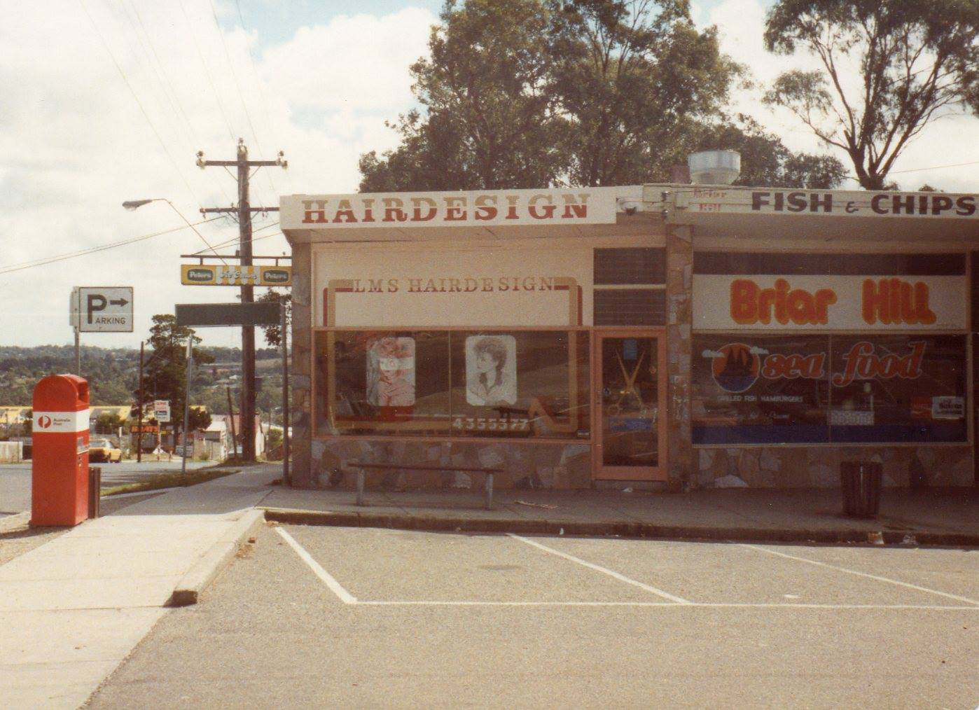
Leanne Small-Rankin‎ I GREW UP IN THE GREENSBOROUGH DISTRICT

I owned the hairdressing salon at Briar Hill from 1980-1985. This photo 1984.

