Briar Hill Timber and Trading
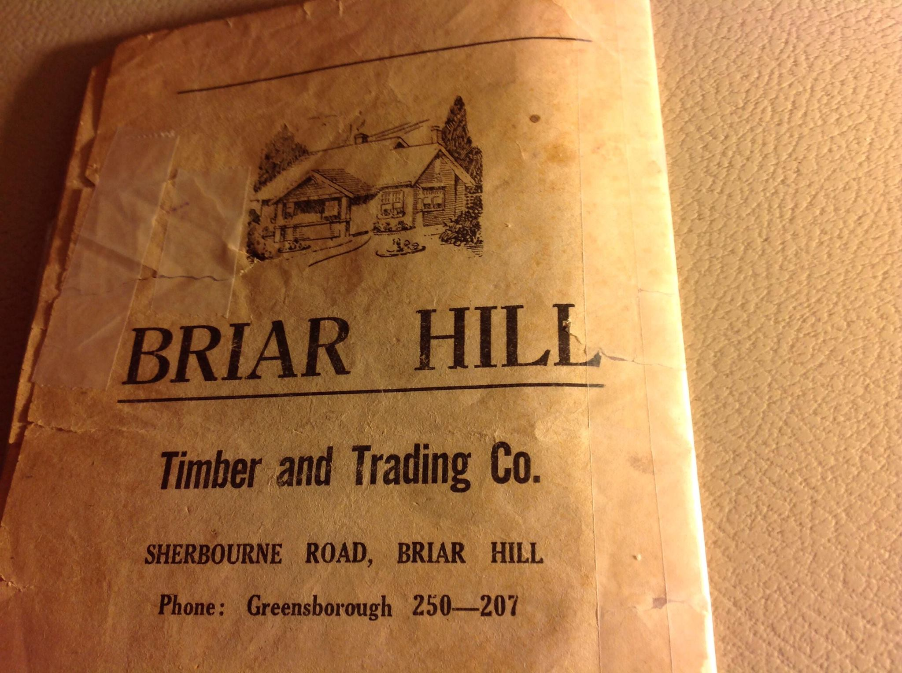
Faye Fort‎I GREW UP IN THE GREENSBOROUGH DISTRICT

John Leaford did his joinery apprenticeship here 1952-1957. My first job was in the office straight from school 1958. My father Reeve Chamberlain was yard foreman from 1954, he later worked at Stubleys Hay and Grain, then Delta Hardware, Main Street before retiring from Burgundy Hardware in Heidelberg.
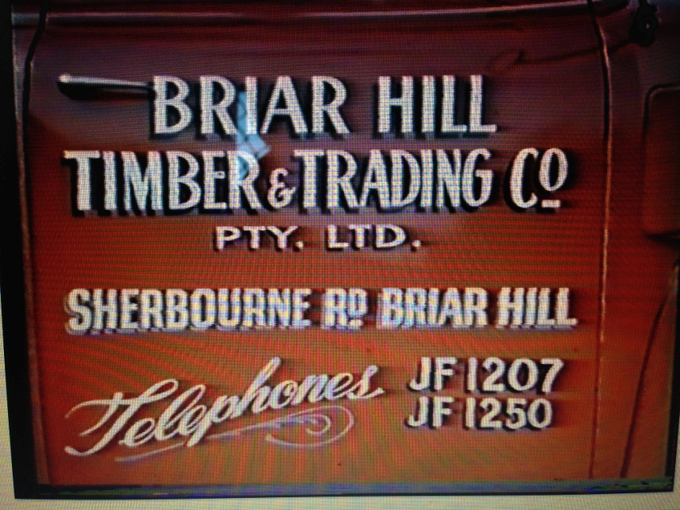

Matt Craig‎I GREW UP IN THE GREENSBOROUGH DISTRICT

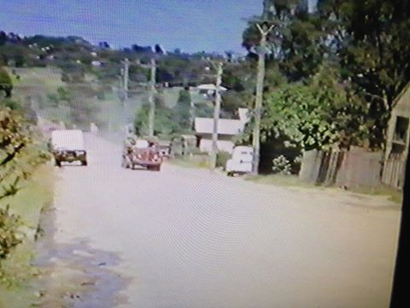
Matt Craig Truck from the Briar Hill Timber Yard coming up Sherbourne Road with a load of logs from Flowerdale.
Lieanne Hawkins My dad worked there for over 39 yrs until it closed gee things have changed
Matt Craig Lieanne Hawkins, what year exactly did the Timber Yard close down then?
Lieanne Hawkins I think it was 10-15years ago l’ve got a clipping gonna look it up for you I’ve also got all the back story on Briar Hill from Mr Squire he pretty much made Briar Hill the place it is l'll find it & try & post it on here
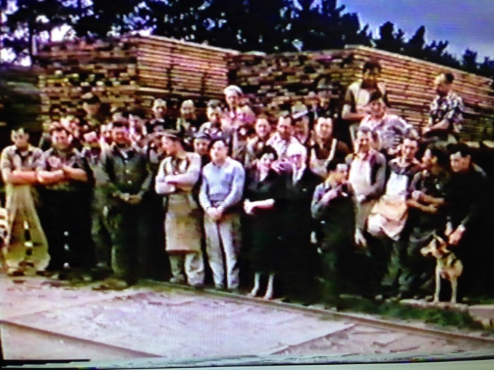

Matt Craig ‎I GREW UP IN THE GREENSBOROUGH DISTRICT
Staff from the Briar Hill Timber Yard

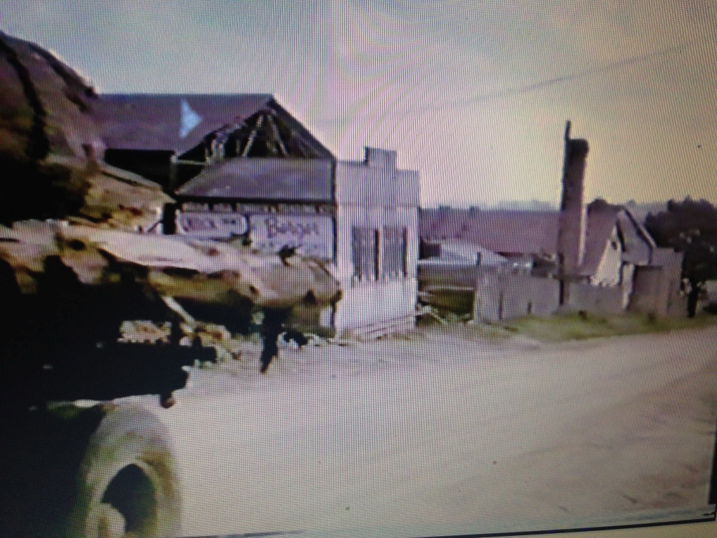
Matt Craig ‎I GREW UP IN THE GREENSBOROUGH DISTRICT
Nicole Blackmore My mum nearly fell over when I showed her this photo Matt Craig,I said "look at the dirt road!" And she said "I know Nicole! Do u know how many bloody times I walked across it???Hahaha
Nicole Blackmore She told me she and her younger sister used to have to go over there at night with kerosene lamps to put wood on the kiln fires coz her father had had too much to drink!!! Hahaha
Lee Shanhun I remember the buildings......but the road wasn't dirt when I was a kid....it was sealed but there was no curb and channel.
Jim Downey Wow..great photo. I think I remember a massive conical shaped pile of sawdust as well. early to mid sixties.
Matt Craig Jim Downey, many a child played in that pile of sawdust much to Bob Manuells dismay. He never knew whether somebody would have got smothered by the sawdust collapsing on them. I guess we weren't supposed to play in there.

Richard Kottek loved the smell of fresh sawdust and the heat deep in the pile

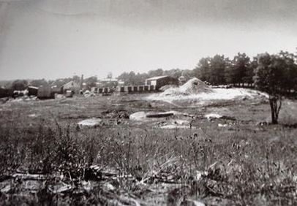
Faye Fort‎Greensborough & Diamond valley forgotten memories.... whats your story ?

Matt Craig That was the big pile of saw dust that Mark Lewis and myself and a hundred other young kids used to play in... Poor Bob Manuel would have had a fit if he knew.
Mark Lewis for some reason they were always on fire or smoking,it must have been spontaneous combustion.
Sandy Anton Timber yards always kept the wood wet
Lyne Clough Walker It would have been steam not smoke.
Mark Lewis It was glowing red,it definitely caught on fire sometimes in the drier weather,and yes it used to steam as well.
Lyne Clough Walker Yes, it would be hard to control it in the hot summers we had.

