Dobell’s Greenhills Road
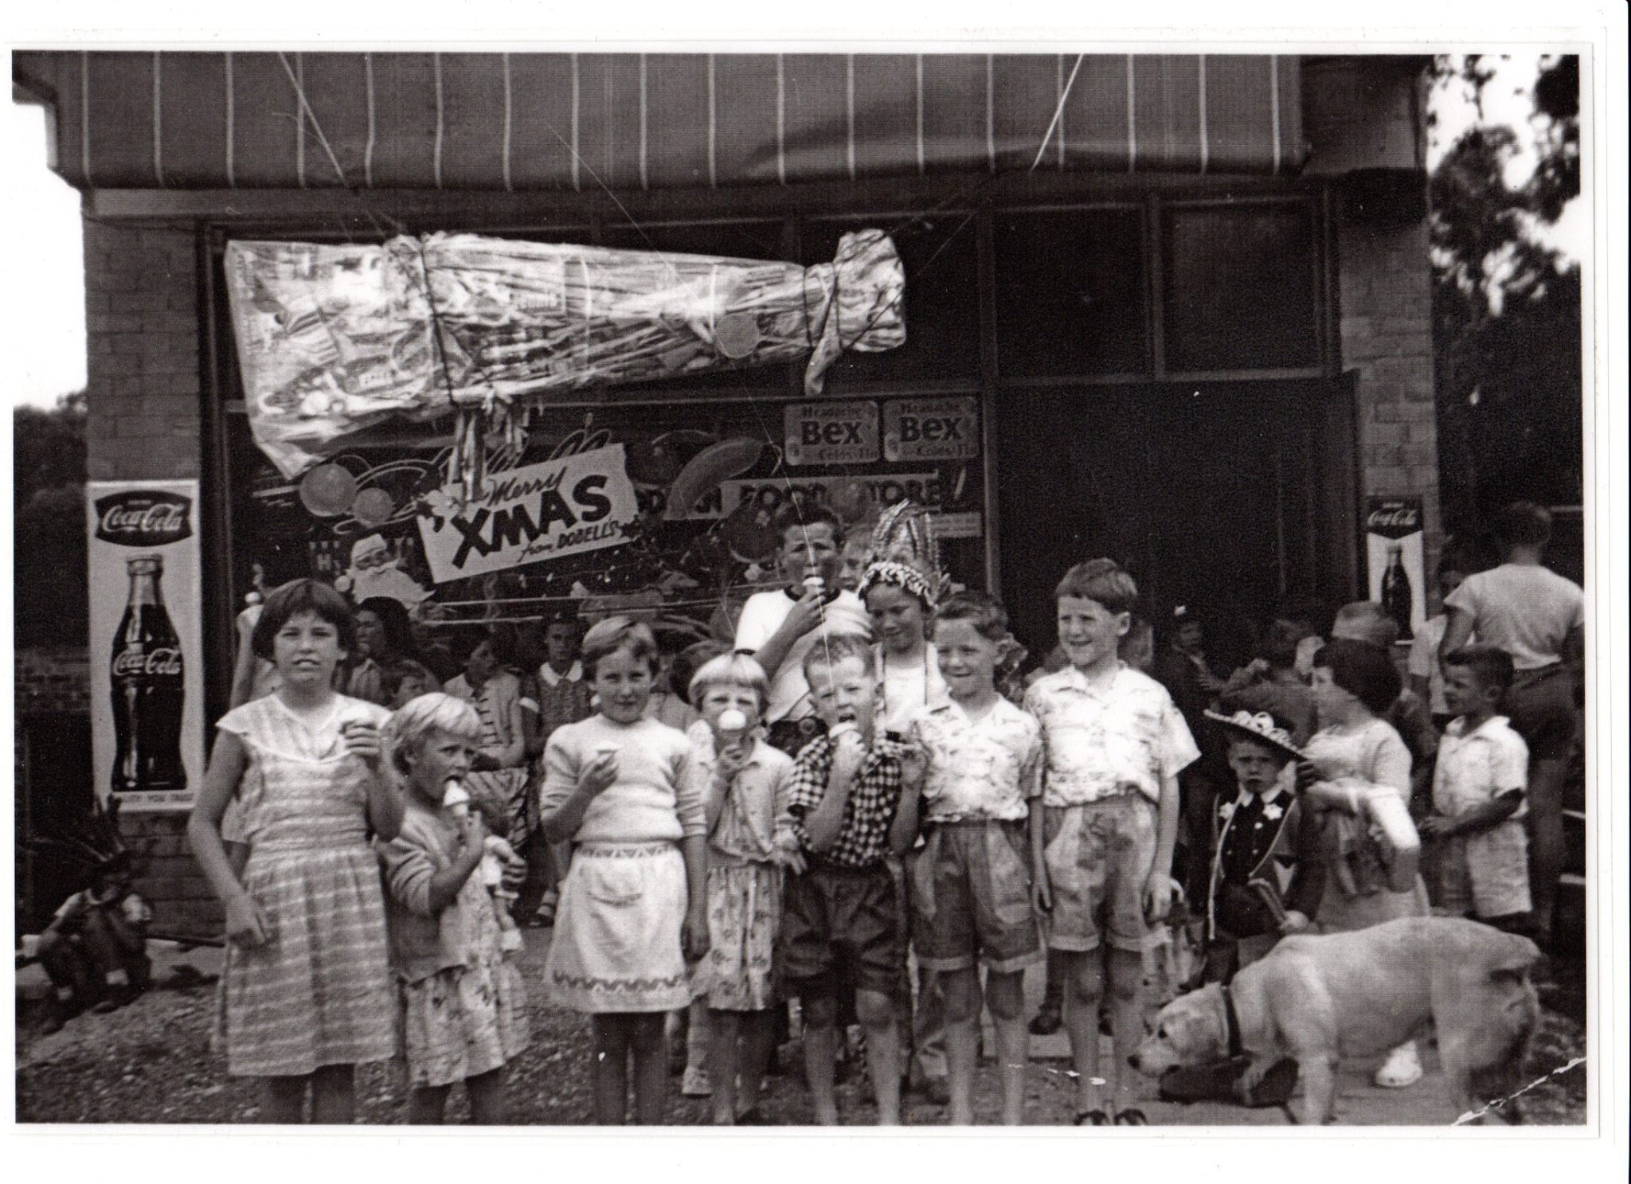

Colin Mc Gregor ‎I GREW UP IN THE GREENSBOROUGH DISTRICT
Here is a new photo of us all eating ice creams supplied by Dobells 1960

Lyne Clough Walker We must have been just turned 5? It must have been the Christmas before we started school

• Faye Fort Wyn and Don Dobell built their shop in 1957 it was a grocery store then they built a store room then the dwelling at the back 12 months later they built 3 more shops Margaret O Connor has lived next door since the 1950s. Bill Berrill lived a bit further down. He bought. Ben and Joe Partington’s house after they passed 1942, 1943. They owned all that land before it was subdivided right up to the school

• Cathy Cukier Mum and Dad (O'CONNOR) built their home in 1953. There were the O'Connors then Thorpes, then Turners, then Laings then Birrells. On the other side of the shops were the Rogers then Sutherlands. The paddock now the park held awesome bonfire events

• Matt Craig So good to hear all those names being repeated. I can remember all of them as they were either on the paper round route I did back in the day or we just knew them all as it was a very small community back then and you knew everybody. Our parents used to stop for a natter and catch up and it was so unhurried back then. Plenty of time to kill chatting and gossiping.

• Faye Fort Margaret O’Connor from Greenhill Road played the organ at St Mary's Catholic Church for 40 years she also worked at Churinga School for over 40 years
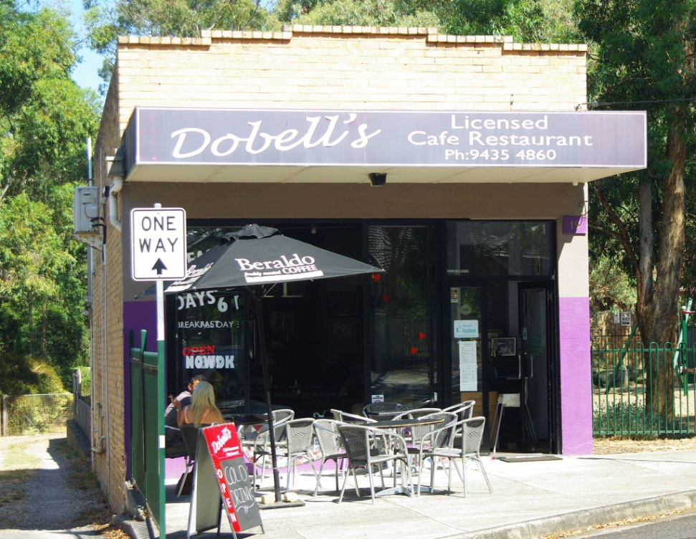

2014 – Dobell’s Café – photo Marilyn Smith
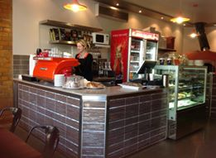
2015 – The Clay Pot – photo by Faye Fort

