Greensborough 1968

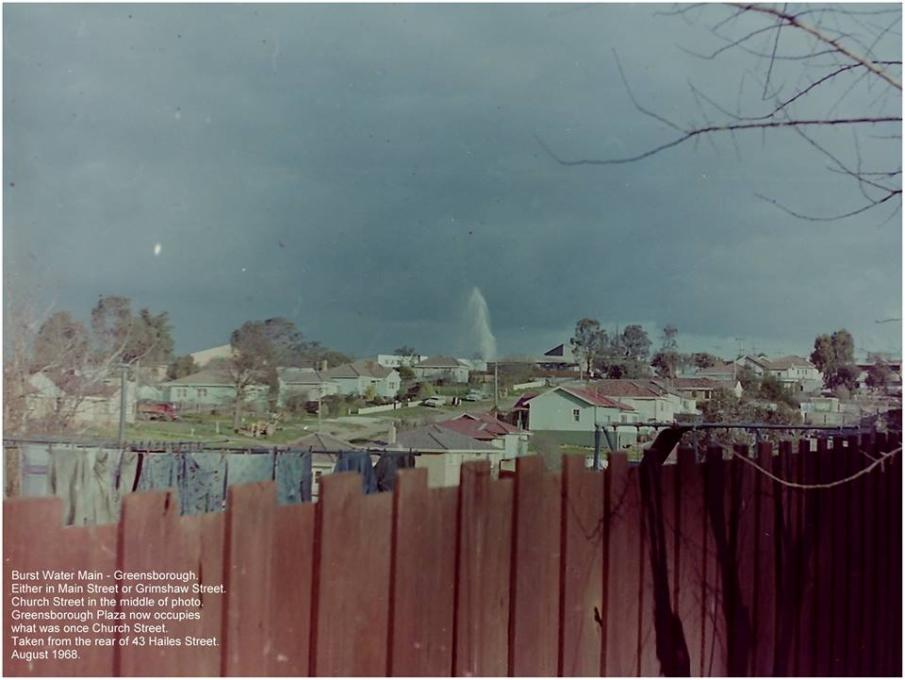

Paul de Sauty ‎I GREW UP IN THE GREENSBOROUGH DISTRICT

I took this photo in August 1968 in an attempt to capture the burst water main in either Main Street or Grimshaw Street. It's a pretty ordinary photograph in itself, however, it now has some historical significance illustrating what was once Church Street.
Jim Blackwood Willy Willmont lived in the green house, Church on the corner

Ben Lavric That's a great photo, I did not realise how populated Church St was. If anything I always thought, it was a through road with no houses.

Matt Craig A typical scene looking over the backyard with the washing hanging out on the Hills Hoist and the set of Monkey Bars by the looks of it to the right. It seems the burst water main is near the Church if that is the building with the pyramid shaped roof which I recall All Saints had. I stand corrected though.
Jim Blackwood Matt you are 100%
Sandy Anton Another great photo. You can see New World the start of the changes that had all been All Saints land and All Saints built that new church when they sold the land

Marilyn Smith Yes Sandy, New World sign, is that a house roof or?? between the trees on the left.

Sandy Anton on the left Maz? l think that’s the telephone exchange and post office

Sandy Anton Church St was steep

Paul de Sauty I used to walk down Church St on my way home from school. I'd walk to school via Jessop St.

Ross Hogan What a great place the borough was in ‘68 !

