**Greensborough 1970s**

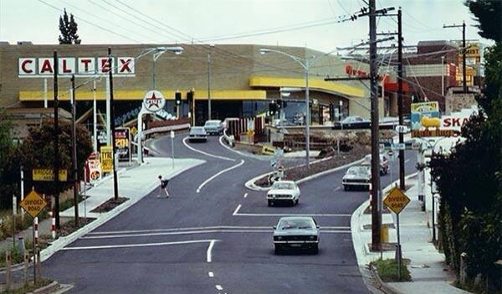

Photo from [Alan White](https://www.facebook.com/alan.white.1420?fref=photo) ‎[I GREW UP IN THE GREENSBOROUGH DISTRICT](https://www.facebook.com/groups/468839069910597/)

Must be not long after Watsons of Greensborough moved and they built that huge store.

The by pass railway bridge. The big store was Woolworth's originally. No Shell servo then, Purser's brick front fence is still there

I recall the Caltex service station during the early to mid 90s. If I'm not mistaken I think they had a separate tank for topping up mower cans and the like to avoid congestion with customers coming to fill their cars. If I could take a few things captured in that photo it would be the Golden Fleece, Caltex and Four and Twenty pies sign!

Garry Wilkes was the manager of the Caltex-

Saw Zig and Zag at the Caltex servo when it opened

owned by Ivan Martello