**Greensborough Grain Store**

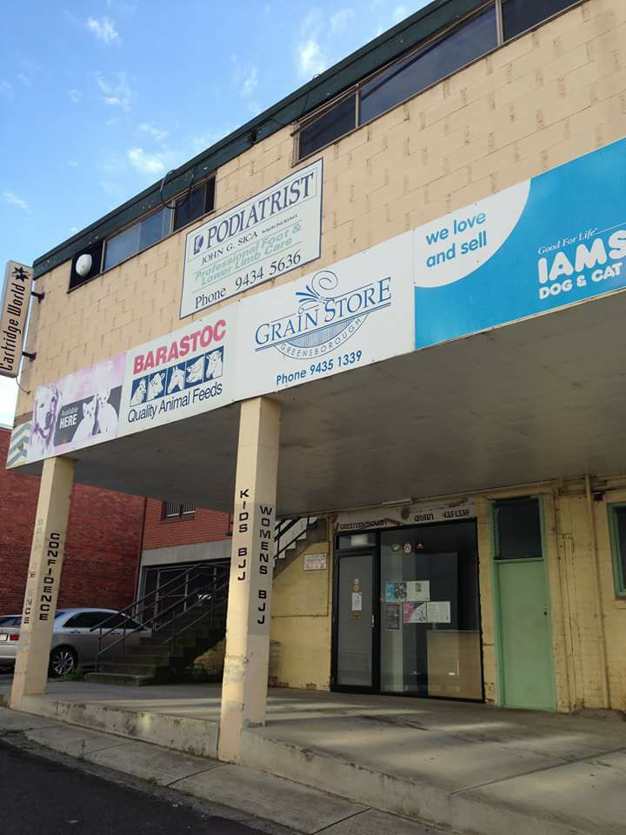

[Sharon Turner](https://www.facebook.com/profile.php?id=100006009524722&fref=gc&dti=468839069910597) As noted on 'the other' Greensborough history site the Stockfeed store, that moved from the rear of Main St to Para Rd is closing its doors. They will still be operating as an online business.

[Emma Spillane](https://www.facebook.com/emma.jane.79827803?fref=gc&dti=468839069910597) Mum used to buy chock food there

[Chris Allen](https://www.facebook.com/christowoody?fref=gc&dti=468839069910597) As a kid in the 60s & 70s the wonderful smell of lucerne & grain from the produce store will remain with me forever https://www.facebook.com/images/emoji.php/v9/ffc/1/16/1f44d.png👍

[Henry de Man](https://www.facebook.com/henry.deman?fref=gc&dti=468839069910597) I can still remember the smell of the grain store as you climbed the stair  
on the way to get a Dairy Queen after swimming at the pool.