**Greensborough Plaza**

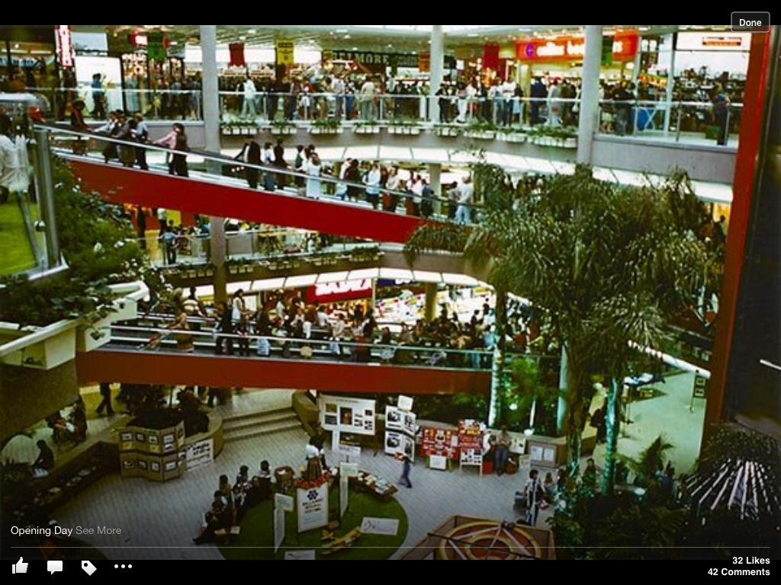

Opening day Nov 1978