Greensborough Police Lock-up

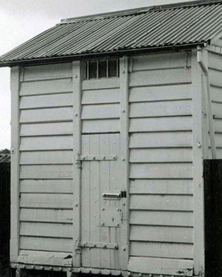
Marilyn Smith‎ Greensborough & Diamond Valley forgotten memories.... what’s your story ?

