**Greensborough Pool**

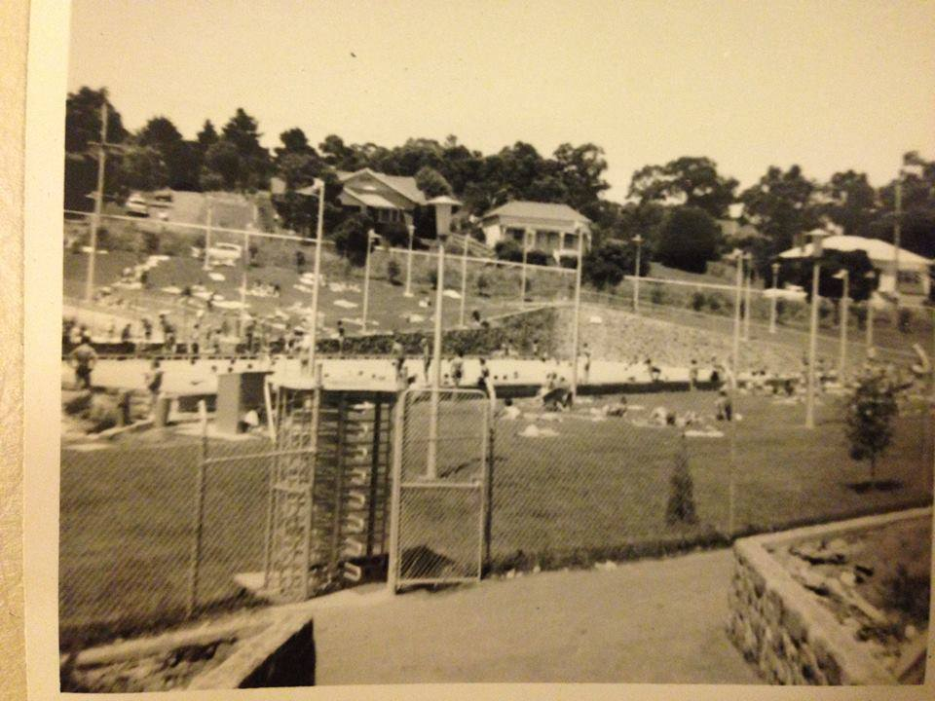

From Facebook: I grew up in Greensborough site