Greensborough Post Office
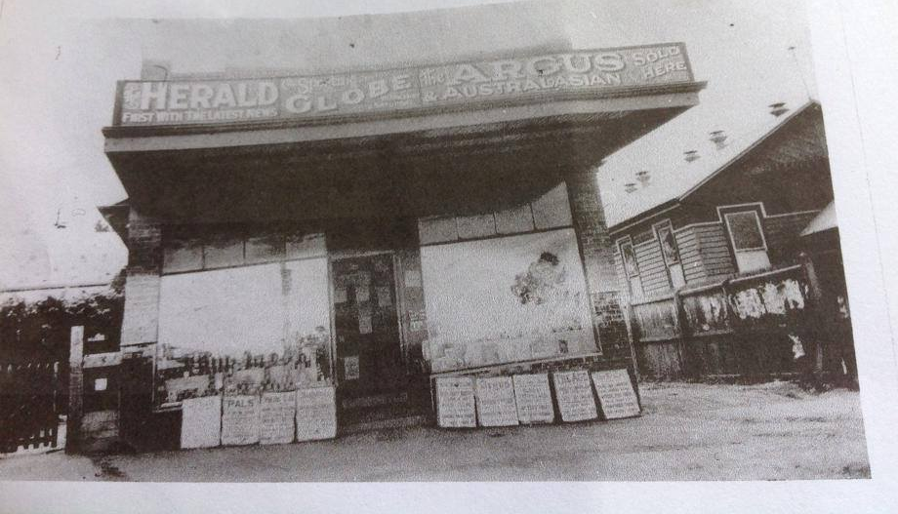
First Post Office
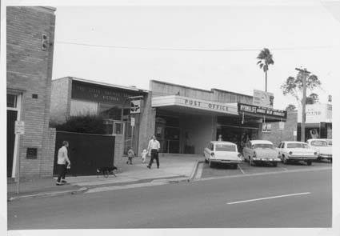
Second Post Office
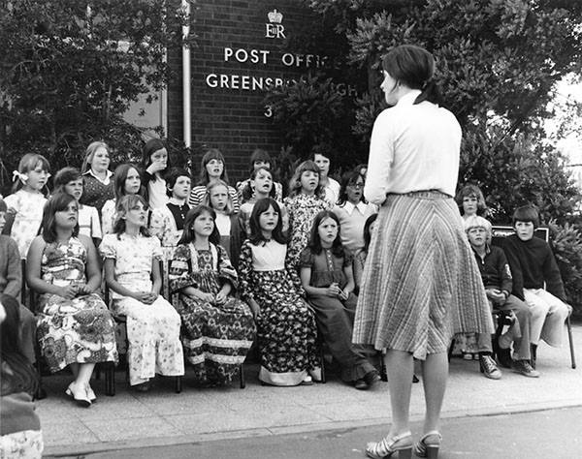Third Post office
Sandy Anton Greensborough & Diamond Valley forgotten memories.... what’s your story ?

