Greensborough Primary School
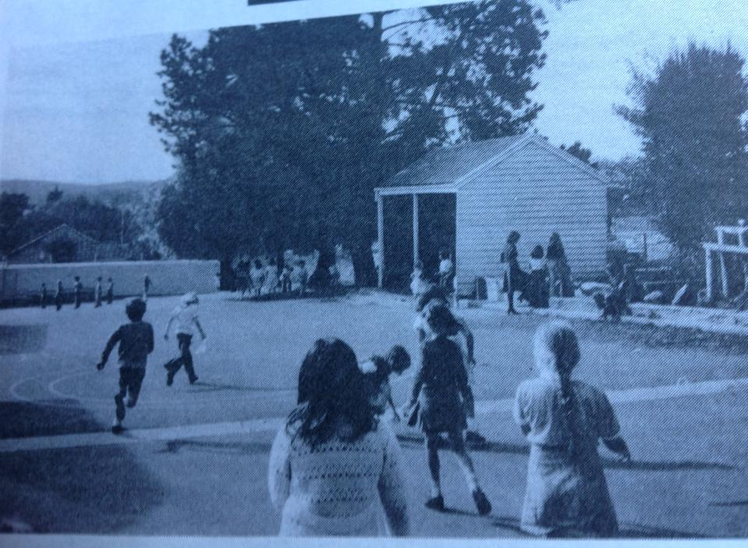
Faye Fort‎ Greensborough & Diamond Valley forgotten memories.... what’s your story?

