**Helen White photos**

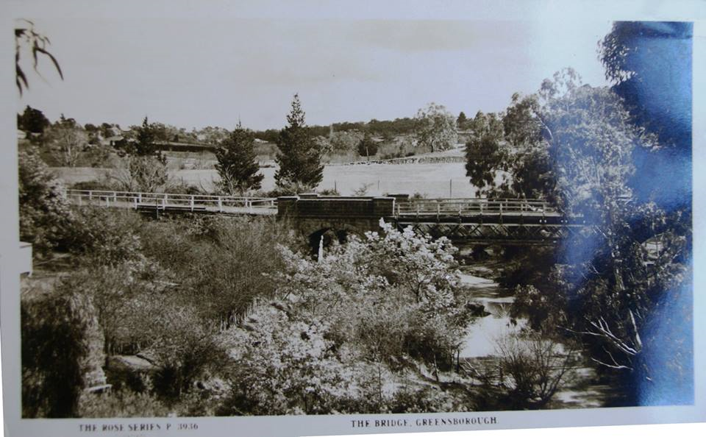

**The Bridge Greensborough [Rose Series postcard]**

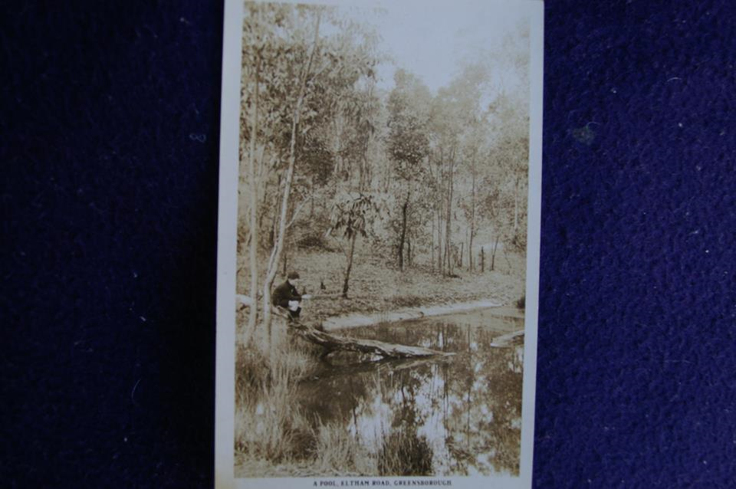**A Pool, Eltham Road Greensborough**

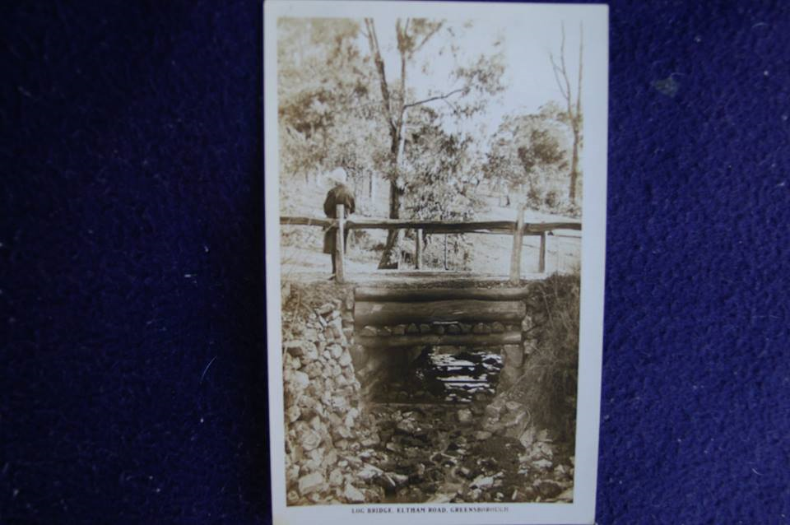**Log bridge, Eltham Road Greensborough**

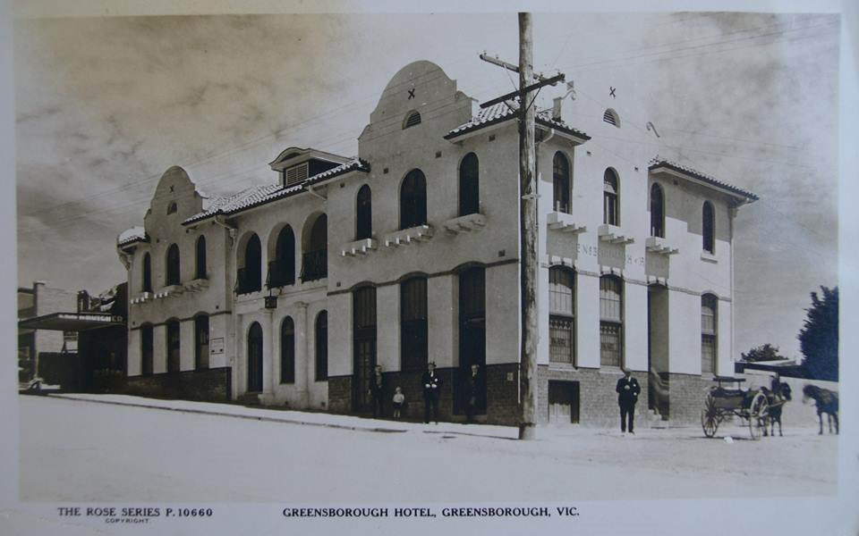

**Greensborough Hotel [Rose Series postcard]**