**Greensborough Station 1975**

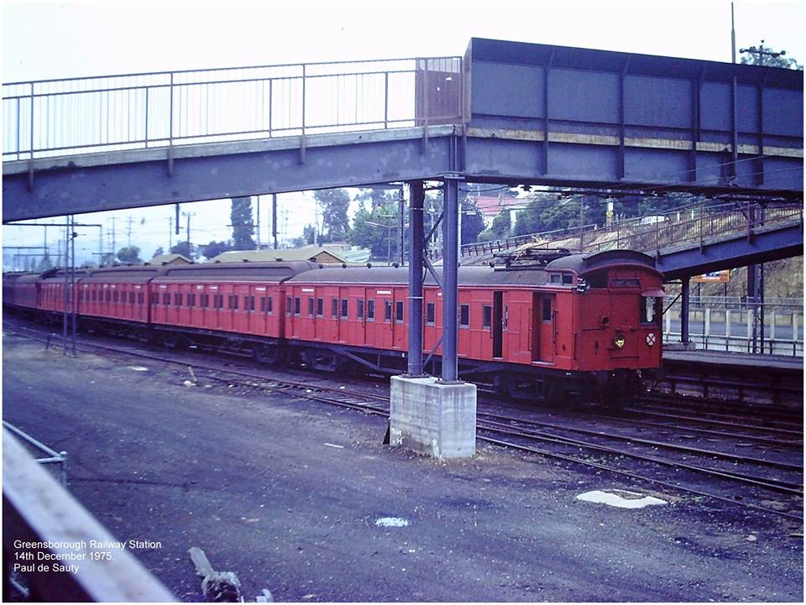

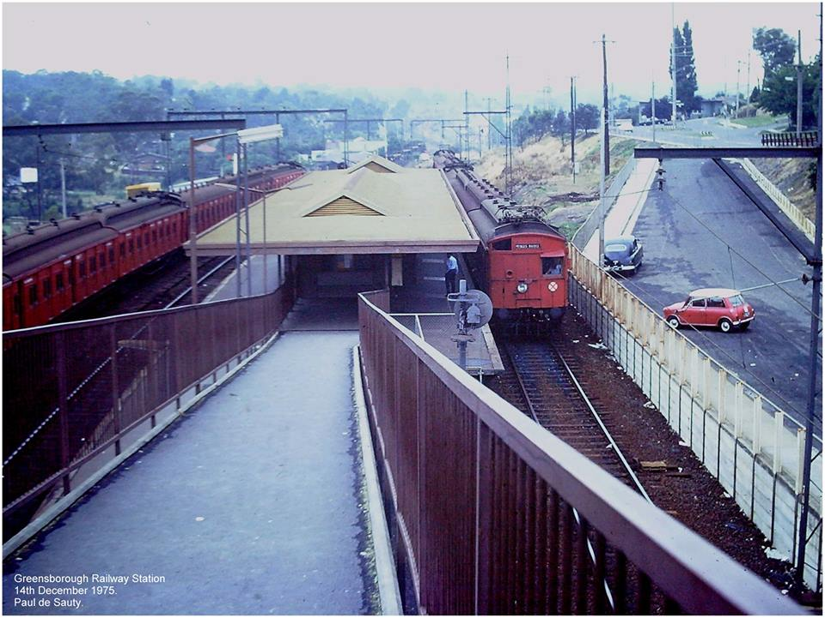

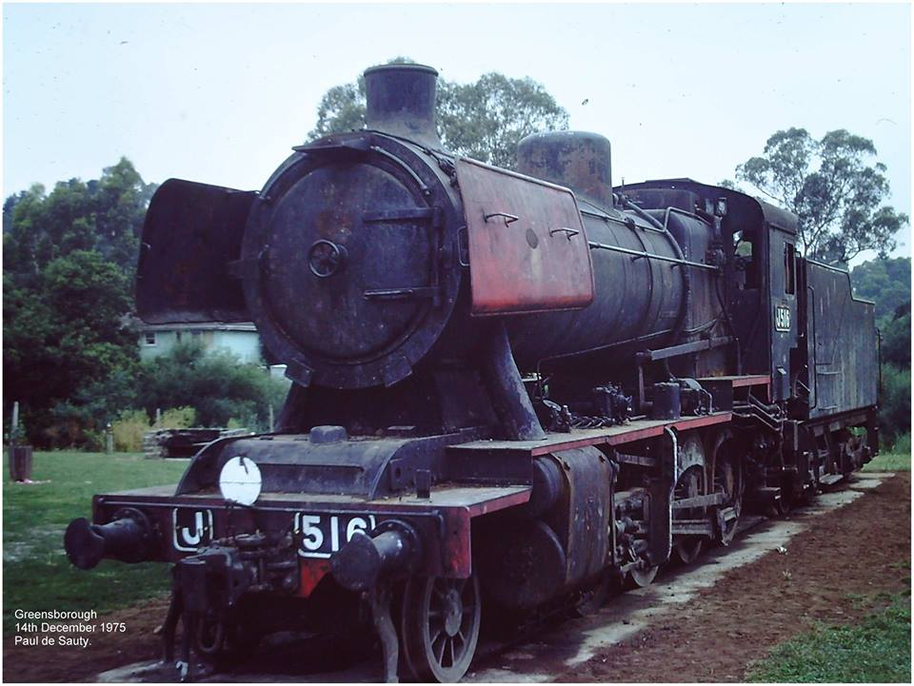

[Paul de Sauty](https://www.facebook.com/paul.desauty) ‎[I GREW UP IN THE GREENSBOROUGH DISTRICT](https://www.facebook.com/groups/468839069910597/)

The taking of photographs sometimes helps specific dates and what one did on that day stay in the mind. On this occasion, Sunday 14th December 1975, I drove from Heathmont to pick up a good friend at the time who lived at 107 Hailes St. for a day out at Emerald Lake in the Dandenongs. (It was also the Christmas party function for the company I worked for. Sperry New Holland in Dandenong). On the way back home, I decided to swing round to Greensborough railway station just to see what was there and observe any changes. There were some changes all right! The goods siding had been removed. Tait trains had replaced the Doggies. The station was now an island platform. Trains were now stabled in the old no. 2 road and J516 had taken up residence in the adjacent park.