**Greensborough Then and Now** – Paul De Sauty

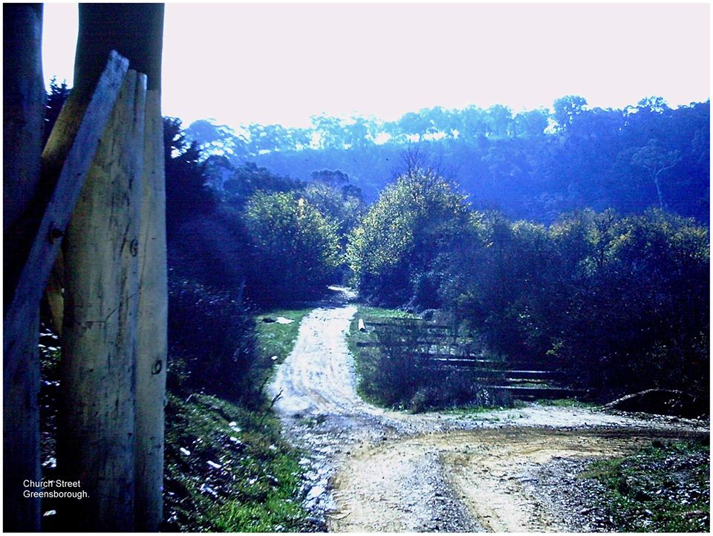

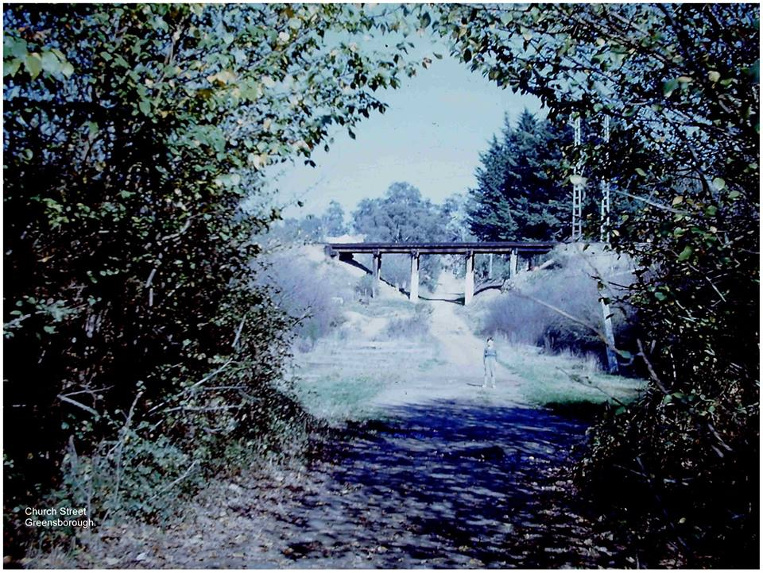

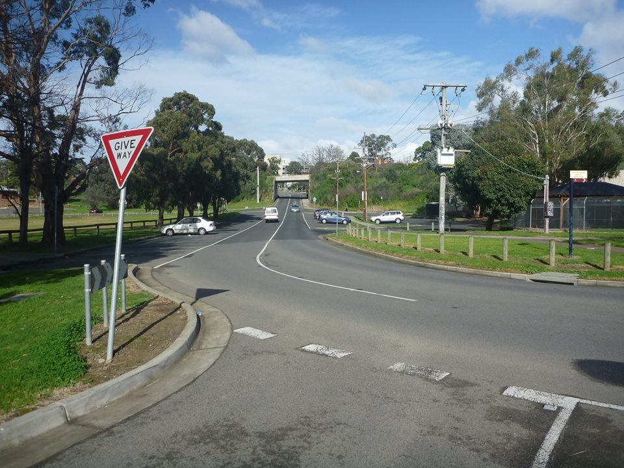

[**Paul de Sauty**](https://www.facebook.com/paul.desauty?fref=nf) **I Grew up in the Greensborough District**

[2016](https://www.facebook.com/groups/468839069910597/permalink/969316329862866/)

The title of this set of photos is "Then and Now". The first photo, taken in 1960 is looking towards Partingtons Flat or Paddock, from the railway trestle bridge. I think the Plenty Creek flows through there. The second photo, taken in 1961 is looking back the other way. That is me in the photo. I would have been 8 years old at the time. This was called Church Street back then but has now been renamed. The third photo was taken by me 50 years later in 2011. I had the previous photo in mind when I took this photo. Didn't quite get the exact location right.

[Sandy Anton](https://www.facebook.com/sandy.anton?fref=ufi) Church Lane. Now tar and cement and the old trestle bridge gone...great paul

[Paul de Sauty](https://www.facebook.com/paul.desauty?fref=ufi) As you know, Sandy we lived across the road from him (Gunga). I seem to remember that he was only boarding there. However, I stand to be corrected on that. My brothers and I went inside the house on quite a number of occasions.

[Sandy Anton](https://www.facebook.com/sandy.anton?fref=ufi) yes he only lived there. Was a strange one. And the stories were true he shot kids if he caught them on the Marsh’s land. Only with salt bullets but they still hurt

[Faye Fort](https://www.facebook.com/faye.fort.5?fref=ufi) Yes Paul he only was a blow in after Richard Marsh passed but he thought he owned the place the way he used to ride around on his horse but that's what he liked - having control

[Faye Fort](https://www.facebook.com/faye.fort.5?fref=ufi) Paul the house is still much the same inside today. Judy who owns it and the lady before her have tried to keep it much like the original That's the only reason she sold it to Judy cos she knew she loved the old house also

[Paul de Sauty](https://www.facebook.com/paul.desauty?fref=ufi) I remember the old lady telling us that she hadn't opened the front door since her husband died and that had been about 16 years ago at that time.

[Faye Fort](https://www.facebook.com/faye.fort.5?fref=ufi) Paul that bluestone cellar just inside the original front gate was built to hang the meat after it was killed. But Teresa [Marsh] wanted another one so that one was built around near the rail bridge. People often wonder why it was built so close to the rail line. But the Britnells built the house in 1860 and the rail line only went through in 1902

[Faye Fort](https://www.facebook.com/faye.fort.5?fref=ufi) Richard Marsh bought the house early 1900s he was the one who put all the bluestones around the place He met Teresa while he was working overseas. She was a young girl. He told her when she was 21 he would bring her to Aust. He brought her family out to live.