Henry Street Greensborough
Vicki Wilson‎ Greensborough & Diamond Valley forgotten memories.... what’s your story ?

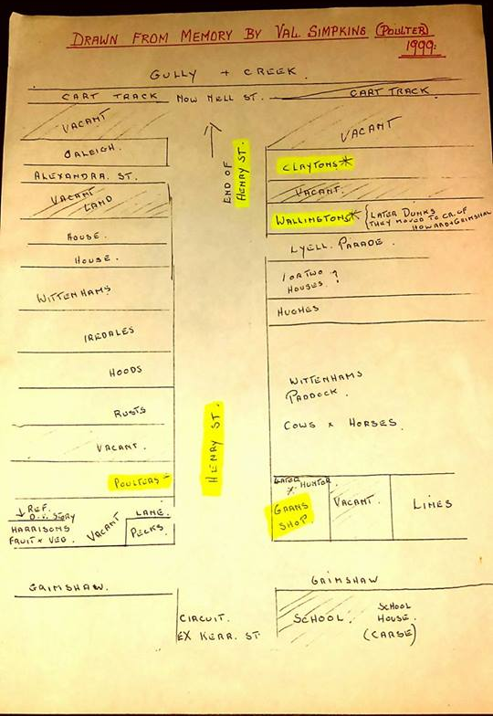
Old map remembered by Val Poulter, my Mum's cousin..of Henry Street Greensborough. Gran's shop on corner tearooms (owned by Amy Clayton my Great Grandmother) Dunks also in our family.
Vicki Wilson Val was my Mum's cousin. Married name Gibson. Maiden name O'Neill.
Ross Brooks Vicki was Val’s mum Ethel Poulter do you know Val’s married name?
Vicki Wilson Val is now in her early 90's
Vicki Wilson No Val's married name is Simpkins.
Vicki Wilson Val's parents were Jack and Olive Poulter. Had a lot to do with them. Mum very close to her Aunt Ol.
Vicki Wilson Val was bridesmaid in Mum's wedding also.
Ross Brooks my dad was a Poulter, I never realized there were 2 Val Poulter's
Vicki Wilson Wow how about that! It's actually Valma, but still uncanny. I guess you must be related to Val somewhere there.
Ross Brooks do you know who Jack's father was?
Vicki Wilson I do but would have to look it up. I personally haven’t researched this side of family (the Poulters) My side is Clayton. Olive was a Clayton. Her parents Fred and Amy were old residents of Greensborough.
Vicki Wilson I think maybe Giles...but will have to make sure on that.
Ross Brooks I will have to get out my copy of the family tree
Sandy Anton No Vermont Pde or Ester St.. Must be in that Whittinghams paddock
Sandy Anton love it Nell St was the cart track
Sandy Anton What year was this memory ?
Vicki Wilson 1999 top of map Sandy.
Sandy Anton yes saw that but what years was she saying it was like this?
Vicki Wilson Oh ok, she is now early 90's and she mentions Gran's shop, so presuming it was Gran's then, so whatever the timespan Gran had the shop prior to Hunters owning it. (as she states on map) Maybe early 30's I guess.
Sandy Anton She’s still going that’s wonderful. l remember her in Henry St
Vicki Wilson Really? I don't think you're old enough. Don’t think she was there much after the 30s as she married. She lived Rosanna/Monty area for years.
Vicki Wilson Yes great that she is still going.
Sandy Anton Well there was a Poulter in Henry St about 2 behind the Ampol servo
Sandy Anton Can’t be her Vicki no l’m not that old lol
Vicki Wilson Ha I knew you wouldn't like that one! Wonder who the other Poulter was, obviously a relative of hers I guess
Sandy Anton l remember the lady it was either the 2nd or 3rd house sure Mum called her Mrs Poulter
Helen White Where is Vermont parade it should be on the left? Our house was on the right in Henry St opposite Vermont parade or I thought it was Vermont Parade. I could be wrong
Sandy Anton your looking at it wrong Helen your house was on the left. No Vermont Pde or Ester St they were still paddocks going by this
Sandy Anton Grimshaw St is at the bottom. Your house is there
Sandy Anton Whittinghams paddocks is the footy ground. The right hard side is not to scale to the left hand side. Lyell Pde is closer to Nell St than Alexandra St is.

