Johnny Chester
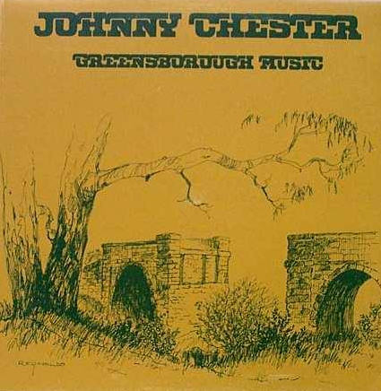

Lyne Clough Walker ‎I GREW UP IN THE GREENSBOROUGH DISTRICT

Johnny Chester, Greensborough Music, 1975. Cover by Ron Reynolds, old bluestone bridge.

OMG I have that cover but not the album. It is signed by Johnny Chester as I was one of the Greenhills primary school choir singers on that simple song
Cool! I was in grade 3 at Greenhills PS in 75. We used to go to the Chester’s home after school sometimes. Johnny was so popular back then!

