Macleod Station 1980s
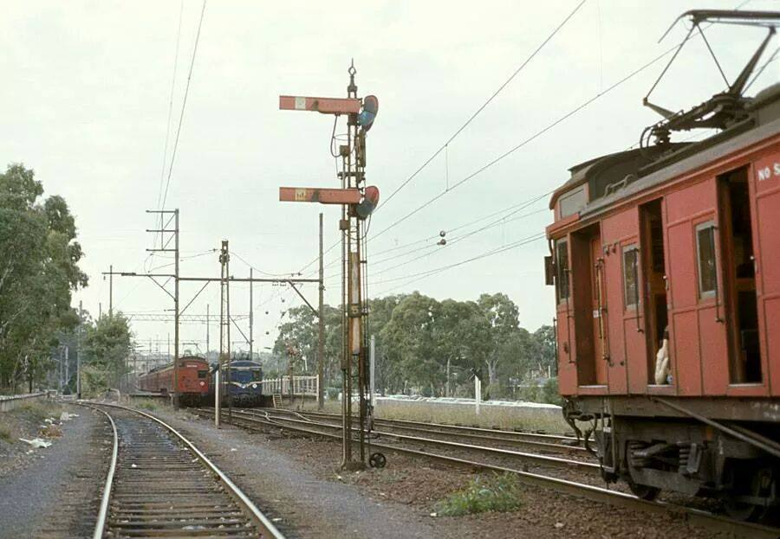

Stewy Barber‎Greensborough & Diamond Valley forgotten memories.... what’s your story?

