**Methodist Church Greensborough**

[David Collyer](https://www.facebook.com/dccollyer?fref=gs&dti=1425752810974725&hc_location=group_dialog)‎ FACEBOOK

[Greensborough & Diamond Valley forgotten memories.... what’s your story?](https://www.facebook.com/groups/1425752810974725/?ref=gs&fref=gs&dti=1425752810974725&hc_location=group_dialog)

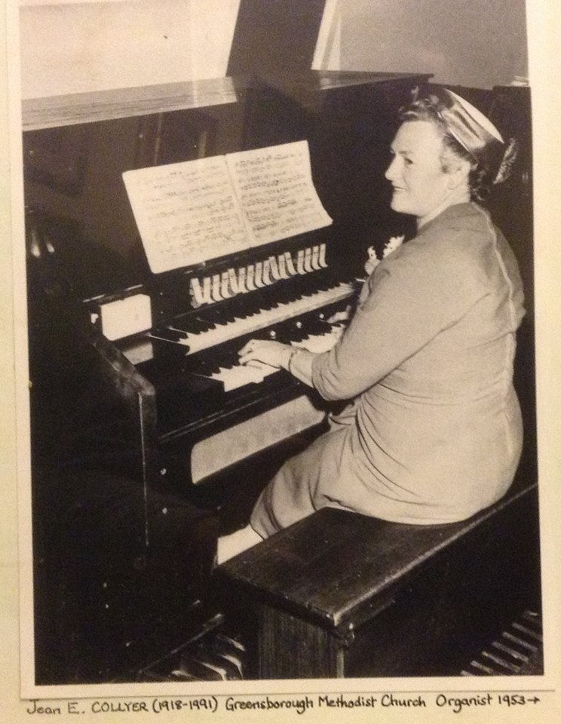

Here you go Faye - Mum (Jean E. COLLYER) at the organ. But I reckon this is the opening of the new Church in Grimshaw St.

[Faye Fort](https://www.facebook.com/faye.fort.5?fref=gc&dti=1425752810974725) What a beauty has the musical part come down through your mum David?

[Faye Fort](https://www.facebook.com/faye.fort.5?fref=gc&dti=1425752810974725) Love to know if it was the new church or the old one for sure David

[David Collyer](https://www.facebook.com/dccollyer?fref=gc&dti=1425752810974725) It's the new church Faye. See the sloping angle of the wall behind the organ. Within a short time, they built a pit to hide this ugly monstrosity. Most of the music is from Mum's side, but Grandma COLLYER had many uncles who played in Brass bands in Daylesford from the 1860s onwards.

[Faye Fort](https://www.facebook.com/faye.fort.5?fref=gc&dti=1425752810974725) So you couldn't miss out could you David. Lucky you. Nothing was passed down to me I am afraid My sister and my son copped some of it

[Sandy Anton](https://www.facebook.com/sandy.anton?fref=gc&dti=1425752810974725) it’s at the new church though

[Debra Bruning](https://www.facebook.com/debra.bruning?fref=gc&dti=1425752810974725) There is a photo of a couple of ladies sitting in the old church....

[Faye Fort](https://www.facebook.com/faye.fort.5?fref=gc&dti=1425752810974725) The new Uniting church. Opened in 1966

[Debra Bruning](https://www.facebook.com/debra.bruning?fref=gc&dti=1425752810974725) Faye, do you have a photo of the inside of the old Methodist Church showing some ladies sitting on chairs along a wall? One of the ladies is Olive Laing. Her grand-daughter Jenny Saddington (Chapman) has just joined our group

[Faye Fort](https://www.facebook.com/faye.fort.5?fref=gc&dti=1425752810974725) Deb I'll look in the book where I got this photo of inside the church I've have one of our wedding day in 1957

[[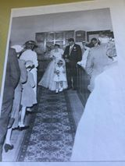](https://www.facebook.com/photo.php?fbid=2067928656762660&set=p.2067928656762660&type=3&ifg=1)](https://www.facebook.com/photo.php?fbid=2067928656762660&set=p.2067928656762660&type=3&ifg=1) July 1957

[[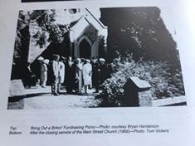](https://www.facebook.com/photo.php?fbid=2067928773429315&set=p.2067928773429315&type=3&ifg=1)](https://www.facebook.com/photo.php?fbid=2067928773429315&set=p.2067928773429315&type=3&ifg=1)

[[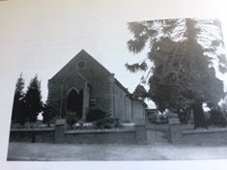](https://www.facebook.com/photo.php?fbid=2067928880095971&set=p.2067928880095971&type=3&ifg=1)](https://www.facebook.com/photo.php?fbid=2067928880095971&set=p.2067928880095971&type=3&ifg=1)

[[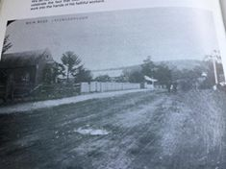](https://www.facebook.com/photo.php?fbid=2067928956762630&set=p.2067928956762630&type=3&ifg=1)](https://www.facebook.com/photo.php?fbid=2067928956762630&set=p.2067928956762630&type=3&ifg=1)

[Faye Fort](https://www.facebook.com/faye.fort.5?fref=gc&dti=1425752810974725) My Grandfather was the first child christened in this Main Street Church in 1872. William James Partington

[[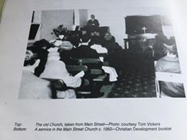](https://www.facebook.com/photo.php?fbid=2067932223428970&set=p.2067932223428970&type=3&ifg=1)](https://www.facebook.com/photo.php?fbid=2067932223428970&set=p.2067932223428970&type=3&ifg=1)

[Debra Bruning](https://www.facebook.com/debra.bruning?fref=gc&dti=1425752810974725) The red brick front fence must've been after this picket fence

[Faye Fort](https://www.facebook.com/faye.fort.5?fref=gc&dti=1425752810974725) The rest of the photos are of the new church Deb

[[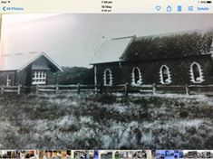](https://www.facebook.com/photo.php?fbid=2067934140095445&set=p.2067934140095445&type=3&ifg=1)](https://www.facebook.com/photo.php?fbid=2067934140095445&set=p.2067934140095445&type=3&ifg=1)

[Faye Fort](https://www.facebook.com/faye.fort.5?fref=gc&dti=1425752810974725) The horses were tethered in this paddock with the jinkers etc while church was conducted

[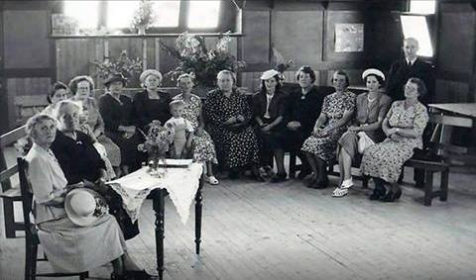](https://www.facebook.com/photo.php?fbid=2067934753428717&set=p.2067934753428717&type=3&ifg=1)

[Faye Fort](https://www.facebook.com/faye.fort.5?fref=gc&dti=1425752810974725) Ladies Guild my grandmother Annie May Partington in black. Sitting next to Mrs Weaver

[Debra Bruning](https://www.facebook.com/debra.bruning?fref=gc&dti=1425752810974725) Oh Faye, you are a treasure!!  
Jenny Saddington, centre left in the above photo! Your maternal grandmother??

[Faye Fort](https://www.facebook.com/faye.fort.5?fref=gc&dti=1425752810974725) My dad's mother Deb

[[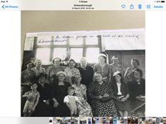](https://www.facebook.com/photo.php?fbid=2067937023428490&set=p.2067937023428490&type=3&ifg=1)](https://www.facebook.com/photo.php?fbid=2067937023428490&set=p.2067937023428490&type=3&ifg=1)

[[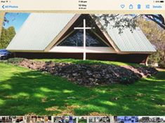](https://www.facebook.com/photo.php?fbid=2067937393428453&set=p.2067937393428453&type=3&ifg=1)](https://www.facebook.com/photo.php?fbid=2067937393428453&set=p.2067937393428453&type=3&ifg=1)

[Debra Bruning](https://www.facebook.com/debra.bruning?fref=gc&dti=1425752810974725) Yes, I and my sisters were married here