**Para Road Industrial Strip**

Matt Craig FACEBOOK

Greensborough & Diamond Valley forgotten memories.... what’s your story?

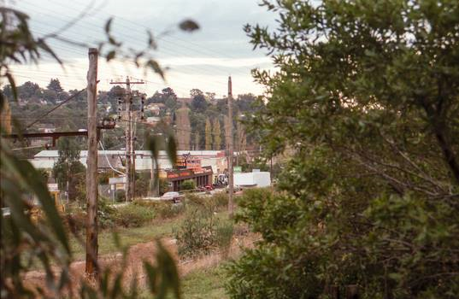

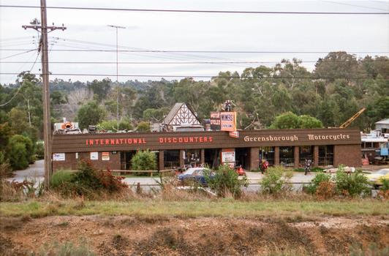

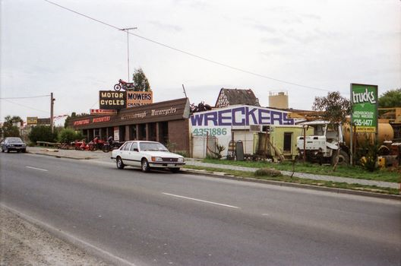

[Jamie Collyer](https://www.facebook.com/jamie.collyer.98?fref=gc&dti=1425752810974725) OMG, the old Greensborough Wreckers.. How many times did we get phone calls from someone wanting this part or another, as Mum & Dad's phone number was 435 1866

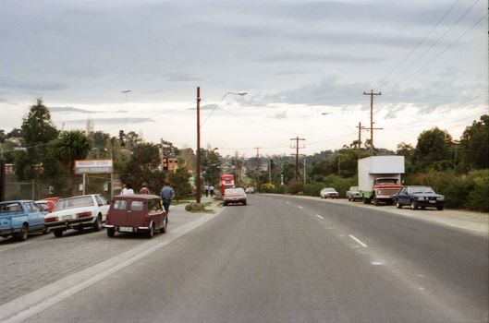

Matt Craig This area used to be Hutchinson Soil and Gravel