Purdy’s Furniture

Sharon Turner I Grew up in the Greensborough District
· January 14, 2016
All these pics were taken by my sister, the timber yard not long before it was demolished. Not sure of the year. Maybe early 90's?

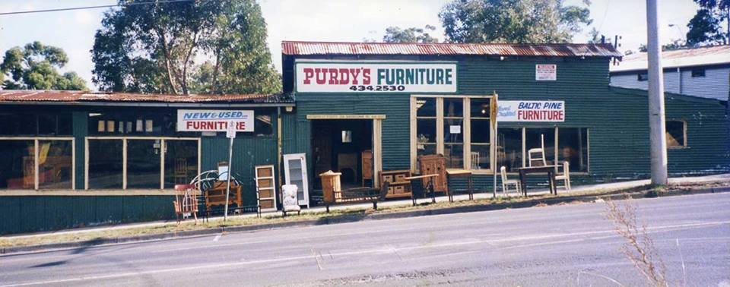
Purdy’s 2nd hand/antique furniture. Sherbourne Rd just down from the corner of Gladstone Rd . The sheds used to be part of Briar Hill timber.

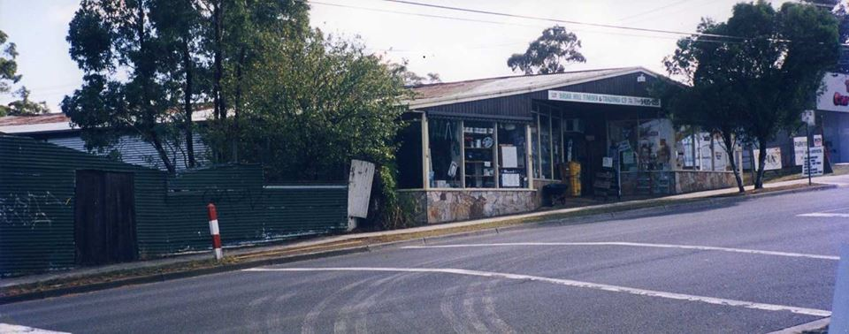
Briar Hill Hardware. Cnr Gladstone Rd and Sherbourne . This site and the old Purdy’s sheds are where the newer Purdy’s now stands .
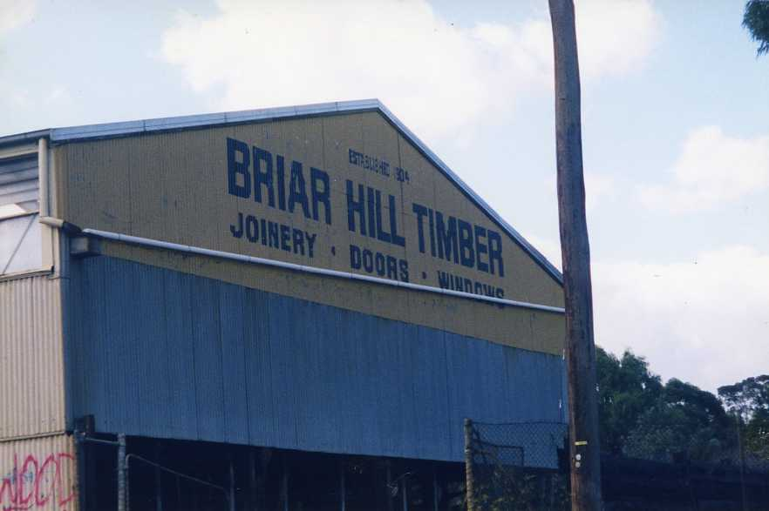
Entrance to the yard. These pics were all taken not long before it was all demolished.
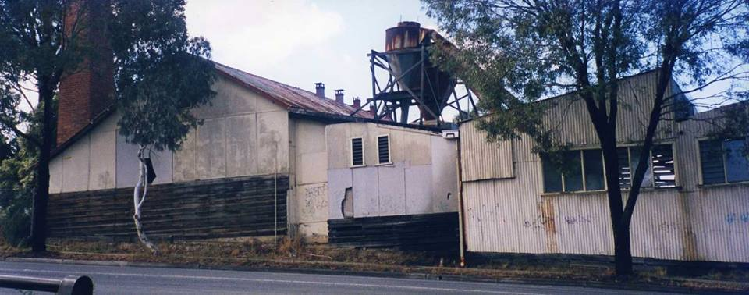
Briar Hill Timber a bit further on up from the entrance gate.
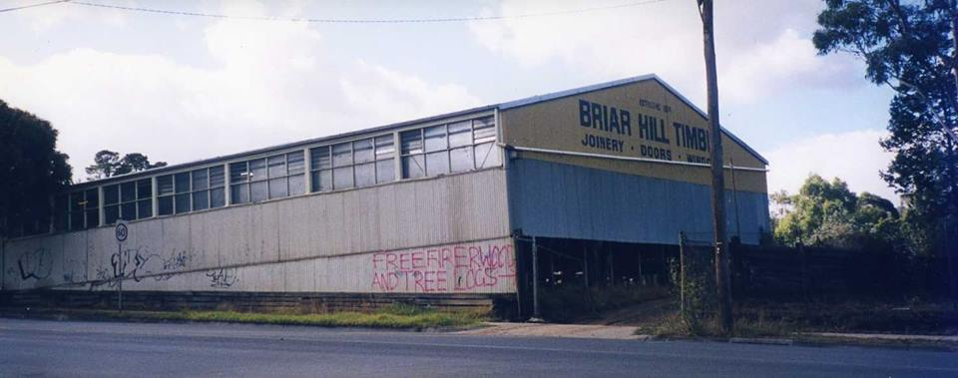
A long view of the big shed .

Colin Mc Gregor I also remember playing in the saw dust piles & later on working in the mill making garden stakes
Diane Nelson I remember them...Mr Manual (Bob I think his name was, we were kids and didn't call adults by their first name) owned the hardware shop. I remember a car drove through the front of the shop once.
Leila Leaford These photos bought back a lot of memories for John and his apprenticeship in these buildings. My first job was in the office
Peter Willis Bob Manual donated a voucher to Watsonia Tech. I received the voucher at the end of year 11 for improvement etc.
I bought tools for my apprenticeship with the voucher and I still use most of those tools now.

