“Train in the Park” Greensborough

Paul de Sauty I GREW UP IN THE GREENSBOROUGH DISTRICT
Just a few photos of the steam locomotive J 516, (displayed in Greensborough) that I took a number of years ago. First two: Inside Bendigo Roundhouse 24/01/1969. 3rd: Geelong September 1971. 4th: Greensborough December 1976 and finally at Healesville in May 1991. It is now receiving a long term restoration.
- 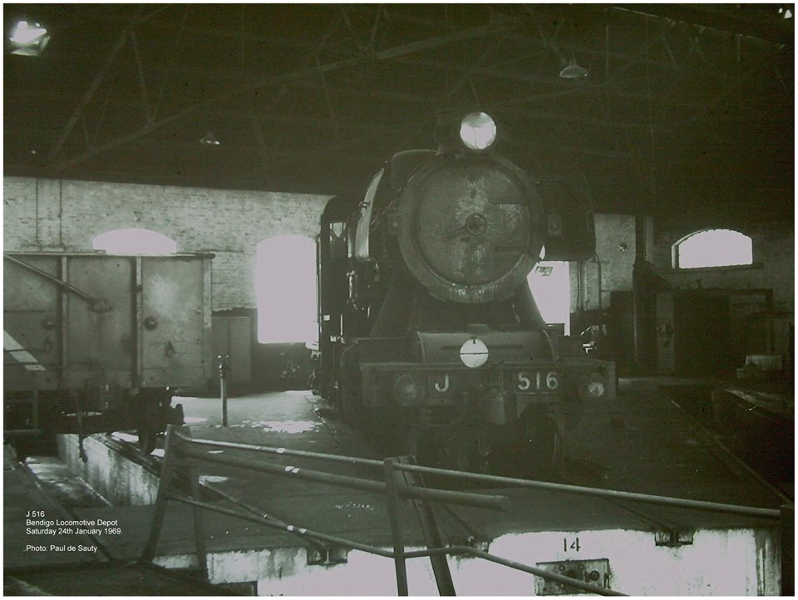

- 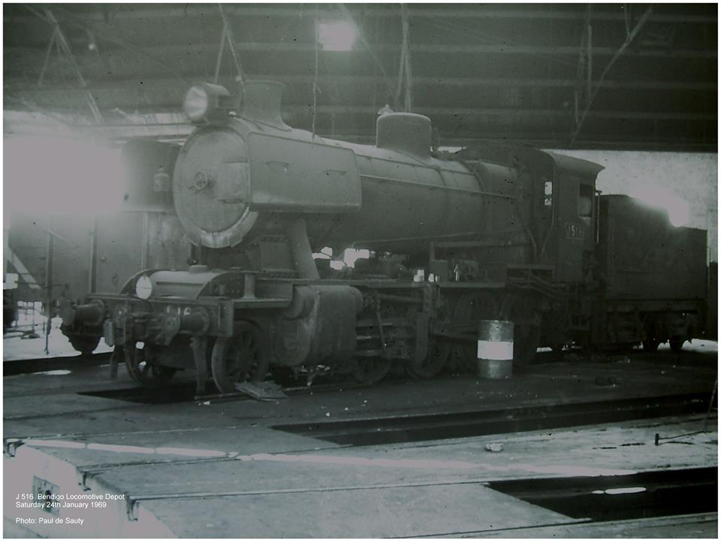

- 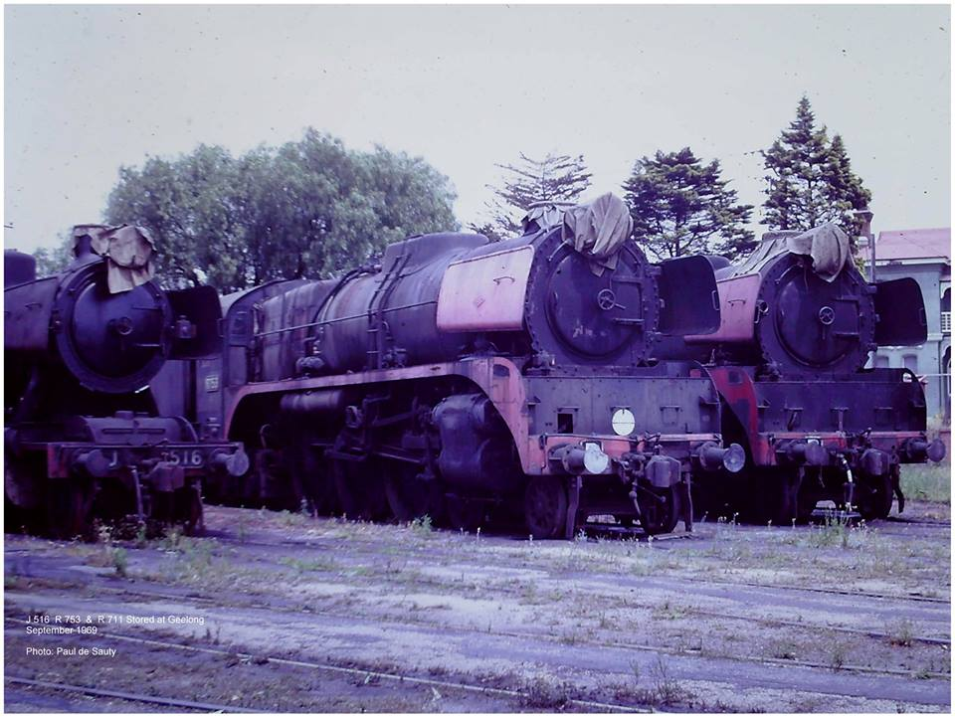

- 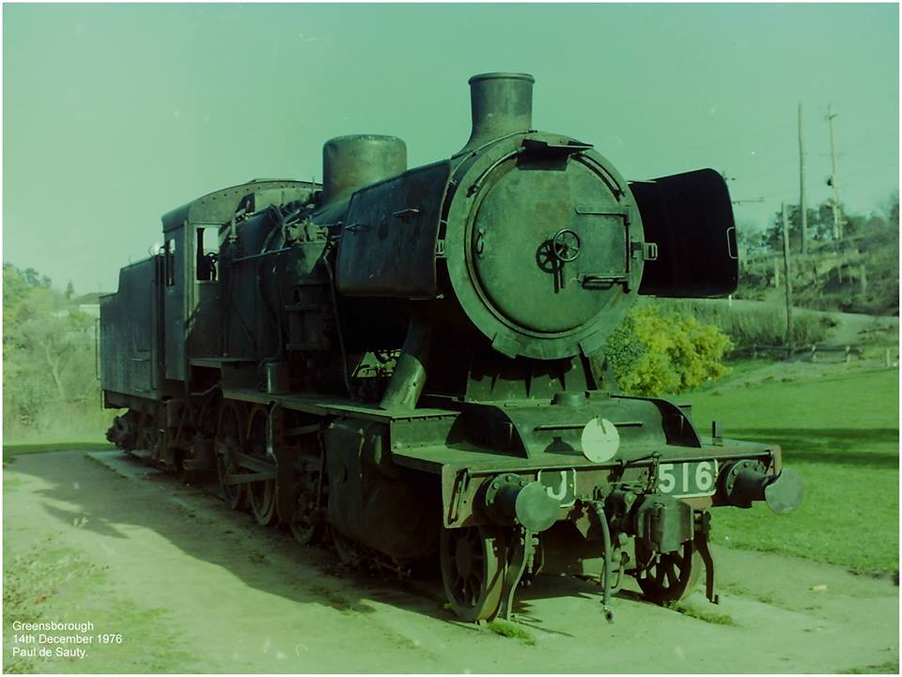

5.