**Watermarc 2009-2016**

Greensborough Pool to Watermarc. 2009 to 2016.

Michael O’Keefe **I grew up in the Greensborough district**

[[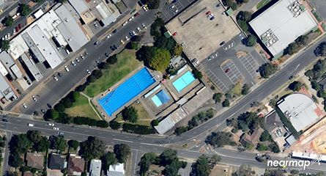](https://www.facebook.com/photo.php?fbid=647495415426268&set=pcb.954242974703535&type=3)](https://www.facebook.com/photo.php?fbid=647495415426268&set=pcb.954242974703535&type=3)

[[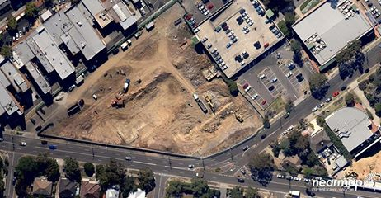](https://www.facebook.com/photo.php?fbid=647495408759602&set=pcb.954242974703535&type=3)](https://www.facebook.com/photo.php?fbid=647495408759602&set=pcb.954242974703535&type=3)

[[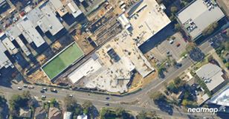](https://www.facebook.com/photo.php?fbid=647495412092935&set=pcb.954242974703535&type=3)](https://www.facebook.com/photo.php?fbid=647495412092935&set=pcb.954242974703535&type=3)

[[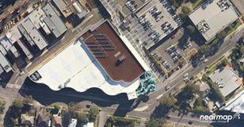](https://www.facebook.com/photo.php?fbid=647495585426251&set=pcb.954242974703535&type=3)](https://www.facebook.com/photo.php?fbid=647495585426251&set=pcb.954242974703535&type=3)

[[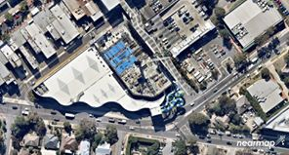](https://www.facebook.com/photo.php?fbid=647495602092916&set=pcb.954242974703535&type=3)](https://www.facebook.com/photo.php?fbid=647495602092916&set=pcb.954242974703535&type=3)

Images from nearmap.com.au