Watsonia shops

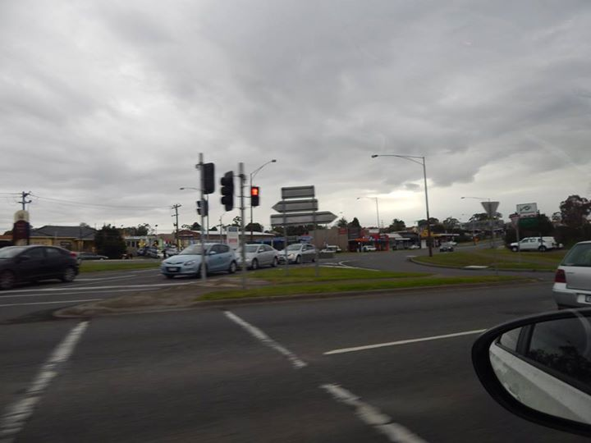

Sandy Anton‎ Greensborough & Diamond Valley forgotten memories.... what’s your story?
Watsonia – looking across to Wally Martins

