Watsonia Station
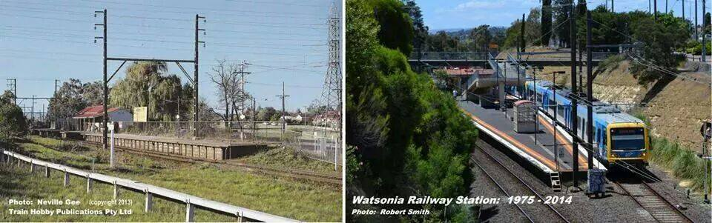
All Photos from Stewy Barber‎ Greensborough & Diamond Valley forgotten memories.... what’s your story ?

Heading towards Watsonia from Nell Street
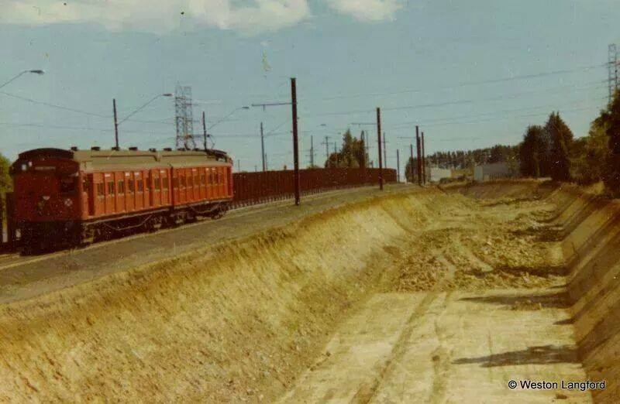
When the station was street level...there used to be a row of pine trees.
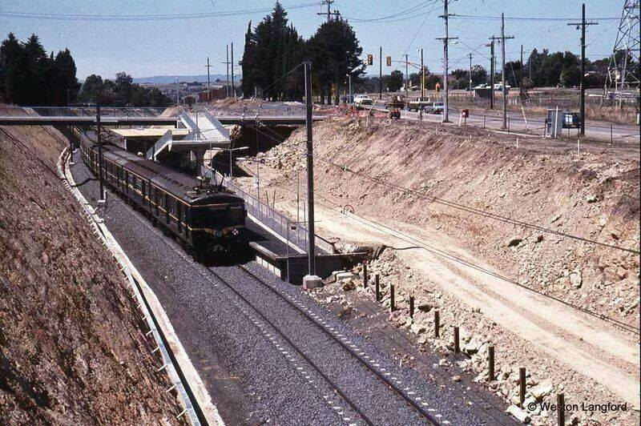
Pine Trees are in this photo
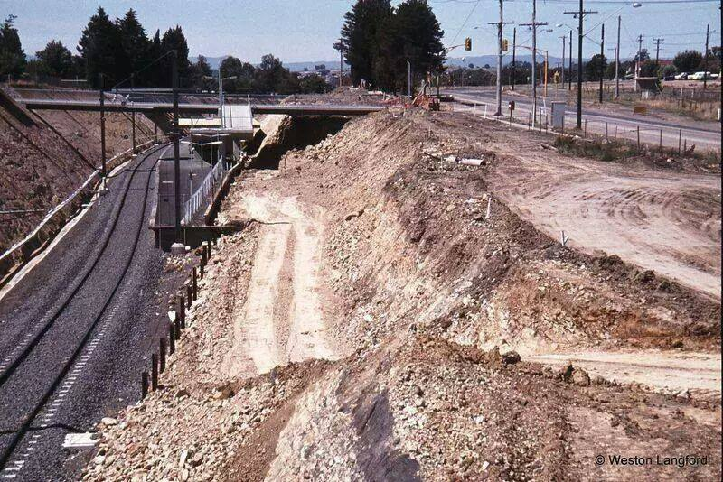
All Photos from Stewy Barber‎ Greensborough & Diamond Valley forgotten memories.... what’s your story ?

Blue Harris train on the single line to Greensborough or Watsonia

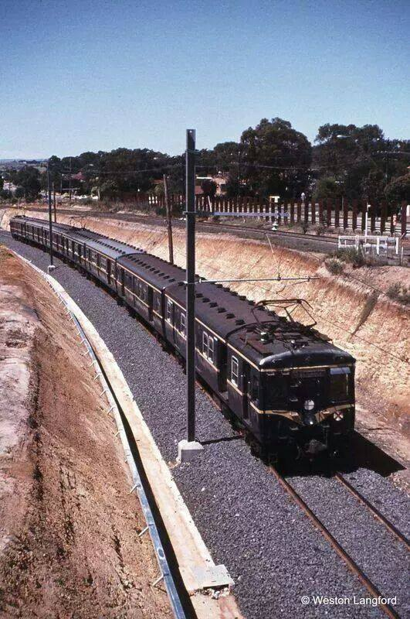

Street level Watsonia station
All Photos from Stewy Barber‎ Greensborough & Diamond Valley forgotten memories.... what’s your story ?

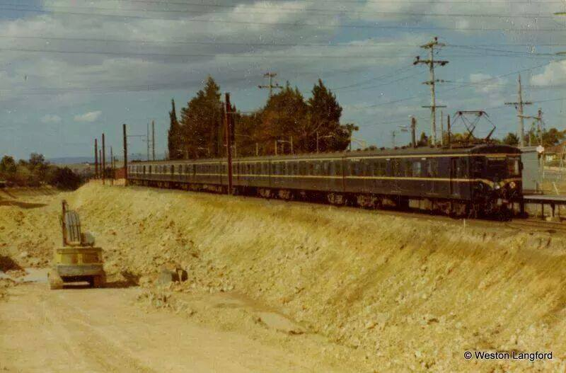
Next to the former Greensborough Road
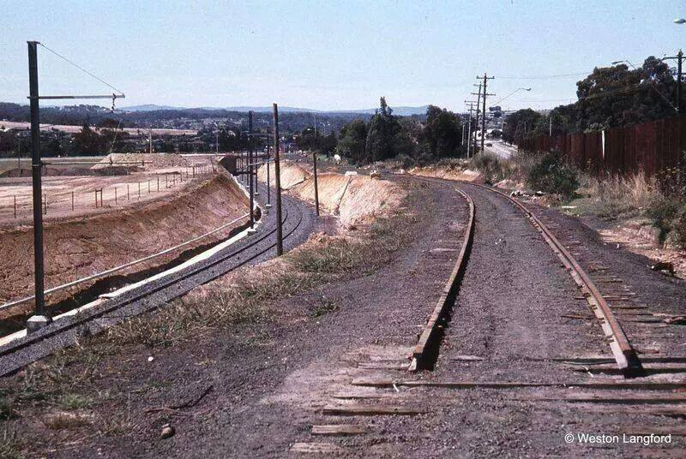
All Photos from Stewy Barber‎ Greensborough & Diamond Valley forgotten memories.... what’s your story ?

Coming into Watsonia station 1982
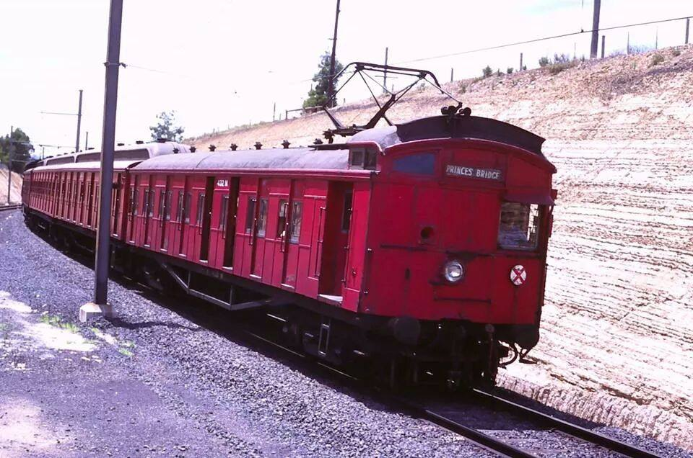
Watsonia crossing.
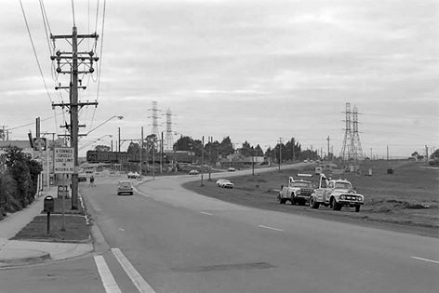

All Photos from Stewy Barber‎ Greensborough & Diamond Valley forgotten memories.... what’s your story ?

