BUNDOORA HALL.
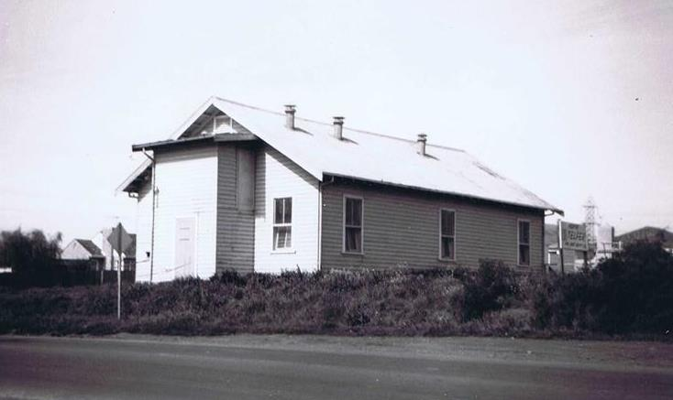
Bundoora Hall was on the corner of Grimshaw Street and Plenty Road.
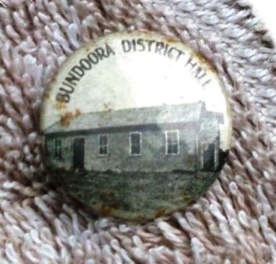 Badge donated by Marilyn.

The Argus, 6th April, 1923.
The new public Hall at Bundoora was opened on Easter Monday with a sports meeting in the afternoon and a concert and dance at night.

Advertiser (Hurstbridge) 23th November, 1923.
BUNDOORA HALL. Mark this Date. Wednesday, November28th.1923. Dancing Extraordinary. Demonstrations by the Foremost Exponent of the art of Fox-trotting in Victoria Jerry Hales Supported by Geo. Ridley and Party and a Real Jazz Band of Five Performers. Choice Refreshments. Don't Miss it. Gent's 2s 6d; Ladies is 6d. C. E. H. Brownhill, Hon. Sec.

Advertiser (Hurstbridge, 25th July 1924.
Bundoora District Hall. The half-yearly meeting of the debenture holders of the Bundoora District Hall was held on Wednesday, I6th inst. Mr W. McLean was chairman. There was a fair attendance. The secretary gave an interesting resume of the working of the hall since its inception, and brought forward a statement of accounts. He pointed out how very successful had been their efforts, and the wonderful results achieved. Up to the present they had had an income of £900. To this they raised £300 on overdraft to pay for the building. The report proceeded "Needless to say our expenditure has been very heavy. The hall itself cost us £860. To this has to be added £40 for a Gloria light plant and up keep. We have also paid off 65 on the piano. After paying interest and bank charges of £23 odd, our overdraft has been reduced by £106, leaving now only £194 indebtedness on the hall. The secretary added that he felt sure that with the same energetic support they received, in 12 months the hall would be out of debt, and they could then go ahead and put on improvements that are absolutely necessary, and would greatly add to the convenient of all. It was the unanimous wish of the meeting that they should make one grand effort and clear the hall, and with this end in view it was decided to hold a bazaar on the same lines as the previous one. A good ladies' committee has been formed, and are now hard at work. They will hold meeting on Saturday afternoon and will gladly welcome anyone wishing to help. It was decided to call for tenders to fence in the hall ground. The secretary was instructed to inform those debenture holders who have not finalised their payments that the last day for doing so will be August 31st. After that date debentures will be issued only to fully paid-up members.
The new Bundoora Hall is at Noorang Avenue, Bundoora.
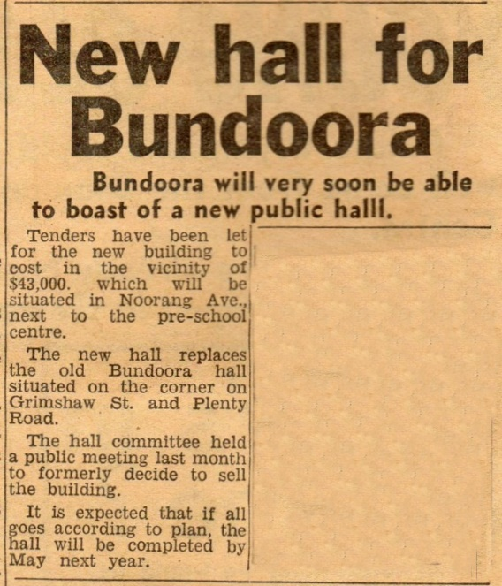

Diamond Valley News. 21 November, 1967.

Noorang Avenue, Bundoora. Photos taken 18.June 2017.

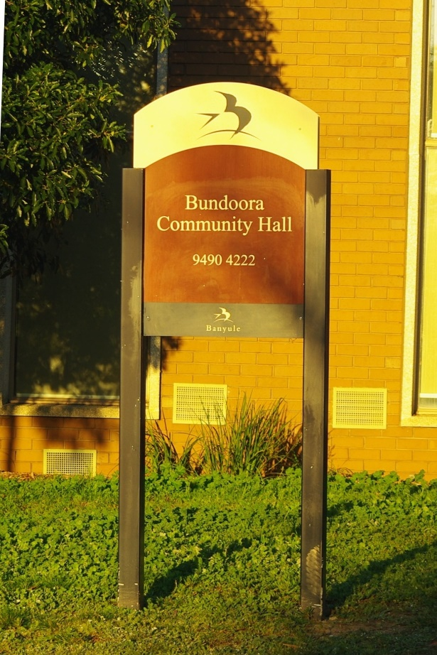

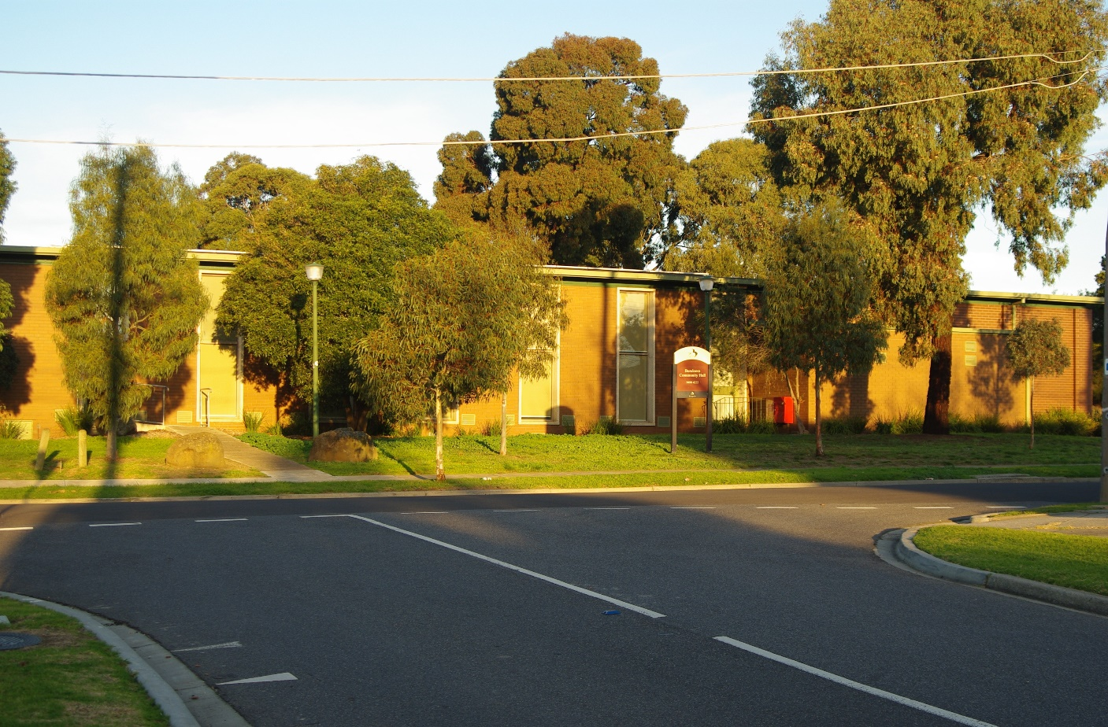

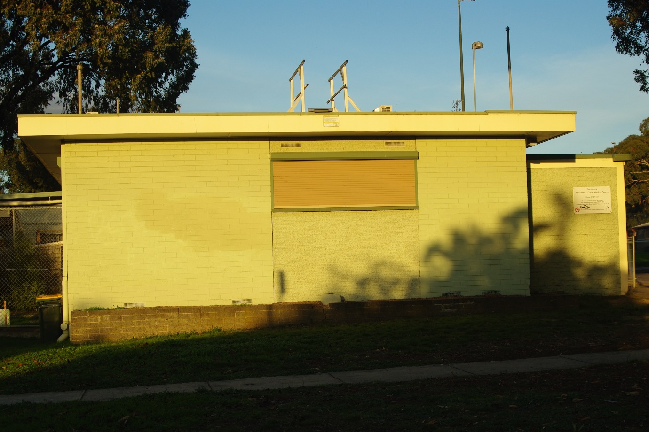

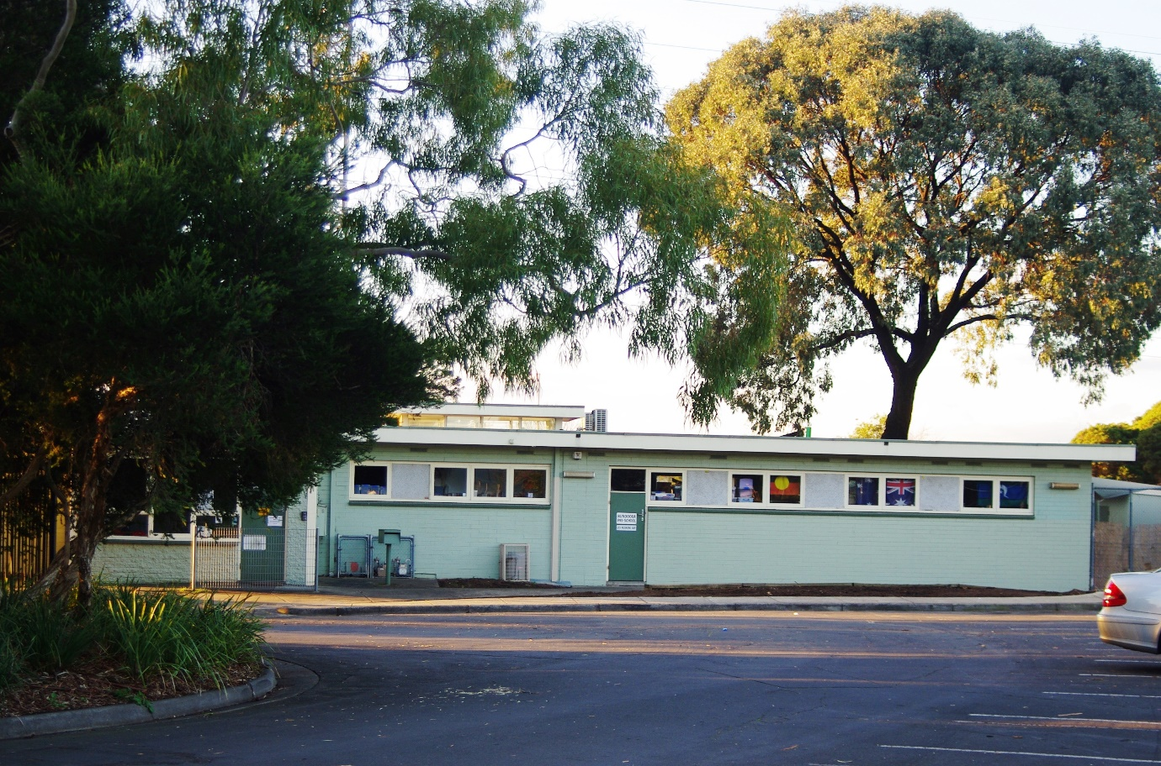

MARILYN SMITH. 2019.

