35 Sherbourne Rd, Briar Hill.
Crystal Clean Bay Car Wash 35 Sherbourne Road, Briar Hill.
Google Map. 1.8.2019

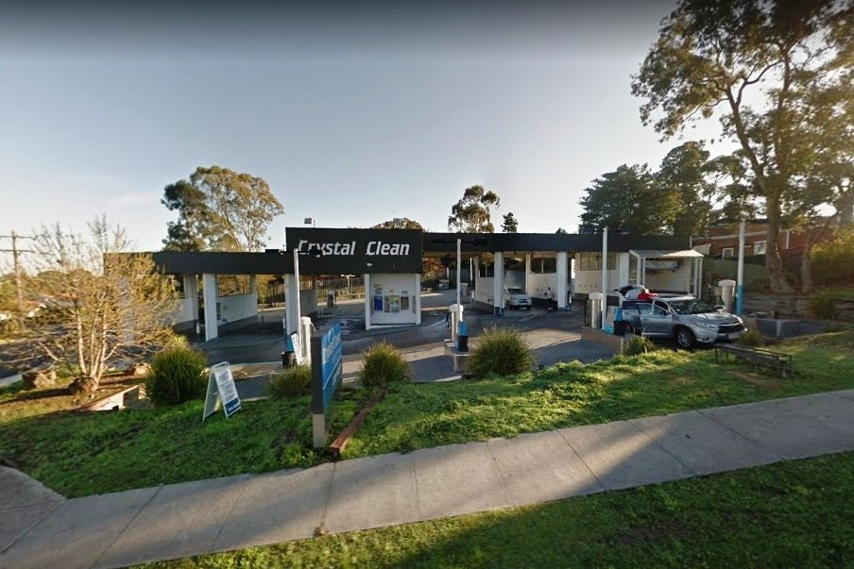

Gone about 5 July 2019

MARILYN SMITH

