The Ashley family
Thomas Edward Ashley married Elizabeth Ashley nee Anderson in 1899. Thomas passed away 9 April, 1932 and Elizabeth 22 April, 1958 they are both in Preston Cemetery. Their son Stanley Edgar Ashley was born in Chiltern in 1907.

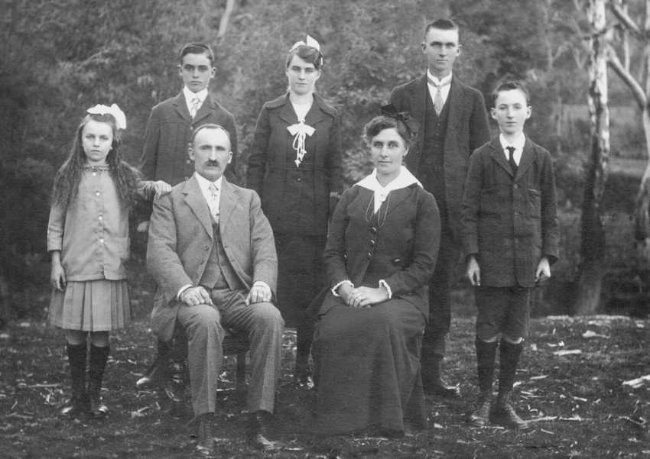

Thomas and wife Elizabeth Ashley seated, and their five children, from the left Alice, Edward, Annie, William and Stanley. All the children were born in Chilton. 1917.

Stan married Vera Alma Gravenall in 1939.
Vera Alma Gravenall was born in 1911 to Herbert Walter Gravenall and Cecile Rose Gravenall nee Marendaz. Herbert died in 1945, Cecile is on the Electoral rolls 1949 in Williams Street, Greensborough till 1976 when she died. They are both buried in Preston Cemetery.
Vera’s mother. GRAVENALL Cecile Rose. Death notice 5 SEP 1976 Death at DVCH, late of Greensborough. Diamond Valley Leader 14 SEP 1976.

Stan and Vera are on the Electoral Rolls in 1949 in Williams Street, Greensborough till 1971 when Stanley died, Vera in 2007. They are both buried in Preston Cemetery.
ASHLEY Stanley Edgar Death notice 8 NOV 1971. Death at DVC Hospital, late of Greensborough. Diamond Valley Leader 16 NOV 1971

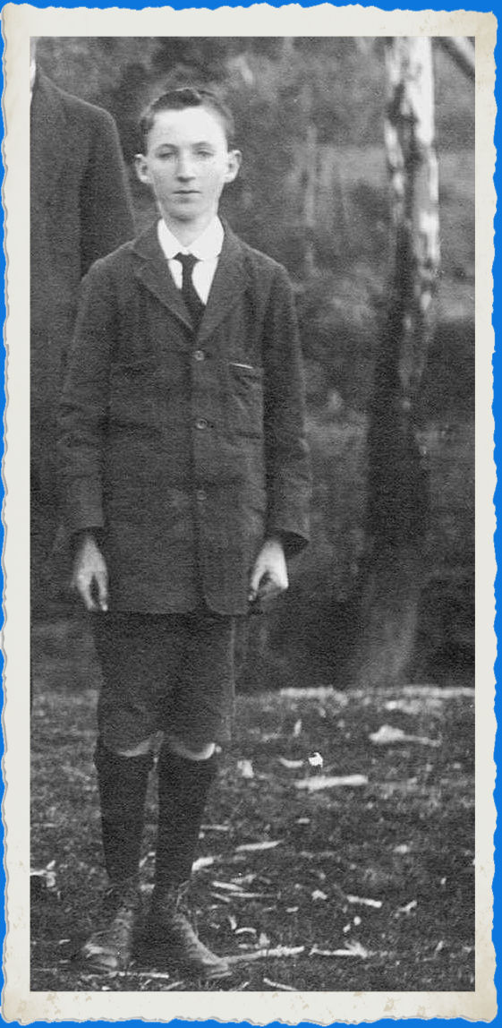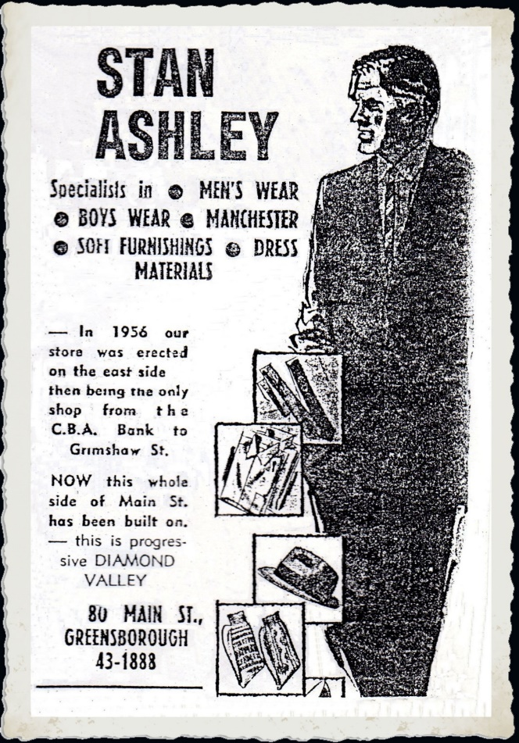
Stan 10 years old 1917. D.V.N 29th September, 1964.

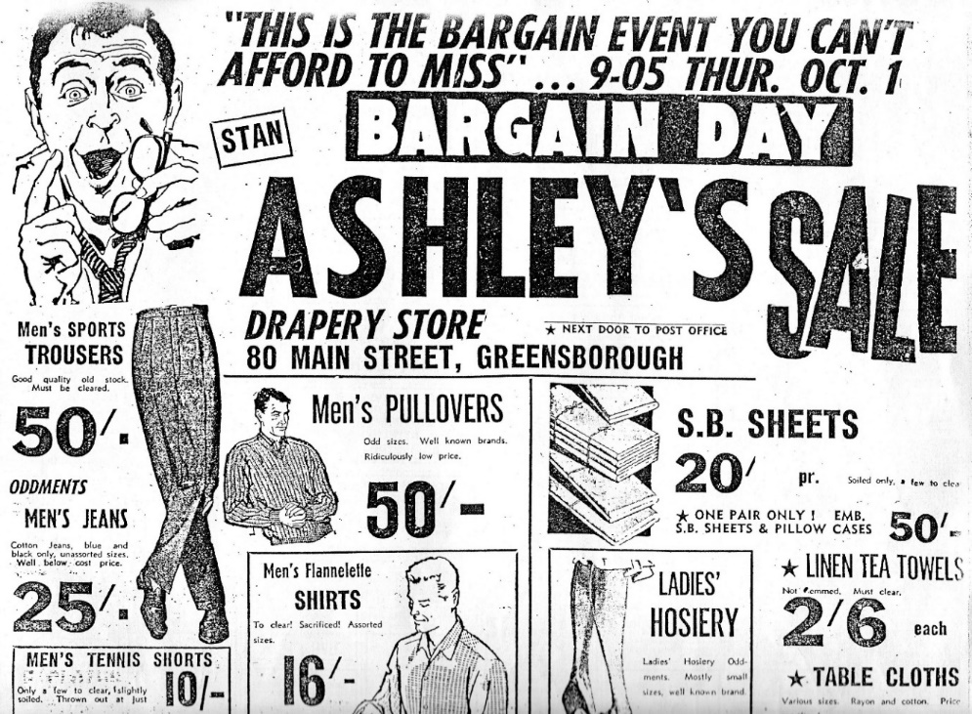
Diamond Valley News 29 September 1964.
The Argus. 22 February 1954.
Lost and Found. WOULD THE FINDER of a Motorcar Seat in Sellars St., Greensborough, Sunday afternoon, please return to Mr. S. Ashley, William Street, Greensborough. Phone JF 1365

The Age (Melbourne) 30th August, 1954.

NORTH WARD.
I HEREBY GIVE NOTICE that at an election held before me on this 28thday of August, 1954, for the election of one Councillor for the North Ward the following votes were recorded: —
First count:
ASHLEY, Stanley Edgar 976
BROWN. Roy William 532
ROBERTSON, William Keith 716
SECOND COUNT:
ASHLEY 1155
ROBERTSON 1069
Majority for ASHLEY 86
I therefore declare the said Stanley Edgar Ashley duly elected a Councillor for the North Ward of the City of Heidelberg. J. L. RYAN, Returning Officer. Town Hall, IVANHOE. 8/1954.

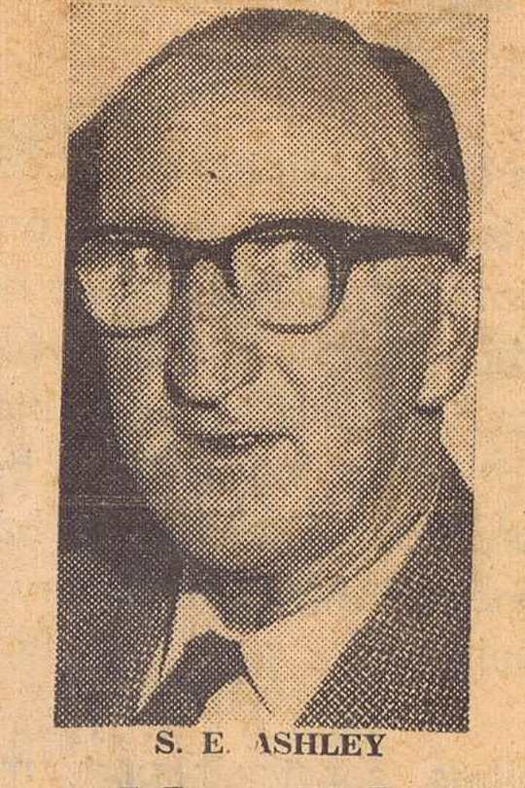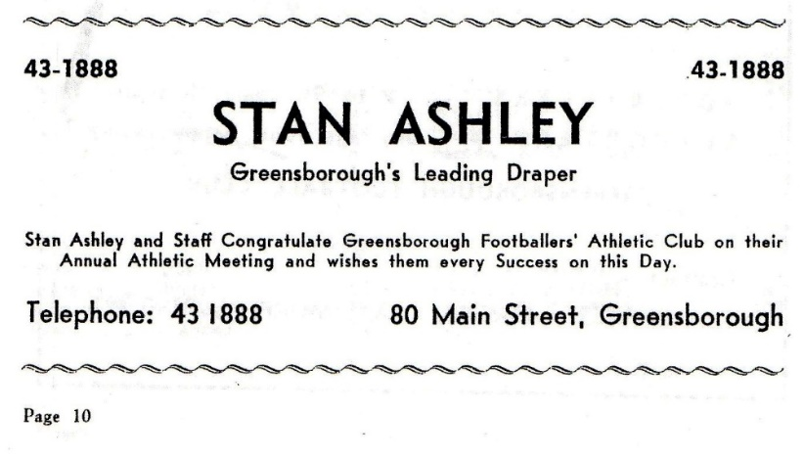
No Date.
Greensborough Footballers Athletic Club.
March 1967.

Herald Sun 6 August, 2007

ASHLEY. - Vera Alma. Aged 96 Passed away peacefully with family by her side, now with her loving husband Stan (dec.) and son Lloyd (dec.). Much loved and missed by her son Ralph. Loving mother-in -law to Barbara and Carmel. Cherished grandmother and great grandmother. Now in Heaven with Jesus.

Stanley and Vera had two sons Lloyd Stanley Ashley

ASHLEY Lloyd Stanley Death notice 30 DEC 2002 Death Herald Sun (Melbourne) 01 JAN 2003

ASHLEY. - Lloyd Stanley, passed away peacefully at home on Dec. 30, 2002. Dearly loved husband of Carmel. Loved father of Shane, Joy, Alma and Amanda. Adored grandfather of Chiquita. Deep in our hearts you will always stay, Loved and remembered every day.

ASHLEY Ralph Death notice 10 SEP 2009 Death 69 Herald Sun.

ASHLEY. - Ralph. Passed away peacefully on Thursday, September 10, 2009 Aged 69 years Much loved husband of Barbara Loved father and father-in-law of Mindy and Gene, Georgie and Jon, Kathy and Peter, Penny and Aeneas. Proud Pa of Shannon, Riana, Teah, Bailey-Anne, Amy, Luke, Wyatt, Sarah, Lachlan, Matthew, Andrew, Justin, Kirrah and Sharni. Softly within the shadows, there came a gentle call. With farewells left unspoken, you quietly left us all. Please see later paper for Funeral details

ASHLEY. - The Funeral Service for Mr Ralph Ashley will be held at St Andrew's Uniting Church, cnr Brook and Barkly Streets. Sunbury, on FRIDAY (Sept. 18, 2009) at 11 a. m. The Funeral will leave at the conclusion of the Service for Burial at Sunbury Lawn Cemetery. In lieu of flowers, donations may be made to Alzheimer's Australia. Envelopes will be available at the Church.

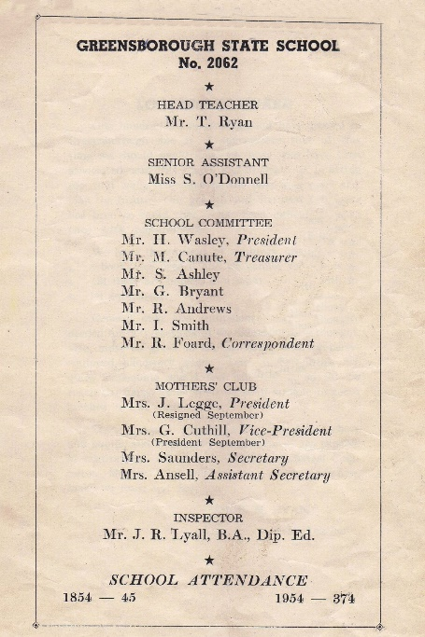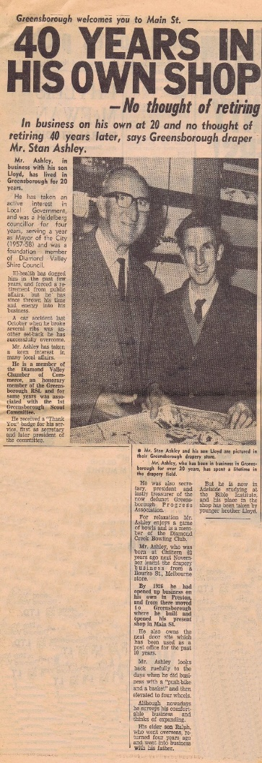
D.V.N. 9 July, 1968
MARILYN SMITH. 2019.

