The Adams Family

George Adams enlisted on the 22 March, 1916. He embarked for overseas on the H.M.S Arcadia on 29 July 1916 to Alexandria. His service No. 251 he was in the 2nd Machine Gun Battalion. He embarked to Australia on the Miltiades and landed in August 1919, he received The British War and Victory Medals.
George Thomas Adams and his wife Doris Mary nee Hunter are on the Electoral Rolls 1949 to 1954 at Old Greensborough Road, Watsonia, then 1958 to 1967 at 7 Eldale Ave, Greensborough. George died 1 March 1968 and Doris 19 August 1970 both died in Greensborough both in Fawkner Cemetery.
Their son Thomas Irwin Adams and his wife Beryl Yvonne Harmer are on the Electoral Rolls 1949 to 1954 at Old Greensborough Road, 1963 to 1972 at 28 Dunn Street, Watsonia, then in 1980 at 119 Kinglake Road, Whittlesea. Thomas was listed as a Butcher from 1949 to 1980 on the Electoral Rolls.

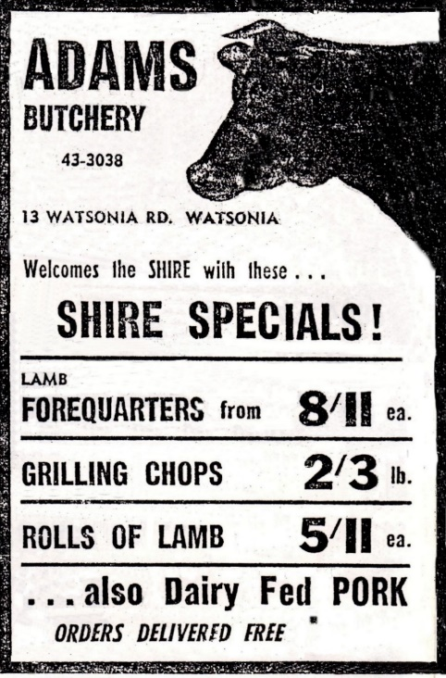

Diamond Valley News. 29th September, 1964.

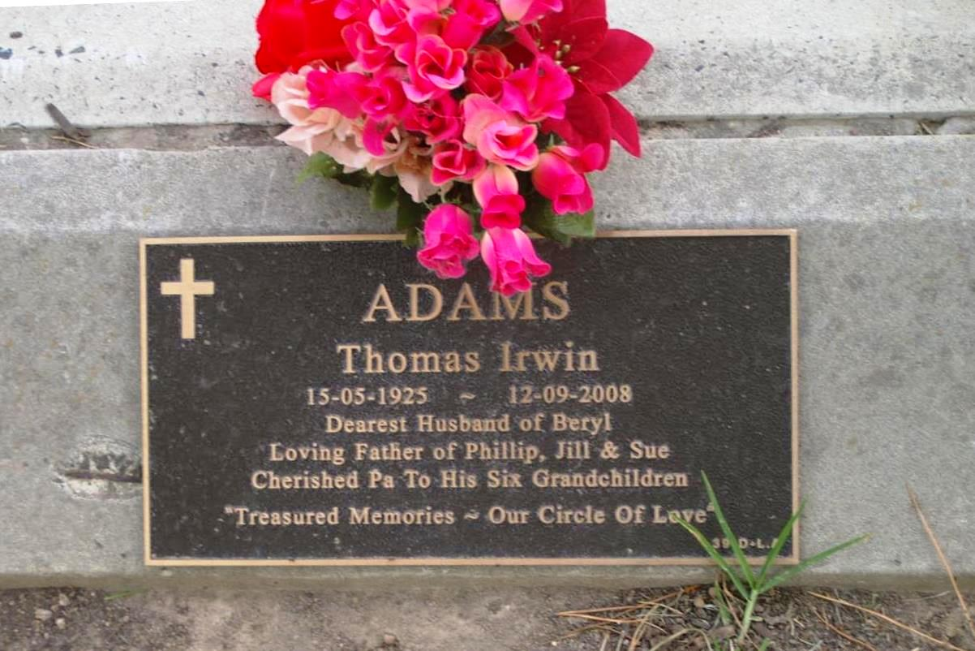
Thanks to Carols Headstones from Yan Yean Cemetery.

Thomas Irwin Adams was born 15 May 1925 died 12 September 2008 Beryl Yvonne nee Harmer was born 25 April 1929 died 18 October 2015 (Beryl’s information from The Herald Sun). They had two daughters Jill and Sue and one son Phillip born about 1952 he died 1983 in Mernda. Thomas, Beryl and Phillip Adams are in the Yan Yean Cemetery.

ADAMS. - Thomas Irwin (Tom). Peacefully on Sept. 12, 2008 aged 83 years Dearly loved husband of Beryl, much loved Dad of Phillip (Dec. ), Jill and Sue. Fond father-in-law of Hugh. Treasured Pa of Emma, Kate, Sarah-Lou, Daryl, Rohan and Jen. Loved and remembered always. Our heartfelt thanks to Dr John Colbert and the caring Staff of Whittlesea Lodge.

ADAMS. - The Funeral Service for Mr Thomas Irwin (Tom) Adams will be held at Whitehaven Receptions, corner Glenburnie and Wallan Roads, Whittlesea on WEDNESDAY (Sept. 17) at 1 p. m. Following this Service, Burial will take place at the Yan Yean Lawn Cemetery.

MARILYN SMITH. 2019.

