Adams Cake Shop - The McWhirter Family
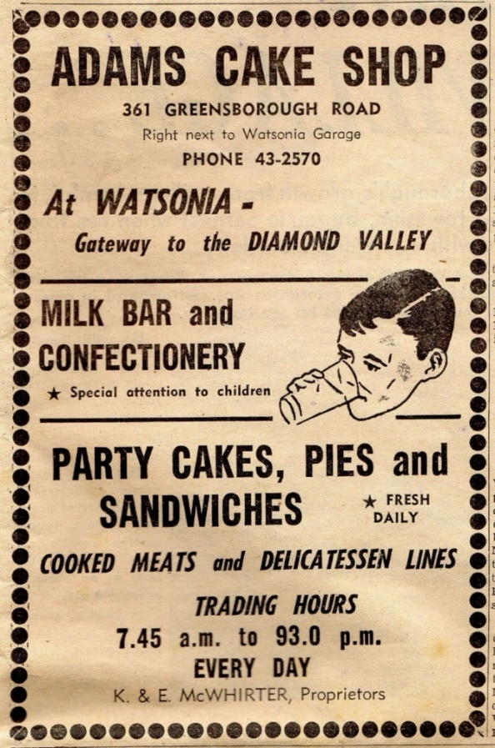
Diamond Valley News. 29th September, 1964.

Robert Richard Leslie McWhirter married Flora Amanda May Freeman in December 1919.
Their son Keith Leslie McWhirter and his wife Edna Marie nee Sherlock are on the Electoral Roll 1967 to 1968 at 6 Sellars Street, Greensborough then to 1980 at 147 Elder Street, Greensborough.
Keith and Edna where proprietors of Adams Cake Shop. Keith Leslie McWhirter born 1921 passed away 27 April, 1988 was cremated at Fawkner Cemetery 29 April, 1988. Edna Marie Sherlock born 1919 passed away 2013.
They had three sons Raymond Keith 1950-2009. Neil Robert 1953-1958 and Glenn Norman 1958-2014. All cremated Fawkner Cemetery.

MARILYN SMITH. 2019.

