‘THE PICTURES’ AT GREENSBOROUGH
By Dawn Bennetts (Petts) 2019
One of the ‘special memories’ that I have from my younger years, is going to the Greensborough Picture Theatre with Glenice (my Auntie) and a friend of hers from Greenhill Road – Maureen Brennan. This might have been my first outing to the pictures because I know that I was very young. Around sixty years later, the only thing that I could remember about the film was that the young lady starring in it was called Tammy and there was a goat in the story at some stage. My son Ian has recently done some research to find out that the film was probably “Tammy and the Bachelor” made in 1957, starring Debbie Reynolds. At the age that I was then, the goat obviously made more of an impression on me that the romantic storyline of the film! Glenice and I would often go on a Saturday afternoon, to the Ashril Theatre in Greensborough - mostly to see Elvis films. I remember watching out for the posters inside the front doors of the theatre that would be advertising what films were ‘currently showing’ or ‘coming soon.’ There were always two films each session with an interval in between – that is when everyone would go to the counter to purchase ice creams or lollies. When the session had finished, the doors at the rear of the carpeted area adjoining the actual theatre would be opened, and we would all exit the building and make our way along the laneway to Main Street. The showing of pictures / films has provided many years of entertainment in Greensborough and I have researched as much as I can to show the progression of how it developed.
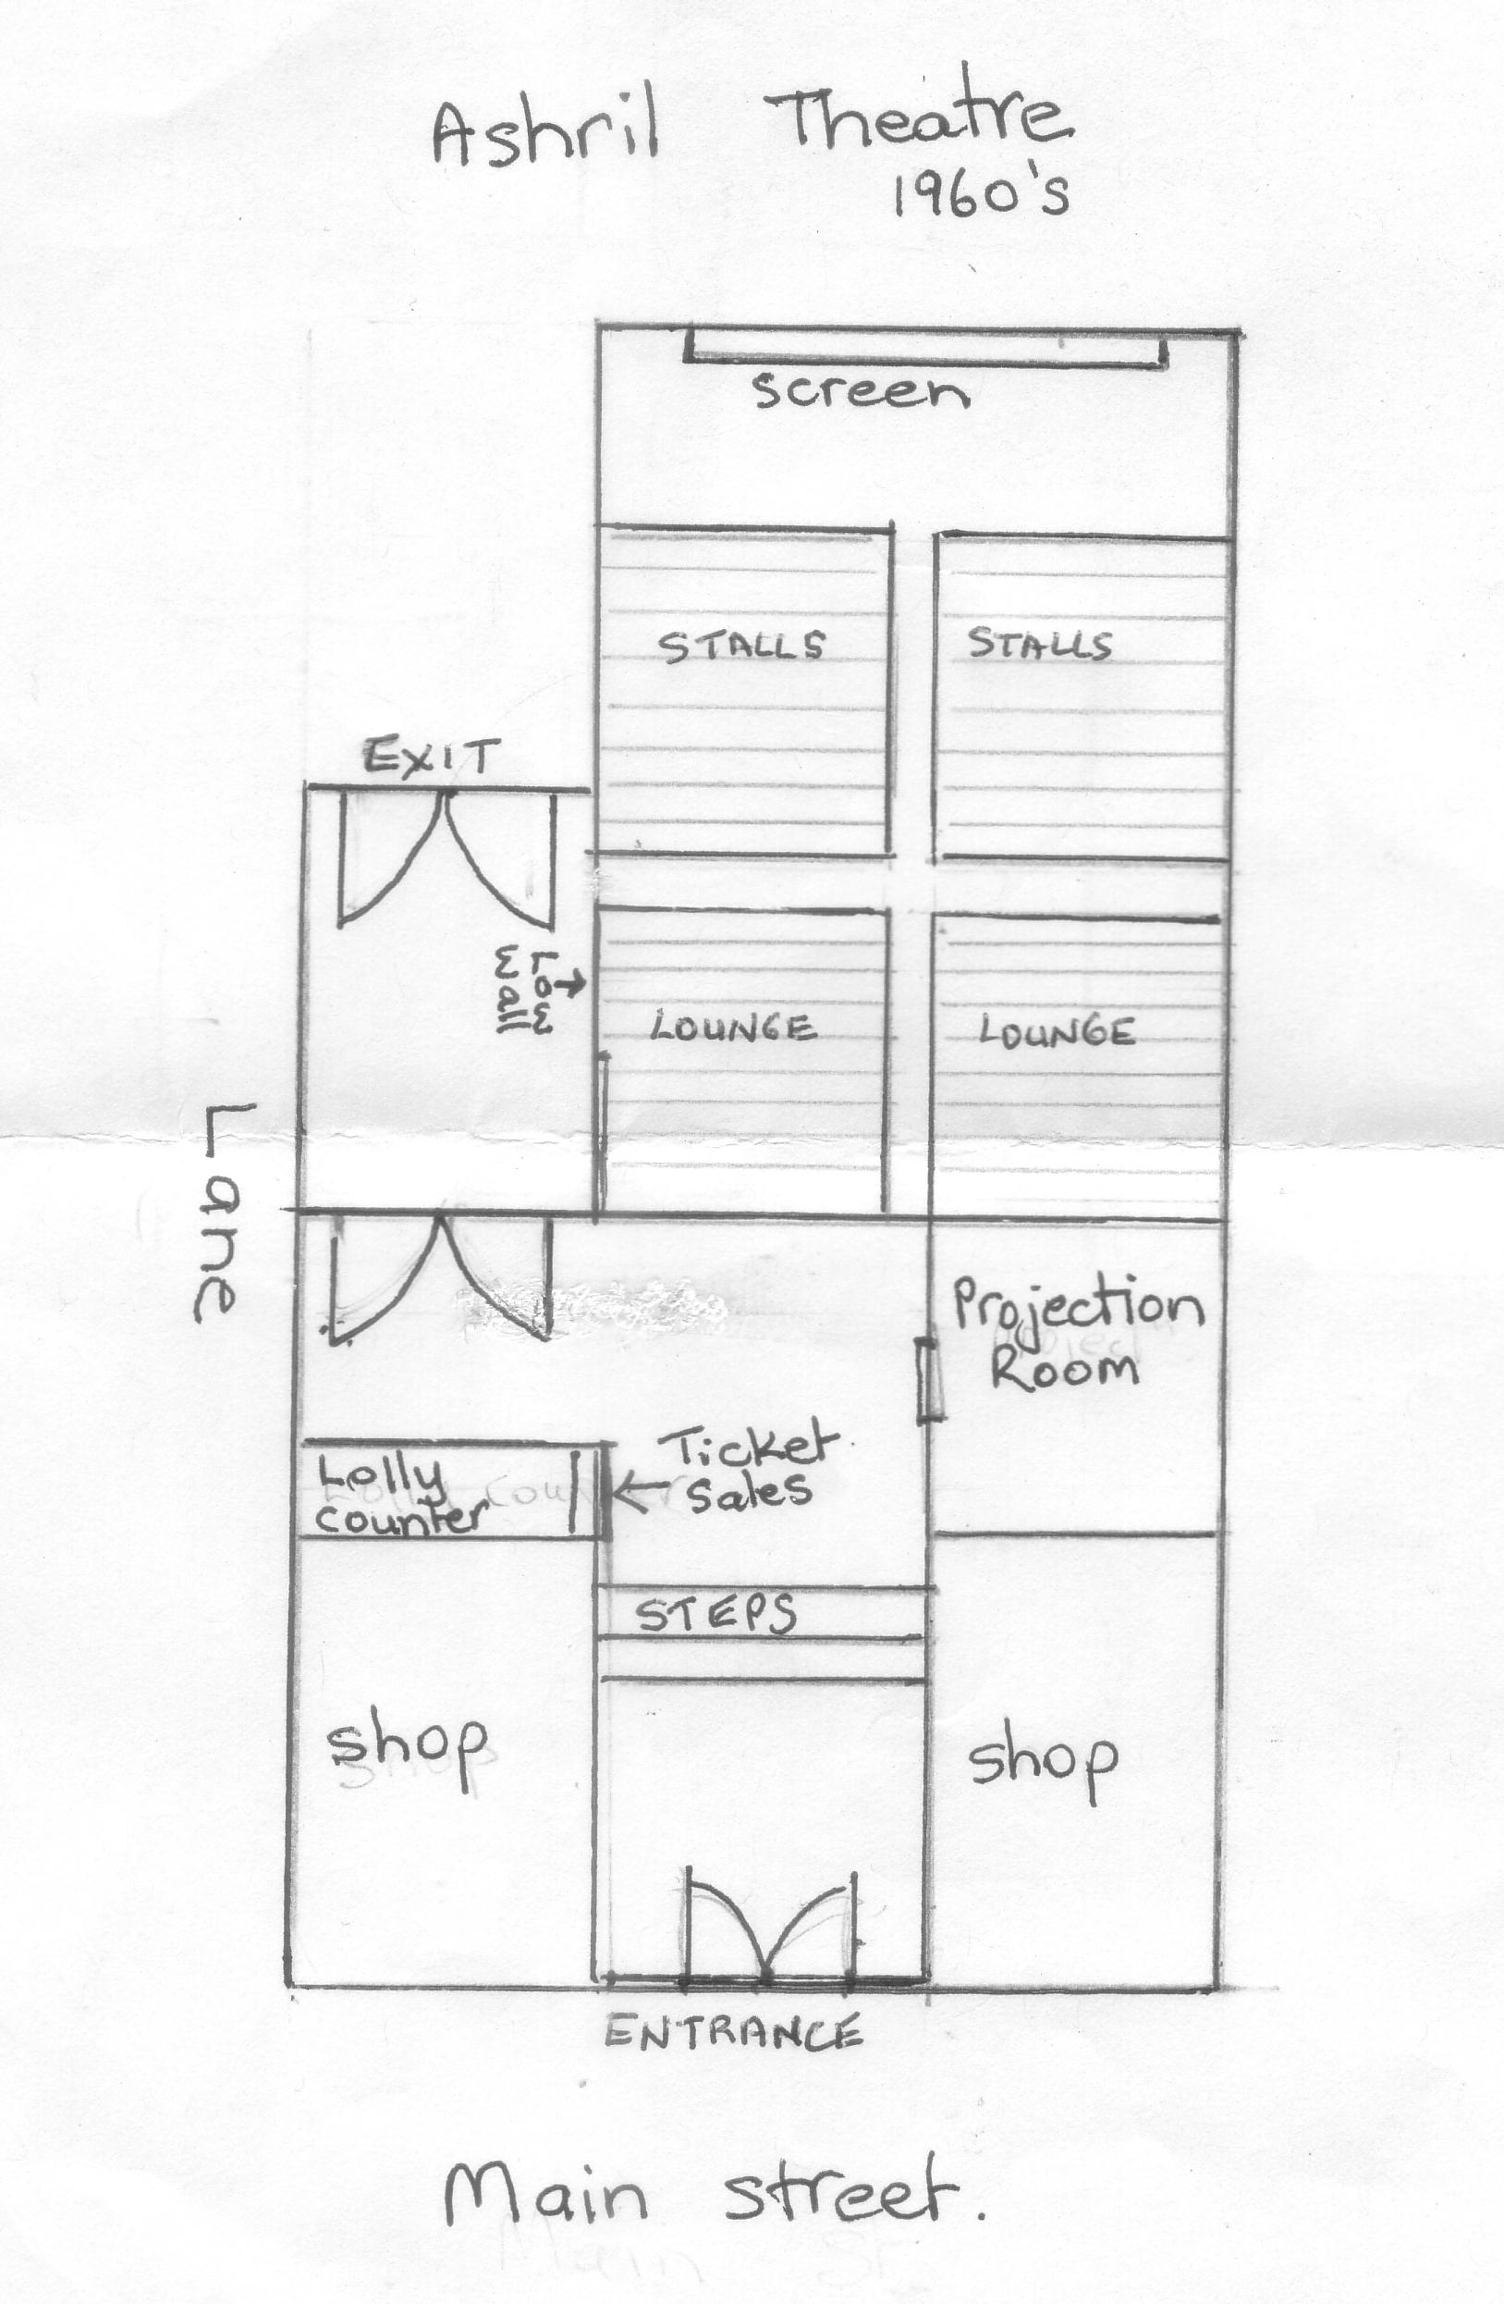
Ashril Theatre 1960’s as recalled by Dawn Bennetts
The first known record that I have found of ‘Pictures’ being shown in Greensborough, is in a letter written by Campbell Duncan, dated August 5, 1993. Campbell was living in Horsham at the time of writing the letter, but as a young boy he lived in Greensborough between 1914 and 1922 with his Grandfather – Louis Amiet.
“I have written down some memoirs of my life there. Amusements – virtually nil. The only time I saw a film was when a showman erected a tent near the school and showed a short length for 6 pence. The star was “Snowy Baker” - and as the man had very little film, he had to run it at a slow pace, causing the big fight scene to end up as a slow-motion farce.”

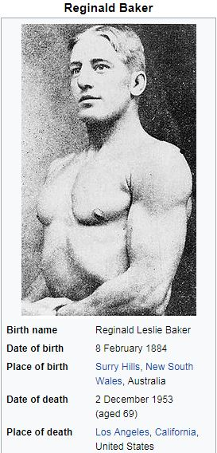

From Wikipedia...Snowy Baker - Reginald Leslie “Snowy” Baker (8 February 1884 – 2 December 1953) was an Australian athlete, sports promoter and actor. His movies included The Enemy Within (1918) The Lure of the Bush (1918) The Man from Kangaroo (1920) The Shadow of Lightening Ridge (1920) The Jackeroo of Coolabong (1920) aka The Fighting Breed and Sleeping Acres (1921)

1921 - UNIVERSAL PICTURES
The next mention of pictures / films being shown in Greensborough was in 1921 – and advertised with “Electric Light.” This may have only been temporary electric light though, as in October 1922 – ‘pending improvements’ – arrangements were ‘being made to run the films by electricity’.
‘Grand Opening Programme’– Includes Frank Mayo in ‘The Girl in Number 29.’ (This was an American 1920 silent drama film) A Two Reel Western Picture ‘The Girl and the Law.’ Pictures were being shown weekly at Greensborough, Diamond Creek, Panton Hill and Hurstbridge according to an advertisement in the local paper, November 1921.
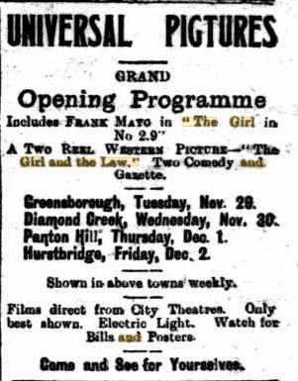
Eltham and Whittlesea Shires Advertiser – Friday 25 November, 1921. Page 2
The last advertisement that I was able to locate for Universal Pictures in the Eltham and Whittlesea Shires Advertiser, appears to be Friday 6 January, 1922, page 2. The Pictures were not being shown at Panton Hill by that stage. Admission cost:-Adults 1s 1d Children 6 1/2 d.
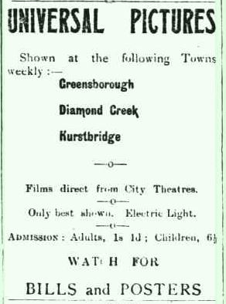
Eltham and Whittlesea Shires Advertiser Friday 16 December, 1921. Page 2
1922 – ROYAL PICTURES
By September 1922 - Films were shown at Greensborough and Eltham by proprietors Preston & Lucas, under the name of ‘Royal Pictures’. It is not clear exactly where these films were shown, however it appears that they might have been shown in a hall because of the news recorded in October, 1922. “Pictures are advertised to be shown every Wednesday at Greensborough and every Thursday at Eltham. The proprietors are Preston and Lucas and the programme for next week includes David Barthelmess in ‘Tol’able David’ and ‘The Child Thou Gavest me’. As these two townships are fast filling up empty spaces, there should be ample people to keep the movies going.”
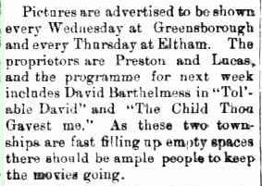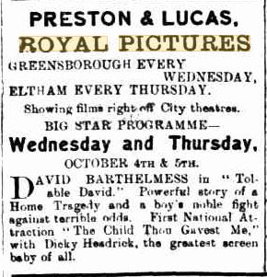
Advertiser (Hurstbridge) Friday 29 September 1922. Page 2
Advertiser (Hurstbridge) 29 September, 1922. Page 3

In October 1922, the pictures were not going to be shown for a couple of weeks because of ‘improvements.’

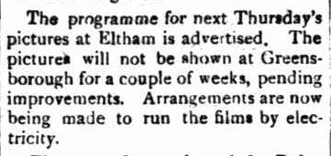
Advertiser (Hurstbridge) Friday 6 October, 1922. Page 2
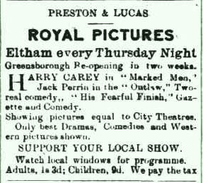
Advertiser (Hurstbridge) Friday 6 October, 1922. Page 3

“Admission cost:-
Adults 1s 3d Children 9d”.

From IMDb – Marked Men is a 1919 American silent Western film starring Harry Carey. Outlaw is a 1921 Western film starring Jack Perrin. His Fearful Finish is a 1921 black and white silent comedy starring Charles Dorety.

1923 – VICTORY PICTURES
By March 1923, Pictures were shown by ‘Victory Pictures’, with the proprietors being Messrs. Nitschke Bros – residents of Greensborough. Around this time, ‘Victory Pictures’ were being shown in an open air venue at the rear of the old hotel and advertised as - ‘Good Light and Steady Pictures’. The film screening at the time was ‘The Golden Snare.’ A black and white silent film released in July 1921, staring Lewis Stone and Wallace Beery. Admission cost:-Adults 1s 71/2d Children 9d.
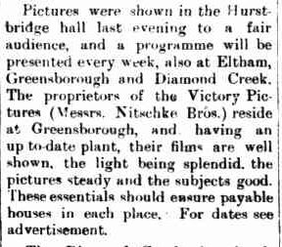
Advertiser (Hurstbridge) Friday 2 March, 1923. Page 2

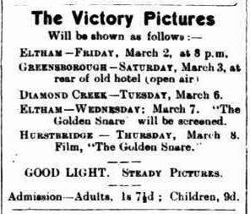
Advertiser (Hurstbridge) Friday 2 March, 1923. Page 3

The Victory Pictures screening at Greensborough 10th March, 1923 was ‘Scrap Iron.’ From IMDb - a 1921 black and white film starring Charles Ray as a boxer.
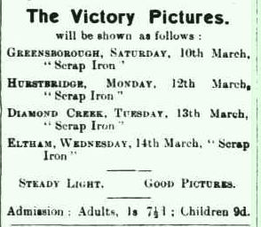
Advertiser (Hurstbridge) Friday 9 March, 1923. Page 3

Another screening for The Victory Pictures was the 1921 picture - ‘Tol’able David.’ From IMDb – a 1921 Drama starring Richard Barthelmess.
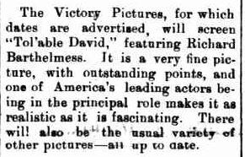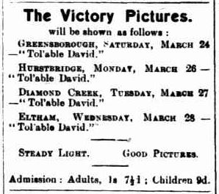
Advertiser (Hurstbridge) Friday 23 March, 1923. Page 3
Advertiser (Hurstbridge) Friday 23 March, 1923. Page 2
In 1924, the Greensborough Hall underwent enlargement and renovations. The building at this time was owned by the Masonic body, and alterations were to extensively change the front of the building and include 2 shops, with a Masonic lodge room upstairs.
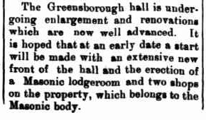
Advertiser (Hurstbridge) Friday 25 July, 1924. Page 2
I have not been able to locate any advertising for pictures/films being shown in Greensborough from this point until 1926. There are several listings in the Hurstbridge Advertiser in January 1925 for ‘Hoyts Pictures’ at Ivanhoe however, so perhaps there was no operating picture theatre in Greensborough for a short time?
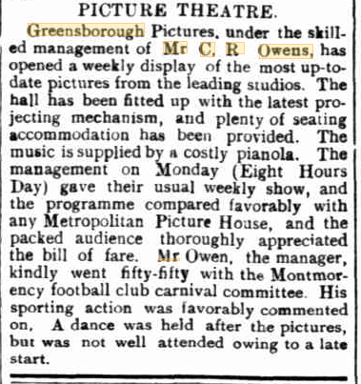
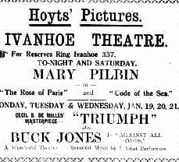
Advertiser (Hurstbridge) Friday 16 January, 1925. Page 2

Advertiser (Hurstbridge) Friday 30 April, 1926. Page 3

1926 – GREENSBOROUGH PICTURES
In 1926, residents were able to attend the ‘Greensborough Pictures’ weekly, under the management of Mr C.R. Owens. The hall was fitted up with the latest projecting mechanism, and plenty of seating had been provided.
In 1927 an advertisement lists Latest and Best PICTURES shown in Whittlesea Saturdays and Greensborough Mondays.
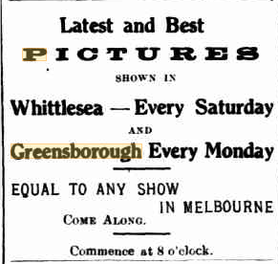
Advertiser (Hurstbridge) Friday 7 January 1927 Page 3

GREENSBOROUGH Hall Improvements
In August 1929, the Masonic Hall underwent more improvements, both in the hall and in the upstairs lodge-room.
‘The Masonic Hall, where all entertainments are held, has recently undergone a great improvement. The whole of the interior has been stained and painted brown and buff, the ceilings being white with indirect electric lighting. A similar light has been installed in the lodge-room.’
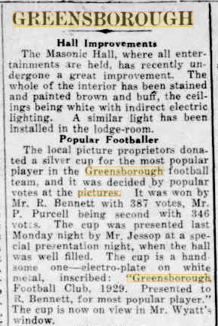

Advertiser (Hurstbridge) Friday 30 August, 1929. Page 2

Pictures on Monday ‘Owing to the Greensborough Hall having so many bookings on Saturdays, the pictures will in future be shown on Monday evenings, commencing from May 5, 1930 when the programme will include Greta Garbo in ‘The Mysterious Lady’ and Lew Cody in ‘Single Men.’
From IMDb - ‘The Mysterious Lady’ - 1928 silent drama/romance film. ‘A Single Man’ -1929 MGM silent comedy film.
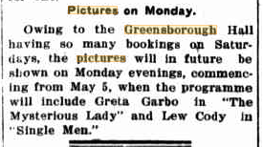
Advertiser (Hurstbridge) Friday May 2, 1930. Page 4

In May 1930, The Greensborough Pictures changed hands, with the new management installing some new innovations – the proprietor being Mr Musgrove – a new resident of the township. The lighting, general appointments and attendance had improved to such an extent that owing to the number of requests, pictures were going to be shown again on Saturday nights instead of Monday nights.
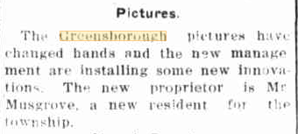
Advertiser (Hurstbridge) Friday 30 May, 1930. Page 1
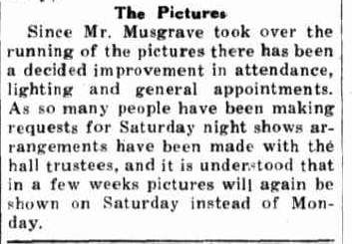
Advertiser (Hurstbridge) Friday 13 June, 1930. Page 2
Around June 1930, The ‘New Greensborough Pictures’ began in the hall providing local entertainment as well as supporting the local community. ‘The Masonic Hall appeared very bright on Monday last, when pictures were shown under new management. Brilliant lights were aglow outside the hall and the interior showed that many improvements had been effected.’
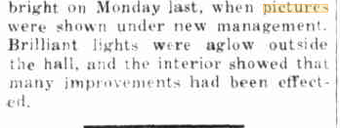
Advertiser (Hurstbridge) Friday June 6, 1930. Page 1
Admission costs - Adults 1s 6d Children 9d.

In an advertisement in July 1930, it was mentioned that the projection plant had been refitted.

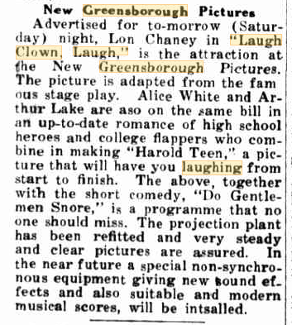
Advertiser (Hurstbridge) Friday 11 July, 1930. Page 4

It was obvious that the picture theatre and films being shown had improved substantially and were therefore supported well by the local community. The theatre also supported local groups too, such as the Greensborough Cricket Club, The Relief Organisation and Fire Brigade. Admission costs - Adults 1/- Children 4d.
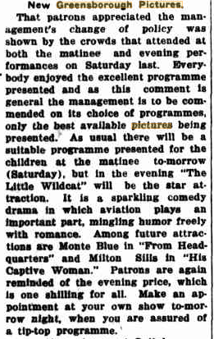
Advertiser (Hurstbridge) Friday 3 October, 1930. Page 4
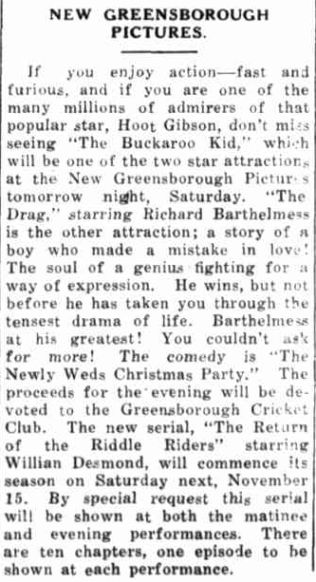
Advertiser (Hurstbridge) Friday 7 November, 1930. Page 1

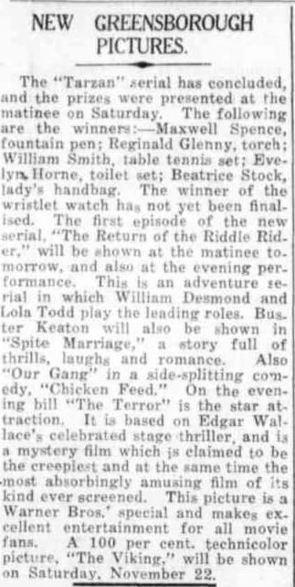
Advertiser (Hurstbridge) Friday 14 October, 1930. Page 6
Some of the pictures shown during 1930 were:-
Laugh, Clown, Laugh. 1928 Drama... starring Lon Chaney. Do Gentlemen Snore? 1928 Comedy... starring Max Davidson. Advertiser (Hurstbridge) Friday 11 July, 1930, page 5 From Headquarters. 1933 Mystery Drama... starring George Brent. Our Dancing Daughters. 1928 Drama... starring Joan Crawford. Advertiser (Hurstbridge) Friday 10 October, 1930, page 5 The Life of Riley 1927 Silent comedy starring Charles Murray. Alias Jimmy Valentine. 1928 Crime Drama... starring William Haines. Advertiser (Hurstbridge) Friday 24 October, 1930, page 5 Disraeli. 1929 Biography, Drama, History...starring George Arliss. Advertiser (Hurstbridge) Friday 31 October, 1930, page 5
Drag 1929 Drama... starring Richard Barthelmess The Buckaroo Kid. 1926 Western... starring Hoot Gibson. Advertiser (Hurstbridge) Friday 7 November, 1930, page 5 The Terror 1928 Horror, Mystery, Thriller... starring May Mc Avoy. Spite Marriage. 1929 Comedy... starring Buster Keaton Advertiser (Hurstbridge) Friday 14 November, 1930 Page 5 The Viking. 1928 Action, Adventure, History... starring Pauline Starke. Forgotten Sweeties. 1927 Comedy... starring Charlie Chase. Advertiser (Hurstbridge) 21 November, 1930 Page 5 The Flying Fleet. 1929 Adventure, Drama, Romance... starring Ramon Novarro. Spanking Age. 1928 Comedy, Family... starring Joe Cobb Advertiser (Hurstbridge) Friday 28 November, 1930, page 5

I have not been able to find any mention of the Picture Theatre or regular films being shown between 1931 and 1937. However many functions were held at the Greensborough Masonic Hall during those years - such as concerts, Euchre nights or film nights that were held purely for fund raising.

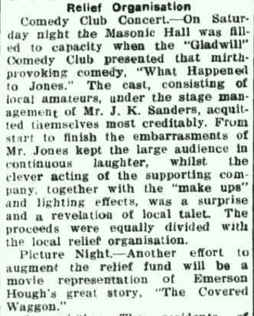
Advertiser (Hurstbridge) Friday 18 December. 1931. Page 6

In June 1938 – ‘Talkies’ were playing at Greensborough on a Thursday night. Admission - Adults 1/6 Children 9d.

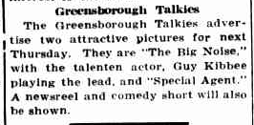
Advertiser (Hurstbridge) Friday 17 June, 1938. Page 2

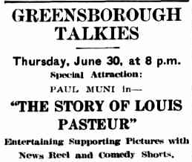
Advertiser (Hurstbridge) Friday 24 June, 1938. Page 6

Further film sessions were listed until August 1938. Thursday July 14. ‘Earthworm Tractors’ and ‘Sing Me A Love Song.’ Advertiser (Hurstbridge) Friday July 8, 1938 Page 8 Thursday August 4. Greensborough Hall. ‘Magnificent Obsession’ and Nobody’s Fool. Advertiser (Hurstbridge) Friday July 29, 1938 Page 6 Thursday, August 11. Greensborough Hall. ‘Show Boat’ and ‘Postal Inspector.’ Advertiser (Hurstbridge) Friday August 5, 1938 Page 8 Thursday, August 18. Greensborough Hall. ‘Show Boat’ and ‘Postal Inspector.’ Advertiser (Hurstbridge) Friday August 12, 1938 Page 8
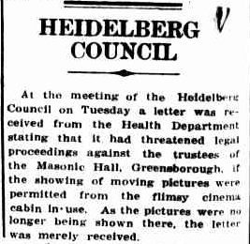
On 26th August, 1938 an article in the local paper refers to a letter that Heidelberg Council had received from the Health Department, concerning the showing of moving pictures at the Masonic Hall. At that stage however, pictures had ceased being shown there.
Advertiser (Hurstbridge) Friday 26 August. 1938. Page 4

On 17th August 1940, the Greensborough State School held a picture night at the Masonic Hall to raise money for the Patriotic fund – so perhaps whatever ‘Health Department’ issues there were, had been dealt with by that time. Eltham and Whittlesea Shires Advertiser Friday 16 August, 1940. Page 2
The night was a great success, and provided much needed funds. Eltham and Whittlesea Shires Advertiser Friday 23 August, 1940. Page 5
Another picture night was held at the Masonic Hall on Thursday 11 December 1941, to assist in the re-forming of the Greensborough R.S.L. The pictures were shown courtesy of Vacuum Oil Company. Eltham and Whittlesea Shires Advertiser Thursday 18 December, 1941. Page 2
Mr Tregonning, manager of the Greensborough Pictures, held a picture night in aid of the R.S.L. Comforts Fund on Wednesday March 4, 1942. Eltham and Whittlesea Shires Advertiser Friday 20 February, 1942. Page 4
Greensborough Summer Girl Quest Many Functions have been held to Support Miss A. Brown – Greensborough Red Cross nominee. On March 7th, 1942, Miss Alice Brown sang at the Greensborough Pictures. The manager, Mr Tregonning was thanked for permitting a collection to be made on behalf of the appeal. Eltham and Whittlesea Shires Advertiser Friday 20 February, 1942. Page 4
During the 1930’s and 1940’s the picture theatre provided a great deal of pleasure to many local residents. Allan Bishop remembers a group of young Greenhills folk would walk to Greensborough on a Friday/Saturday night during the late 1940’s to go to the pictures. Pat Shaw – from the Milk Bar next to Skals’ Garage in Main Street – would sing during interval, accompanied by someone else playing the piano.
In 1949, Lou Riley leased the theatre situated at 25 Main Street, Greensborough, and operated it quite successfully for many years.
In 1951, the theatre known as the Victory, was showing ‘Stage Fright’ with Jane Wyman and Richard Todd – a 1950 British thriller. The Age 13 July, 1951. Page 12-13.
During the 1950’s, Drive In movies began to appear, along with the introduction of television. However despite that, during the 1950’s and 1960’s the theatre was still well attended.

In 1956, the building (known as Victory Theatre) was advertised to be sold by tender – but ‘no tender necessarily accepted’.
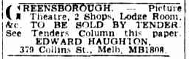
Argus (Melbourne) Wednesday 14 November 1956. Page 23
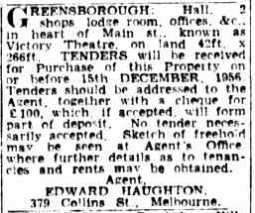.
Argus (Melbourne) Wednesday 14 November 1956. Page 24 * Referred to as Victory Theatre

On 13 May, 1958, Lou purchased the building from the Masonic Lodge for £10,000, and in 1961, refurbished the theatre to include the new cinema technology of Cinemascope. Lou used seating and some fittings from the Regal Theatre in Hartwell which had closed earlier. Also at this time, the name of the theatre was changed to ‘Ashril Cinema.’ (From an article written by Jillian Riley – Lou’s daughter) .

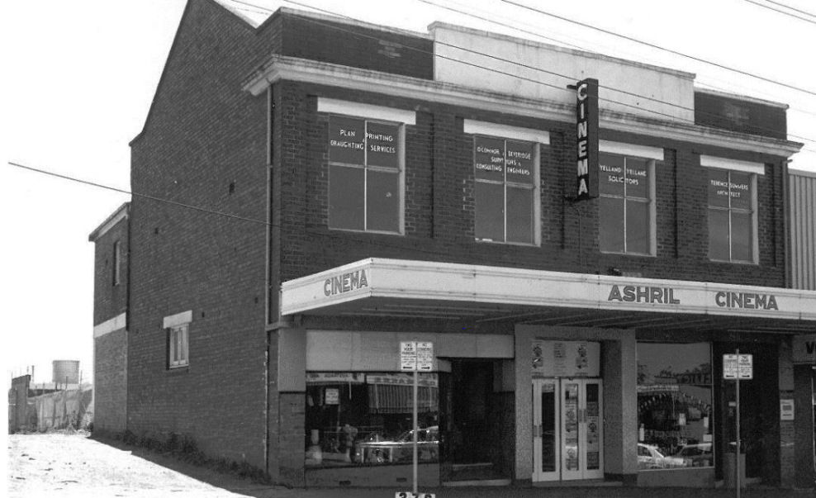
The Ashril Cinema

CAARP (Cinema And Audience Research Project) lists L.A. Riley as the exhibitor from 1949 to 1967, and lists Pennell & Bouncer as Manager and Exhibitor of Ashril cinema from 1968 to 1974.
By June 1972, at the request of Mr Peter Pennell – leasee and manager of the Ashril Cinema, a survey was conducted to see if there was sufficient financial support to form a public company to take over the business of the theatre. The lease was due to expire in September 1972, and Mr Pennell had arranged to advertise his equipment for sale in July or August. (Community News – 26 June, 1972. Page 1, page 15. Edition No. 4/72.)
Unfortunately the cinema closed.

Around October / November 1978, a new ‘Twin’ Cinema was built in Greensborough. This was quite unusual as both Village and Hoyts Cinemas operated from the same area - having one screen each. At one end of the counter you could purchase Hoyts tickets, whilst at the other end you could purchase Village tickets. The cinemas were located off ‘The Circuit’ with the entrance via the car park and the newly built Greensborough Plaza adjoining the cinemas. As you walked into the cinema, the counter was directly in front of you, whilst to the left and downstairs were the two luxurious cinemas and toilets. There was a huge difference between this cinema experience to that of the former Greensborough Theatre. The quite dark, no windows, casual type foyer and counter, was changed to a very light filled, noisy and busy area – with the women attendants even wearing a uniform that consisted of a long length rust coloured skirt and cream coloured top. The entire experience indicated that the little township of Greensborough had certainly modernized as far as a picture theatre!
According to Elaine Greig (who worked at the cinema for approximately 6 years), Star Wars and Superman were two of the first major films shown at the theatre.
The Age – November 16, 1978, Page 22. Hoyts Greensborough was screening Star Wars, whilst Village Greensborough was screening Blue Fin.
The Age – November 21, 1978. Page 30 (Advertisement – Star Wars now showing at the new luxurious Hoyts Greensborough)

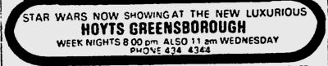

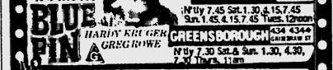

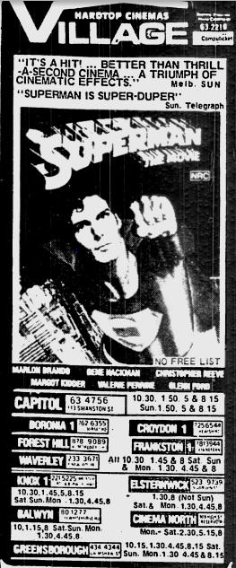
Superman was first released in December 1978
The Age January 1, 1979. Page 12

CATHS (Cinema and Theatre Historical Society) lists the Village/Hoyts Twin cinemas as operating from 1978 to 1989.
Around 1995, (7 December 1995 according to CATHS, a new “Hoyts’ Multiplex cinema was built as part of the Greensborough Plaza.
The entrance to the cinemas was then within the shopping complex.

