The Moomba Parade and Me Rosie Bray.
The public holiday at the beginning of March each year was always called “Eight Hour Day” to celebrate the Victoria eight hour day act which was passed in 1916. This Act was part of successful lobbying by the Unions and devised to regulate the length of the working day---8 hours work, 8 hours leisure and 8 hours rest.
The origin of the first Moomba Parade is worth noting. In 1951, Australia celebrated 50 years of Federation with a Parade and staging of a theatre production “An Aboriginal Moomba: Out of the Dark”. In 1954, Queen Elizabeth11 visited for the first time as reigning monarch, and the City Development Association and the Melbourne City Council proposed an autumn carnival to be known as Moomba. A committee was formed in July 1954, to organise and fund the events, successfully allocating £10,000 to its inaugural running. However before the events were planned , controversy was created when Labor Councillor Frank Williams resigned from the committee branding the whole carnival as a “Bourke street joke for the benefit of shopkeepers” and the Anglican Church added that it was the “beginning of social decay”.
In late 1954 the various clubs, schools, and community groups around Melbourne were asked if they could provide and decorate a float for the first Moomba Parade on March 14th 1955. There was a pleasing response, added to this there was to be a “crowned King and Queen of Moomba and the first Moomba (Let’s get together and have fun) Festival was on its way. It was launched by the Governor of Victoria Sir Dallas Brooks (March 12th 1955) and Melbourne became alive to enjoy the events..
Now what’s this got to do with Rosie Bray ??? Well may you ask??
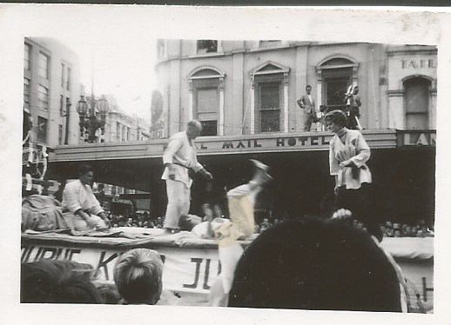
I was married to Ted Robinson, who was a truck driver and also was a student of Judo from Wally Strauss . (Just to mention the Wally and his then girl friend Valerie had escaped Vienna in 1939 and arrived in Melbourne via China after WW11. Wally brought Judo to Melbourne as a sport then). During one of the lesson period it was then decided that there should be a Judo float in the parade and the Ted would approach the firm with whom he was employed to supply the low loading truck (free if possible and making sure the name of the firm was more than visible). Ted would drive the truck very slowing and the judo exponents would demonstrate their skills while it was moving.
Below is a photo of Wally Strauss in 1955 demonstrating his judo skills on the Judo float.

And my claim to fame was that I, with our sons Russell and Stephen sat in the cabin of the Judo Parade float truck and waved to the people.
I must add that the journey along Swanston Street Melbourne was not without some problems. Every year that I was in the front seat, someone had put an advertising banner across the radiator of the truck which always caused the motor to ‘boil’. Ted being an experienced driver, knew that this could lead to many mechanical concerns and even a new motor---and a big cost to the Judo Club. Ted used to be ropeable, as every year, he expressed “NO ADVERTISING OVER THE FRONT OF THE TRUCK” however...someone always managed know better without Ted noticing it? Ted would just stop the truck in the middle of the parade (no matter where and laterally ‘yank’ the offending advertising material off and throw it into the gutter).
Another problem was, it always easy to drive at 10 miles an hour with a big truck engine running smoothly along the streets with all the starting and stopping.
So travelling in the front seat and waving to the people was not without drama.
After about five years the Moomba Parade Committee decided to go up market and glamorise the floats. The Judo Float was deemed out dated. But it was good for us while it lasted.
And it’s still a successful event and has not led to decadence?
I really had little to do with the first Moomba Parade, but I was there and have happy memories.

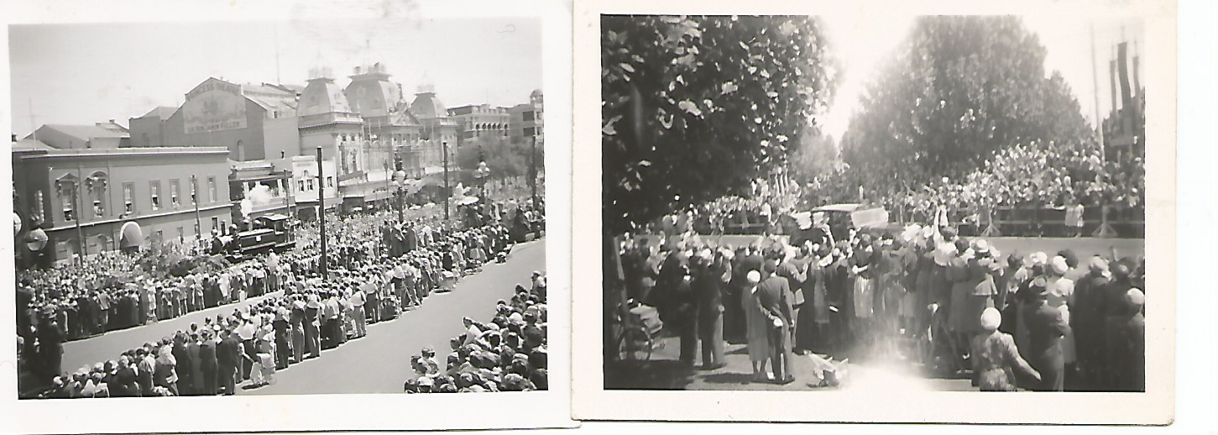
Crowds lining the streets of Melbourne 1955.

