Life and Times: a short story by Rosie Bray

Last night I dreamed that I was back in Garden City.

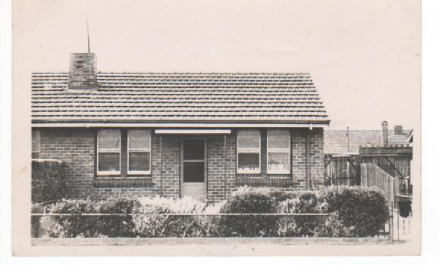No, I am not Daphne du Maurier writing Rebecca (1936), but Rosalie Thrupp aged 12 living with her mother in 32 Gellibrand Road Garden City. The year was 1942/43 and the Second World War was in full swing. Actually, the war situation was so bad at the time that we did not know if we were going to win the war---frightening times for the civilian. Especially for us who had already lost our husband and father to war. Mum and I were both very sad.

32 Gellibrand Road. Garden City

Our location in Garden City was not the safest place to live. We lived two streets from Station and Princes Piers, where there were always at least ten overseas ships ‘on the hook’ waiting for a berth to unload/or load their cargo. One street away from Commonwealth Oil Refinery (later sold by the Menzies Government to British Petroleum) and about two miles away from the big aircraft factory at the end of Salmon Street. Each night the sky was alight with search lights and often there would be bombing practice out in the bay. We often used to go outside of a night time and wonder what would happen next and knew that a couple of direct hits would have demolished all the houses in the Garden City area. It was a scary time for my mum and me.

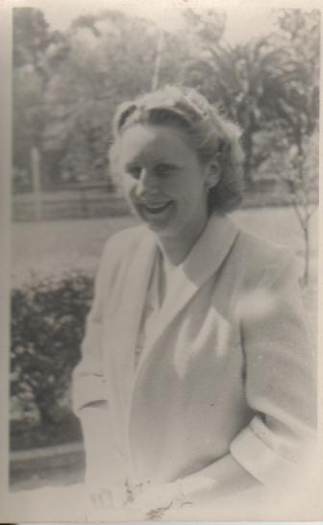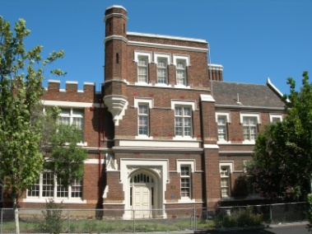I was attending J H Boyd Domestic College South Melbourne (pic right) at the time, and as we moved often, I always found it hard to make friends. However on my first day at College I sat next to Margaret Halfpenny (Jobson) and we are still great friends. Although we were complete opposites, for example, Margaret liked Country music and Rodeos, I liked classics—ballet and opera, but we both liked the hit parade music and got on very well. In fact at school, we were called “The Heavenly Twins”. And on Saturday mornings we would meet in town (under the clocks) at Flinders Street Station and walk around the city ‘window shopping’. It sounds boring by today’s standards, but for two College students the 1940’s it was always exciting. At the end of our morning together Margaret walked to her home in South Melbourne and I caught the bus to Garden City.

Margaret Halfpenny (Jobson)

**In my dream, I was to meet Margaret and we were to do our usual Saturday morning city walk.**

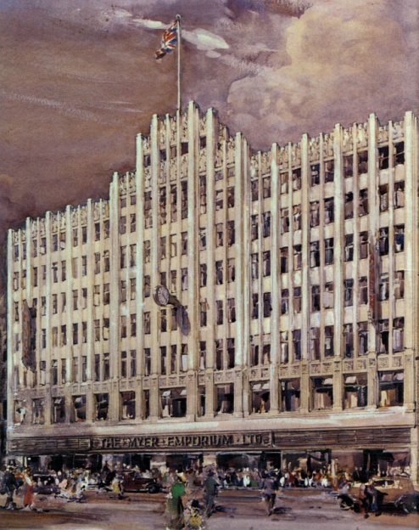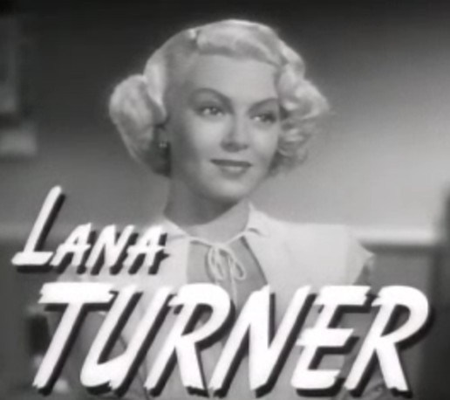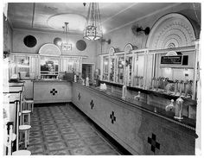We always dressed in our best, remembering that we did not have much. Mainly because we had just come out of a depression and it was war time with clothing coupons, but we both wore gloves (usually white) and held a little hand bag to carry our purse/comb etc. Our first stop would be the Tarax Milk Bar in Swanston Street. Tarax Bars became very popular in Australia because they were modelled on the America Soda Fountain that were featured in the latest American films and there were plenty of American Service personal in Melbourne. Don’t forget Lana Turner was discovered in a milk bar, and went on to become a famous actress so we always felt “very modern” ordering a drink of Crimson Vintage.

The streets of Melbourne were full of people, all going about their own business. There were many queues for items which were scarce because of war time restrictions and on sale on a Saturday morning... Margaret and I would walk, sometimes get ‘bumped’ down Swanston Street, window shopping and usually ended up at the Myer Emporium. Little did I know then that I would work at Myers for my working life until I married Ted Robinson on May 20 1950. Our lives were so innocent, and pleasures so easily enjoyed. We did not envy or want much and were so pleased to be part of the milling crowd during these war times.

I woke up with tears in my eyes. Did I want to be back in those times ---NO----did I feel lonely for those who had gone, or did I want to remember the place from whence I came?

I don’t know but I did thank God for those days of happy innocence.

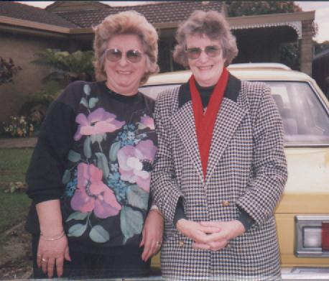

Returning to today, Margaret and I are still firm friends and when we talk together on the phone we do go back and remember the good times. We can still remember the teachers who had been brought back into service after retirement because of the war.... they more or less resented the fact that their retirement had been interrupted (told us so too). But they were good teachers and we were taught the basics which gave us the common sense start that we enjoy today. And I was so glad that I sat next to Margaret Halfpenny.