Greensborough Historical Society acknowledges the Wurundjeri Woi-wurrung people as traditional custodians of the land and we pay respect to all Elders, past, present and emerging, who have resided in the area and been an integral part of the region’s history.

Feature Article

Home Duties
by Sue Ballantyne
In 2020, while researching Greensborough families through Greensborough State School enrolment records and electoral rolls, GHS Vice President Peter Van Eeken commented on the large number of women whose occupation was given as “Home Duties” on the electoral roll. Peter wondered what this elusive occupation might entail, and many conversations were had around the Resource Centre’s morning tea table.
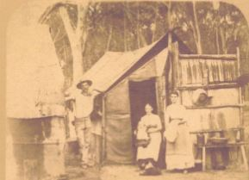
This is my explanation, drawing on my work as a history teacher, reflections of personal and family experiences and stories from the GHS Archives. I’ll start with a definition found on moneymanagement.com.au [Home duties is] …'generally a non-remunerated role using personal exertion to undertake a range of functions associated with place of residence and care of family....' So, unpaid work around the home and caring for family.

A woman’s role in places like Greensborough in the late 19th century was predominately as wife, mother, cook and general homemaker in a mainly rural setting. She had to be the backbone of the household. Women tended to marry in their late teens; families were much larger and relied on the women to provide children to perform free manual labour on the farm in order to maintain the family income.
1 Early Greensborough house, the Angland family

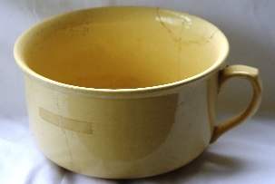
Housework was much more physically demanding because there were no washing machines, vacuum cleaners or supermarkets. Whether a woman was managing her own domestic duties, or was a maid working for a wealthy family, this job could include many responsibilities such as collecting water (plumbing arrived in Australian houses later in the 19th century), chopping wood, growing and preparing food from scratch, and disposing of the contents of chamber pots.
2 Chamber pot *

During the depression of the 1890s, women made their own soap, bought sheeting by the bolt to be stitched into bed linen and bleached. Women cured the bacon and hams, made clothes, knitted socks, stockings and singlets, made handkerchiefs from coloured oatmeal bags, knitted shawls for new babies, made the butter to use, and sometimes sold butter or eggs for extra cash or washed other people’s laundry or sewed clothes to help pay their family’s bills. My own great grandmother, with four children and an absentee husband in the early 1900s, managed her own home and cleaned houses and ironed for other families. It helped pay the rent and put food on the table.

This is my list of some of the jobs undertaken by housewives “on the land” in times past. I’m sure there are many I’ve missed.

- planning meals, depending on what is available, and how many are expected at each meal  - feeding babies – there seemed to always be a new baby in the home (my great-great grandmother had 12 children over 17 years. Her death certificate said she died of bronchitis and exhaustion at age 39!)  - being first up in the morning to light the fire/stove (after clearing previous day’s ashes)  - empty chamber pots  - gather water (from river/stream or pump) – no indoor plumbing  - rouse and dress children  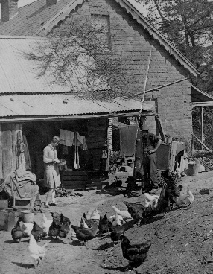  - cook breakfast  - wash breakfast dishes  - feed chickens, gather eggs  - milk cow  - water and maintain kitchen garden / fruit trees  3 Jessie feeding chickens at Willis Vale  - bake bread  - prepare lunch for workers and family (remember all meals are prepared with fresh ingredients usually grown on property)  - clean up after lunch  - sweep and wash floors  - general cleaning  - prepare dinner  - serve dinner  - clean up after dinner  - put children to bed  - sewing as needed | All day –  - looking after small children - supervising older children at play or caring for younger siblings.  - when time permits, teach young children to read/write; more likely, teach young daughters to help with chores! Teenage daughters might be sent to help in other homes as domestic servants. Teen boys would work on the farm  Weekly chores:  - churn butter  - wash clothes (by hand or in copper), hang on line  - change bed linen (boiled in copper), hang on line (hard to dry in winter)  - iron everything - from clothes to bed linen  - bathe children (and self)  And not daily but as required:  - clean and prepare chicken/rabbit/fish and other meats for meals  - preserve meat – e.g., salting lamb or beef  - bottle seasonal fruit and veg for later in year or make jam  - first aid and nursing sick children  - haircuts  - mend clothing, darn socks  - sew new clothes (by hand or if lucky, on a sewing machine) often at the end of the day, and in poor light  - general assistance on the farm as required

As Australia moved into the first half of the 20th century, little changed for the housewife. The world wars upset the status quo as women had to take on extra work (“men’s work”) as sons and sometimes husbands enlisted. Some advances in household appliances made life easier for the city housewife, but in the countryside, life was basic and money was tight, with folks prepared to “make do” with what was available and accept the home as it was. Unlike the current craze to renovate and modernise!

Greensborough was still a very rural township well into the middle of the 20th century. There are many examples of “women’s work” in the GHS archives and I include a few here, reminiscences are dated mid-20th century.

Trinnie says that life was hard on the farm, without mod cons, no electricity, only kerosene lamps, no running water and the constant farm work which included milking cows, morning and night. She reflected how her mother had managed, coming from a more or less suburban house to an isolated farm, coping with these conditions and raising a large family.
However, all the family had their daily chores such as feeding the chooks and gathering wood for the fire to help out, doing these tasks before and after school. (Trinnie di Giacomo, nee Whittingham, in As I Recall? GHS, 2013)
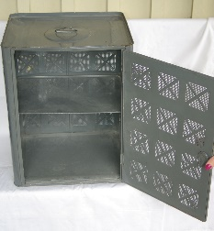
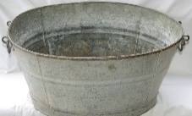
When Mum and Dad moved there in 1941, Willis Vale was over one hundred years old. Mum still had to bath her kids in a tin bath. She had to light the fires, she was always gathering sticks and candle bark, chooks to be fed, cow to milk, she had to walk up to the township across the log with Gary as a baby and having to climb up the rickety stairs to get to the bedrooms in the house with pots under the bed. Still a jug and basin to wash in after bringing the water from the outside kitchen, still only a Coolgardie to keep things fresh, she had to help kill the animals for eating. Only flat irons to do the ironing. (Faye Fort, nee Partington, Life at Willis Vale.)
5 Coolgardie style meat safe *
4 Tin bath *
Later I realized that “home duties” was not and still is not considered work! …. For me those early years seemed to be consumed with coping with the incessant renovations, juggling pregnancies, childhood ailments, gardening, produce processing, making most of the children’s clothes and curtains, … until I had the use of the car one day weekly. What a relief to be able to drive to the pet shop supplies in Heidelberg for our Boxer dog’s meat and then do a BIG weekly shop in Greensborough….so much easier than the trek over unmade dirt roads with the small children, across the river footbridge and then uphill to Main Street. (June Roberts, in Do You Recall? GHS, 2017)

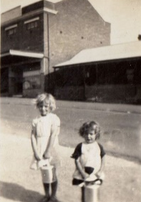
Milk was delivered to the house by us having a billy can ready to be filled from a large container, and the bread was delivered to the house by a man with a cart. (Allan Bishop, in Do You Recall? GHS, 2017)

Their fridge was an ice chest with blocks of ice being delivered to the door, washing done in a copper, doctor paid house visits as needed. Telephone was a box on the corner of the street, mail, milk, fruit and vegetables came by horse and cart. (Thatcher family, Early days in Chapman Street Macleod, in As I Recall? GHS, 2013)
6 Lorraine & Lesley (Hooper) with their milk billies

In my young days electricity was a wonderful thing but many people still used candles, kerosene lamps and hurricane lamps. Laundries or washhouses were outside and were fuelled by a copper with sticks of wood and some may have used coal or briquettes. It was usual to have a bath Sundays (carrying water from the copper inside). You did not have large wardrobes of clothes and the clothes you took off were washed the next day along with sheets and towels. Most of Monday was taken up doing this as well as getting meals and other household chores. City people had gas stoves, but others had to use wood or coal or briquettes. (Betty Joiner, nee McKenzie, in Do You Recall? GHS, 2017)

But no matter how tough things might be for adults, kids remember how much fun they had:
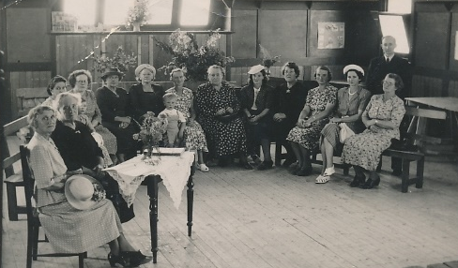
As a large family we made our own fun. Our football was made of newspapers, for our cowboys and Indian games we made bow and arrows from bits and pieces of tree branches and bamboo, our cricket bats were made of scrap wood. We were happy to play as a family. My doll was a golliwog, that mum knitted for me.
(Elaine Drakeford, nee Roberts, in As I Recall? GHS, 2013)

In addition to “home duties”, many women also contributed greatly to community life – school Mothers’ Clubs, church activities and supporting their children’s sports events.
7 Greensborough Ladies Guild, Methodist Church Hall

Post World War II, the city began to expand into Greensborough. The feminist revolution and sexual “equality” conflicted with the earlier ideal of housewife. With the new ideal of working woman, education and career became the goal. Women were now mostly free to choose how many children they had. Developments in home appliances made housework less of a full-time job and the expansion of supermarkets made food preparation less of a task. Home duties are certainly less physical, less all-consuming of the day – days that are now filled with “paid” work outside the home.

And now in the “enlightened” 21st century, what has changed? Women have careers as important and challenging as men. Housework tends to be shared to some degree. I noticed on the 2021 Census that there was a question on how much housework each member of the family does each week, and I look forward to seeing the breakdown on that one!

Going back to the quote from www.moneymanagement.com.au in my introduction; did you know there is an insurance product called ‘home duties TPD’ which can cover a person (male or female) who is unable to perform home duties due to total or permanent disability? The website even gives a list of the range of tasks home duties might entail in the 21st century. Perhaps not as physically challenging as my list from the 19th century, but still somewhat overwhelming when you consider that this homemaker is probably engaged in paid work outside the home.

- shopping  - cleaning the home, for example vacuuming, dusting and cleaning floors  - changing the bed linen and the annual spring clean  - washing, drying and ironing clothes and putting them away  - caring for children including bathing, dressing and counselling  - nursing members of the family when they are ill  - acting as a carer for an elderly or disabled relative | - minor repairs to and general maintenance of the home  - gardening, pruning, mowing the lawns  - looking after the family pet(s), walking, feeding and washing  - providing transport for family members  - organising and supervising tradespeople to undertake repairs and maintenance  - looking after the family finances  - entertaining family and friends.  - preparing meals and clearing and cleaning up afterwards;

A recent notion is that of “emotional labour” – the tracking, planning and organising of a family’s needs. A task that many of us will perform without even thinking of it – planning meals, grocery lists, holidays, birthdays, keeping track of children’s activities … the list is endless. And during this pandemic, home schooling and working from home has been added to the list, requiring yet another set of organisational skills.

I’d like to finish with this story, published in (I think) the Women’s Weekly in the 1990s. It illustrates those skills now being called “emotional labour”.
Mum and Dad were watching TV when Mum said, “I’m tired and it’s getting late. I think I’ll go to bed.” She got up and went to the kitchen and made sandwiches for the next day’s lunches, took meat out of the freezer for dinner the next day, checked the cereal for breakfast, put out the spoons and bowls, put some wet clothes in the drier and another load in the washing machine, ironed a shirt, tidied the children’s games off the table. She watered the indoor plants, emptied the bin, hung up some towels to dry; she yawned and stretched and headed for the bedroom.
She stopped at the desk and wrote a note to the teacher, counted out some cash for a school excursion, found a text book under a chair, wrote on a birthday card for a friend, wrote a quick list for the supermarket for the next day.
Mum then washed her face and cleaned her teeth. Her husband called out “I thought you were going to bed.” “I’m on my way,” she said. She put some water in the dog’s bowl, made sure the doors were locked, looked in on each of the children. In her own room she set the alarm and added 3 things to her ‘to-do’ list for the next day.
About that time her husband turned off the TV and announced to no one in particular “I’m going to bed” – and he did.

* Images marked * are from the Anne Dixon collection. Thanks to Lesley Hooper, Faye Fort and the late Ida Brown for other images which were donated to the GHS Archives.

