Wallaby Creek and the Strath Creek Fire Tower

We had a modest family farm in Pheasant Creek – mixed crops, principally potatoes and beef cattle. Farm income was uncertain and my father started working at Mont Park dairy farm in the early 1960’s.

He moved to a forestry worker position with MMBW at the Wallaby Creek in 1966 and worked there until he retired in 1981. This position was much better in terms of travel and likely coincided with the closure of the Mont Park Farm and opening of La Trobe University in 1967.

I can’t recall which year he started working as a fire watcher at the Strath Creek Fire tower – it was either in the late 1960’s or early 1970’s. He stayed in this position until his retirement.

The tower is 29 meters high and sits at 670 meters elevation. It is constructed of steel. The cabin is 3.5 meters square, surrounded by a narrow steel balcony.

Summers meant long hours in the Tower – and sometimes we barely saw Ted as he’d leave at day break and come home well after dark. Occasionally he stayed overnight. During the rest of the year he worked maintaining the channels and fire access tracks along with the other forestry workers.

Occasionally he’d take me out to the Tower. You drove along narrow tracks through tall mountain ash forests. Suddenly you came to a small clearing, with the Tower and its distinctive cabin looming high above. There was a small dug-out fire refuge near by – in case he was trapped by fire. Thankfully he never needed to use it, and indeed in all those years there was never a fire through the area.

I remember climbing up the Tower a few times – on a long steel ladder, with several landings and a hoop cage as the only protection from falls. At the top there was a small steel and glass cabin with a map table in the centre covered in charts, along with binoculars, radios and other equipment. There was a small balcony around the cabin protected by a steel handrail.

There were stunning views in every direction - miles upon miles of rolling tree covered hills. On clear day could see Port Phillip Heads. Climbing down was harder!

Back then fire watching was all binoculars, maps, rulers and coordinates - and communicating with other towers, especially Mt St Leonards Tower near Healesville, to pin point smoke and fires.

I imagine it was a lonely existence – long days of scanning the horizon with only the sound of the wind and birds, surrounded by miles of bush. However he did have visitors. He used to tell us about the pair of wedge tails eagles who regularly visited him and sat on the handrail of the tower. Sadly there are no photos but I recall him taking slices of raw meat and his thick leather gloves so I can imagine his activities with them.

As a farmer my father was used to handling animals and was a very patient, gentle person. Like many of his generation he had limited formal education but made up for this through his natural ability to learn by observation and interpretation. He had a deep affinity with his adopted home and its flora and fauna, especially the many birds that lived in the Kinglake Ranges. He occasionally brought home injured parrots and cockatoos – sometimes fallen from their nest before fledging. We’d care for them until they were strong enough to be released.

As I grew older he may have sensed my interest in the bush as he also took me on drives to other parts of Wallaby Creek. The channels were a part of the normal landscape of Wallaby Creek – we usually entered through the main gate off Yea Rd. Sometimes we came in from Mt Disappointment or via Upper Plenty.

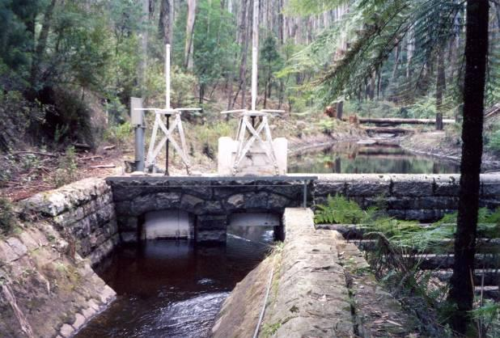
Wallaby Creek Weir

The cascades were a wonderful sight, especially after rain. Silver Creek Weir was a solitary body of water, again reached by driving along narrow tracks.

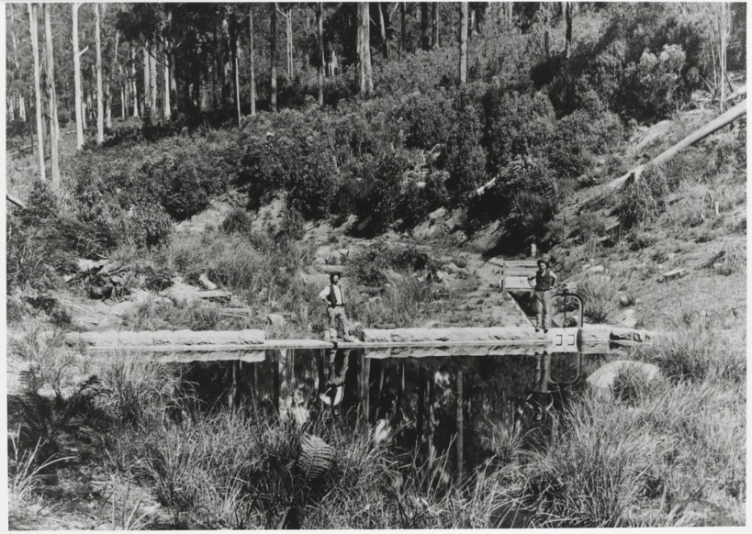
Silver Creek Weir

Once I had my driver’s licence I would sometimes drop Ted off and pick him up from the ‘Quarters’, so we could have the car for the day. Like most families we were a one car household and Ted only had the ‘work’ ute during fire season. I loved this drive in the still of the morning and quietly waiting for him to appear from the shed area after work.

The Wallaby Creek Quarters was a small settlement deep in Wallaby Creek. There were some permanent quarters, as well as various sheds and garages. A number of families lived there. They had a mini bus to drive the children to Kinglake West Primary school or to join the older West kids on the Dyson’s bus down the mountain to Lalor for secondary school.

My father formed many friendships during his time at Wallaby Creek – including Frank Lopatecki, who like him had a small family farm, near Hazeldene and Don Evans from Flowerdale. On reflection, the income from his employment with ‘the Board’ changed our lifestyle and opportunity considerably, as farming in Kinglake was challenging and increasingly the domain of larger holdings. Indeed many smaller farmers sold up or sub-divided into ‘farmlets’.

I was living overseas and when I returned in late 1981, Ted had retired from the ‘Board’. He was replaced as fire watcher by Dave Legat. He continued his association with old work mates, while increasing his work around his farm with his beef cattle.

Retiring must have been an omen as the first big fire since the early 1960’s burnt through part of Wallaby Creek and Flowerdale in late 1982. Ted knew nothing of the fires at the time as he was in the Intensive Care Unit at St Vincent’s Hospital following complications from surgery. While damage was limited to property, it was a precursor to the tragic Ash Wednesday fires of February 1983 which affected areas further east, then the devastation of Black Saturday 2009 which wiped out Wallaby Creek and surrounding communities and farms.
The Strath Creek Tower site was burnt over in the 2009 fire with the fire watcher evacuating safely. The tower was inspected and considered structurally safe, due in part to the clearing round the base and a fuel reduction burn.
I remember looking up toward Mt Sugarloaf and Mt Disappointment from near Greensborough round 12md that day. I could see the billowing smoke and the direction of the wind and knew Wallaby Creek was in its path. But like many I could not have imagined the extent and ferocity of that fire and the devastation that remains to this day.
By Anne Paul
January 2018

