Greensborough Sub-Branch presented the Rememberance Day Service on November 11 2015.

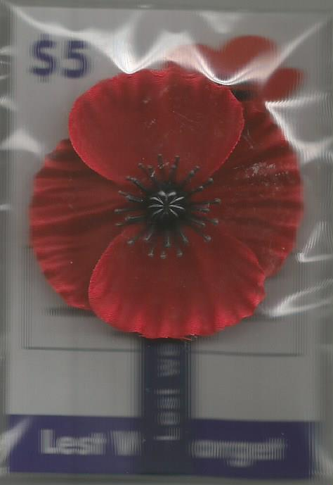A group of ex service personal, local residents and grade 4 from St Mary’s Primary School participated in the Remembrance Day Service at War Memorial Park Greensborough on Wednesday November 11 2015.

The service was led by Reverend Barry Green assisted by office bearers of Greensborough Sub-branch of Greensborough RSL. Councillor Mark Di Pasquale represented the Banyule City Council.

**ANZAC Centenary Time Capsule**

Banyule City Council chose November 11 2015 as a significant day to dedicate a Time Capsule as part of the ANZAC Centennial Commemorations.

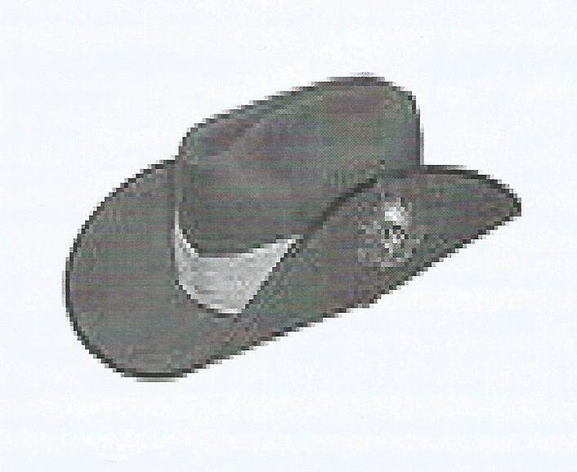The occasion was held at War Memorial Park Greensborough at 9am.

Banyule Council’s Mayor, Councillor Craig Langdon, Councillor Mark Di Pasquale and Councillor Steven Briffa helped to bury the capsule which will be opened every 25 years.

The Mayor in his short address told a small gathering that items held in the capsule ranged in years from 1915 to 2015.

Rosie Bray