Launch of the Redevelopment of the Change rooms at Yarra Valley Swim

School on February 26th 2021.
Mayor of Banyule, Cr Rick Garotti formally launched the redevelopment of the very tired change rooms at the Yarra Swim School Liat Way Greensborough on February 26th 2021.
Ward Councillor, Mark Di Pasquale was on hand to tell the people present that the pool had an interesting history and it was indeed an asset to families of the community.
Club President, Oliver Wein thanked the Banyule Council for the substantial funding to bring the hot water system up to date and to make the change rooms more comfortable for swimmers.
Manager of the pool Ash Crimmins was heartily thanked for overseeing a difficult job at such a problematic time in our history.
Light refreshments were served.
Mayor of Banyule Cr Rick Garotti (below)
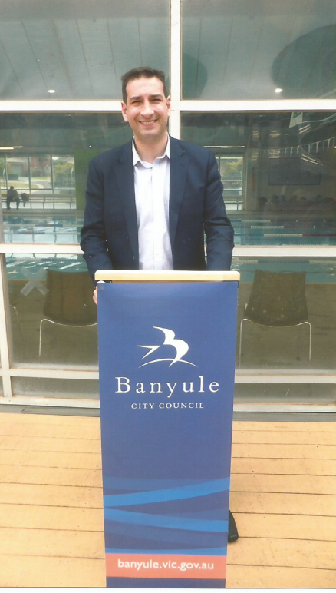
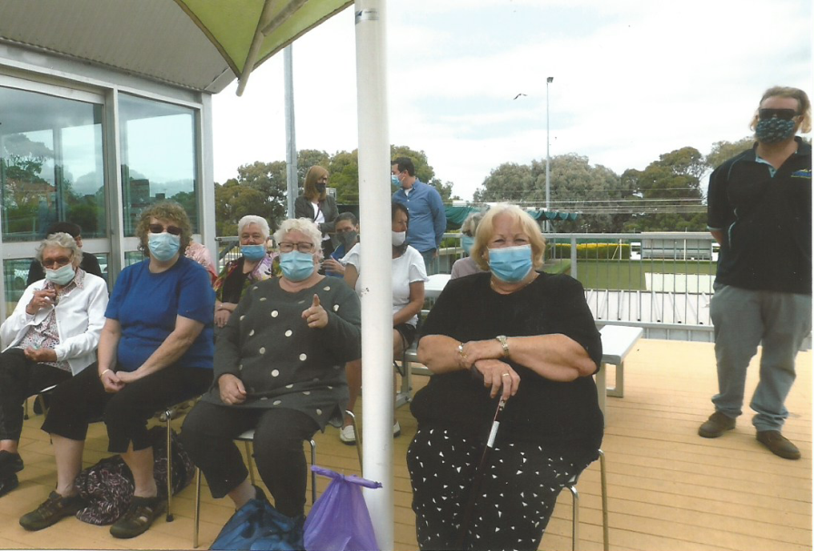
Mature aged swimmers at the launch 26/2/2021.

