Official Opening of Ambulance Station in Watsonia on March 5th 2021 at 306 Grimshaw Street Watsonia 3087.
Minister for Ambulance Services , Represented by Parliamentary Secretary for Health Steve Mc Ghie and Member for Bundoora Colin Brooks officially opened the new Watsonia Ambulance Victoria branch on March 5th 2021.
Ably supported by
- Aleesha Ascial ---Team Manager.
- Mark Ferraro --- Senior Team Manager
- Steve Doyle ---Area Manager
- Narelle Capp---Regional Director.
Pictured below.
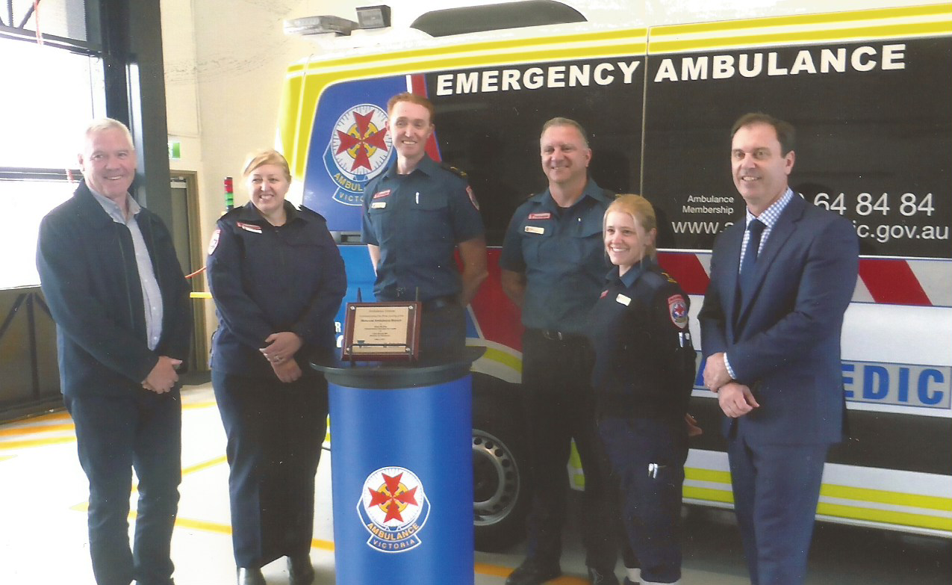 The new state- of-the-art Ambulance Station has been opened since October 7th 2020 and operating 24 hours a day 7 days a week.
The Watsonia Ambulance branch has 19 staff assigned to the branch. The station’s roster is comprised of day and night shifts.
It features
- Three bay-garage.
- Training facilities
- Rest and recline areas
- Fully fitted kitchen
- Secure on-site staff parking
IN 2015 the original location selected was Trist Street Watsonia. This location was deemed by the local residents, the Banyule Council and Colin Brooks Member for Bundoora as inappropriate ---
The main reason for their misgivings was that Trist Street was a back narrow and winding street. It is a heavily residential street, which would cause many problems for both the Ambulance Drivers and the residents.
Local meetings were held and lobby groups formed.
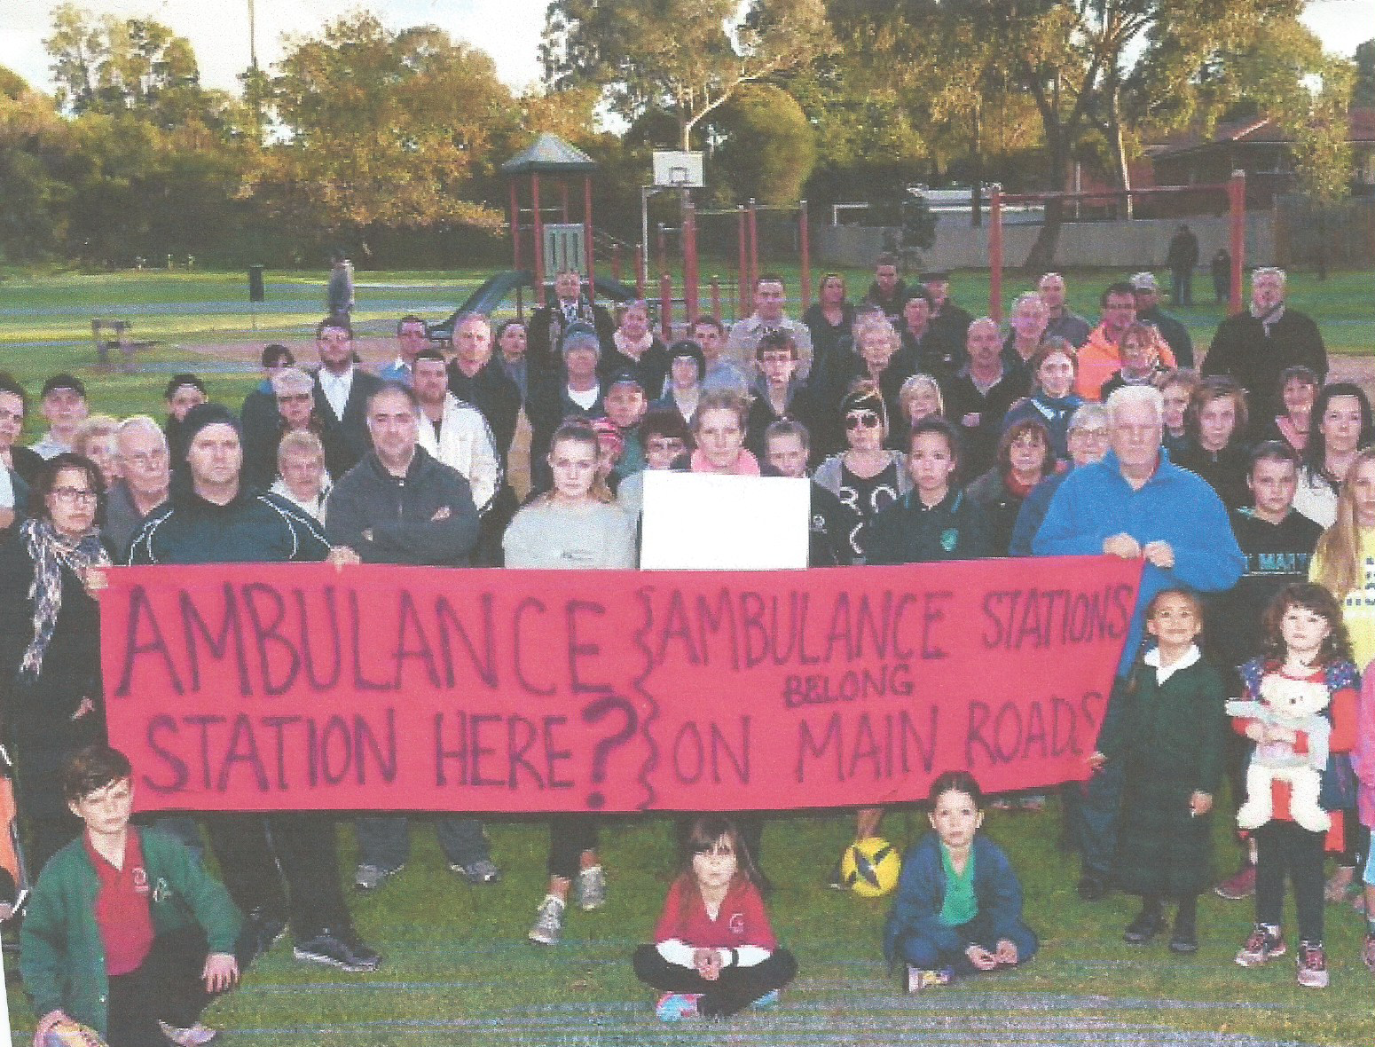

Banyule Council Meeting 6/7/2015 contacted Ambulance Victoria asking them to reconsider the Trist Street location and after meetings and negations, it was decided the better option was 306 Grimshaw Street Watsoina.
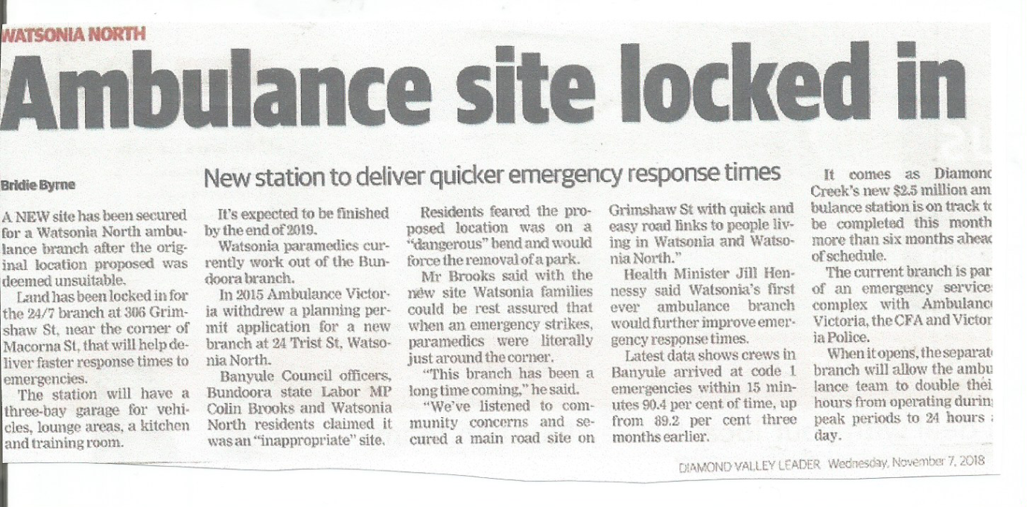
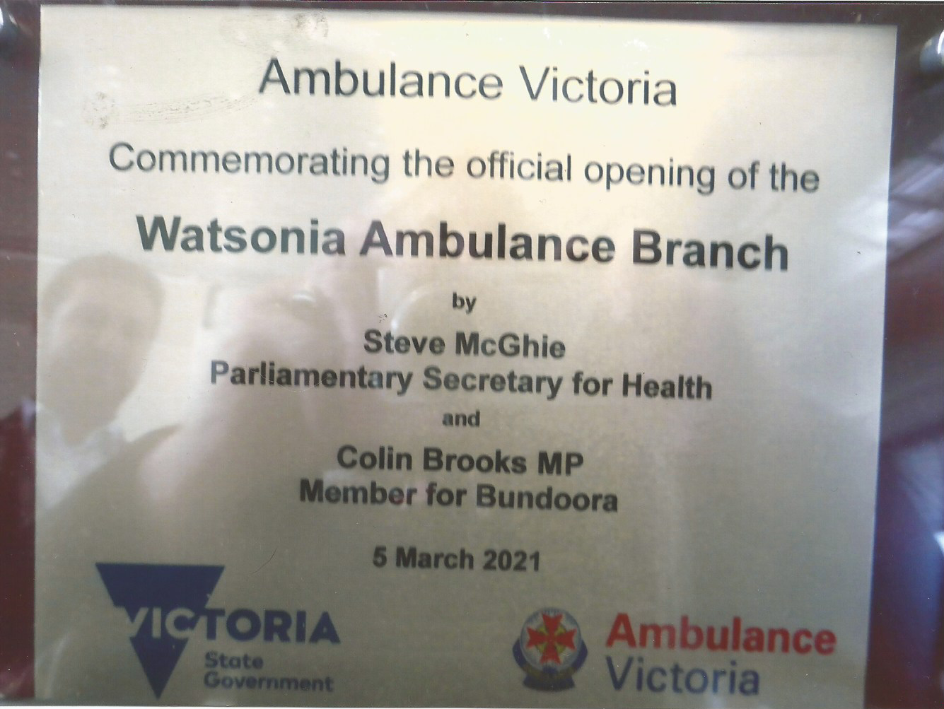
Rosie Bray March 7 2021.

