The Starling and Stewart families,

at Janefield, Yan Yean, Greensborough,

Diamond Creek, Plenty and Yarrambat,

from the 1850s onward.

Compiled by Greg Neumann,

a great-grandson of

George Davey Starling Junior &

Margaret Stewart.

Diamond Creek, 1997

(Photos upgraded: 2020, revised 2025)

CC BY-NC-4.0:

This work is published under a Creative Commons licence:

CC Attribution-NonCommercial 4.0 International

(<https://creativecommons.org/licenses/by-nc/4.0>).

Re-users may copy, distribute, remix, adapt and build upon this material, in any medium or format, for noncommercial purposes only, with attribution to the author or image sources as detailed in the work.

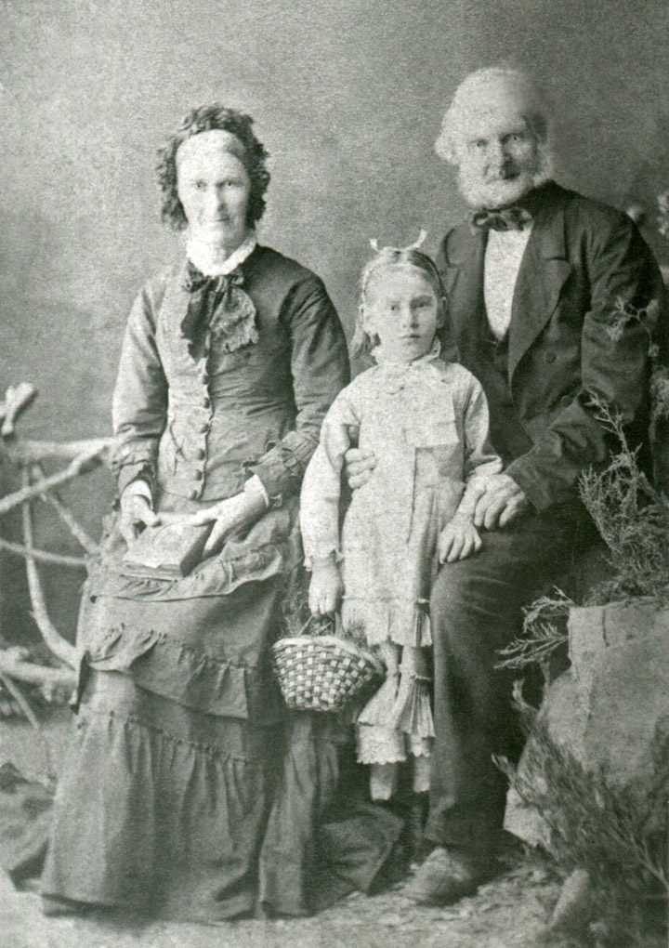

Clementia Starling (nee Davey) and George Durrant Starling, both about 75, with great-granddaughter Augusta, c 1880, Melbourne. (Photo: R. M. Neumann).

In 1858, George and Clementia Starling left economic hardship in Norfolk, England, to start a new life in Australia. George went ahead of Clementia and arrived in Melbourne in Jan 1859 on the ship ‘Oceanica’ (4 month trip), while Clementia arrived in Feb 1859 on the ship ‘Suffolk’ (3 month trip). Initially they lived at Janefield (Bundoora), where they ran a farm. They were later joined by their grandson George Davey Starling Junior, who arrived in Feb 1869 (age 21) with his brother (Alfred) Adrian Starling (age 18), on the ship ‘Corona’.

In 1870, George Davey Starling Jr married Sophia Steele (nee Foyle), from Hobart, Tasmania. Their daughter Augusta Sophia was born in 1874, but her mother died the same year. George Davey Jr then married Margaret Stewart in 1877. Augusta grew up, married Robert Chapman in 1897 and had two children, Clementia (or Clementina) and George, named after her great-grandparents.

Adrian Starling became a blacksmith and married Ellen Nelson in 1877, living at Mernda with three children: Alfred Alpheus, Mary Jane and Nellie (Ellen Leonora). Adrian lived to 103 and died in 1953 at Mooroopna. A younger brother, Ambrose Starling, also migrated to Australia and lived at Wallan with his wife Jane (nee Garthwaite) and daughter Christina.

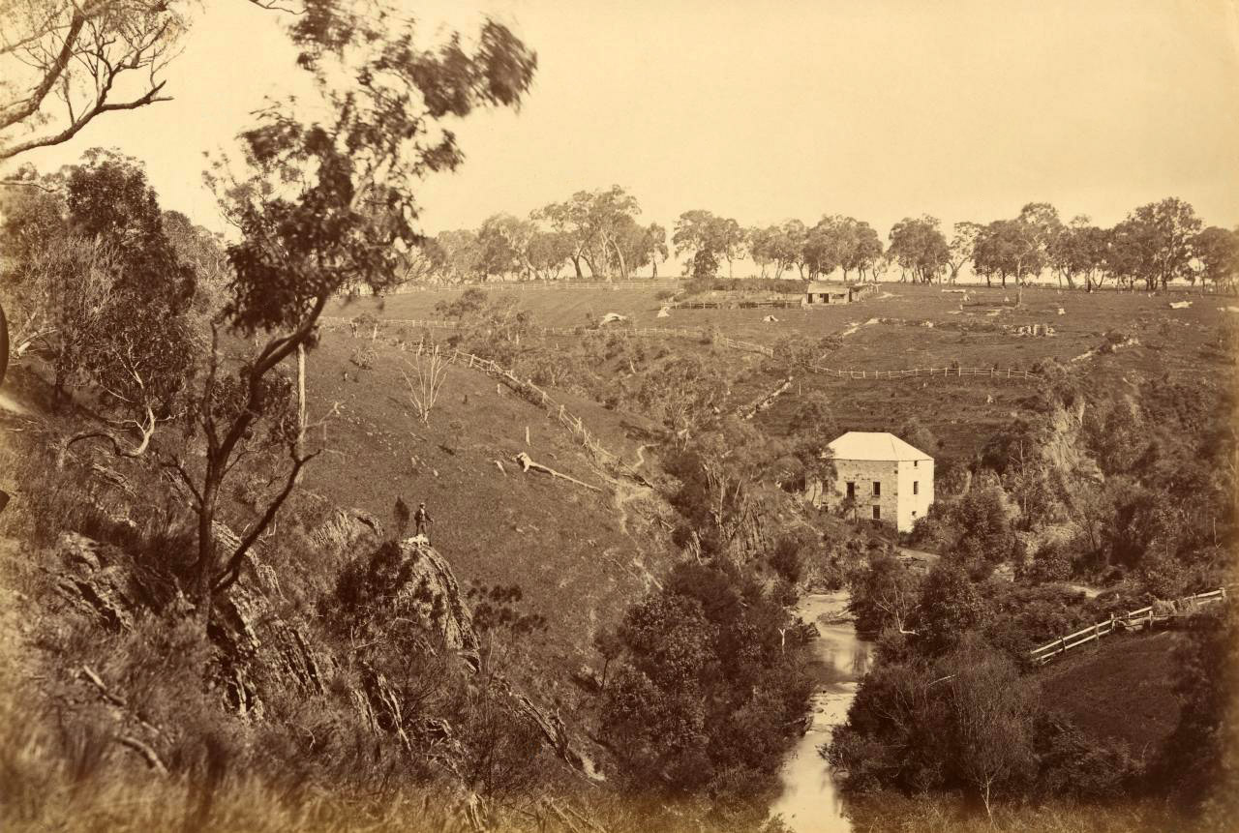

“View on the Plenty River, Janefield”, c 1877, Fred Kruger (National Gallery of Victoria, Melbourne). Looking west, toward Janefield (Bundoora).

George Durrant Starling was a master miller and mill builder from the Great Yarmouth area of Norfolk, England and was about 53 years old when he arrived in Melbourne in Jan 1859. According to Starling family history, George and his wife Clementia lived in the miller’s cottage on the hill above the Janefield Mill (see photo above) and ran a farm there. From 1869 they had the help of their grandson, George Davey Starling Jr, age 22, who had worked at his father's mill at Winterton in Norfolk and wanted to become a farmer.

In a family history by a granddaughter of George Davey Starling Jr, Margaret Murphy (nee Starling, b 1923), Margaret wrote: “As a young child, I remember being taken to the site of the cottage at the Mill and being told stories. How Clementia blew on a cow’s horn to summon George and also how she called him: ‘Jarge, cum and get your wittles’ (victuals [food])”. Such were the stories handed down through the generations.

A story from another branch of the family included the belief that George Durrant Starling ran the Janefield Mill at some point in time (Edwards, 1979, p 31). However no solid evidence to confirm (or refute) this has yet been found and it may simply have arisen from a mix-up with stories of Starling family milling activities in England (see page 6).

That said, George Durrant Starling was certainly a farmer at Janefield in the 1860s, being listed as such from 1868 to 1872 in Bailliere’s Victorian Post Office Directory (‘Post Office Towns’ section for Janefield).

Earlier records are difficult to find. Many early Melbourne records have been lost or deliberately ‘pulped’, according to information from the State Library of Victoria.

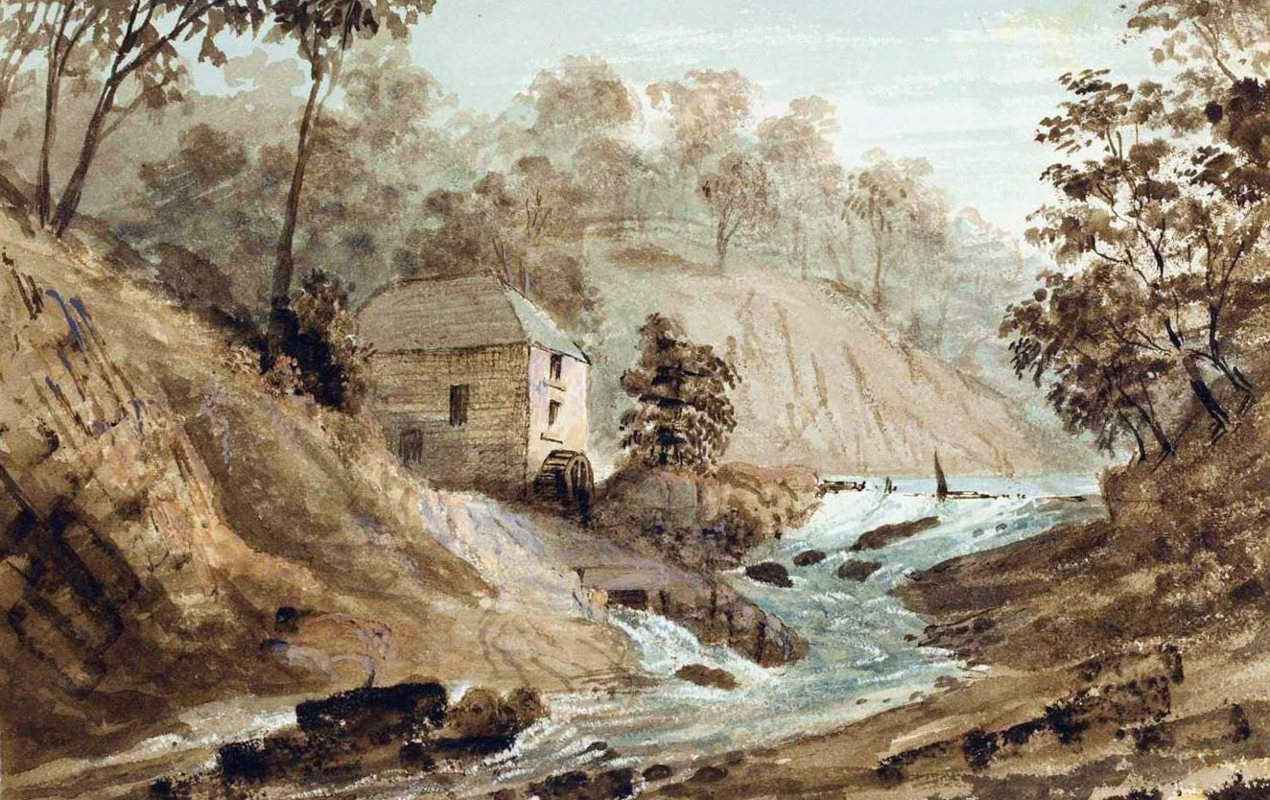

“Janefield Mill, Plenty River, 1855”. Painting by John Black Henderson (State Library of NSW, Mitchell Collection).

George Coulstock had this mill built on the Plenty River in about 1842, at a creek junction (now known as University Hill Creek). The remaining ruins show that the mill building was constructed of mudstone blocks held together with a lime-rich mortar (Vines, 2017, p 15). The floor plan was about 6 m x 12 m (inside), with walls 0.7 m thick, rendered over with mortar for weather protection.

The mill apparently did not operate properly at first, until purchased by John Brock in 1847 and leased in 1848 to Peter Hurlstone & Sons, who refitted the mill with new stones and equipment and built a dam to improve performance. Alfred Hurlstone operated the mill under a seven year lease, from Feb 1848 to Feb 1855, and probably to some extent after that, as Alfred stated that he left the mill in 1858 (Vic Parliament, 1867, parts 518 & 550).

The water wheel had a diameter of sixteen feet (about 5 m). Water from the dam struck the water wheel at about centre height and exited via the tail-race (centre foreground of painting). Grinding capacity of the mill was up to 8 bushels (218 kg) of wheat per hour.

According to Alfred Hurlstone, the mill worked well for nine months of the year and sometimes ran 24 hours per day; but water flow in summer was often too low to drive the mill for more than about four hours per day, during part or all of January and February and also when it was needed most for the peak in the grain harvest, during March. At other times the dam was often damaged by floods following heavy rain, which stopped work until the dam could be repaired.

John Brock’s son, Henry Brock, leased and ran the mill from Mar 1855, retaining the services of Andrew Prismall (Argus, 1855, Feb 23, p 8), a miller who lived on Epping Rd, ran a bakery nearby and at some point milled at the nearby Thomastown Steam Mill. Mr Prismall had probably left Janefield Mill by the time Alfred Hurlstone left (Feb 1858), because by then Henry Brock had inherited the mill and advertised for a miller in March 1858 (Argus, 1858, Mar 13, p 1).

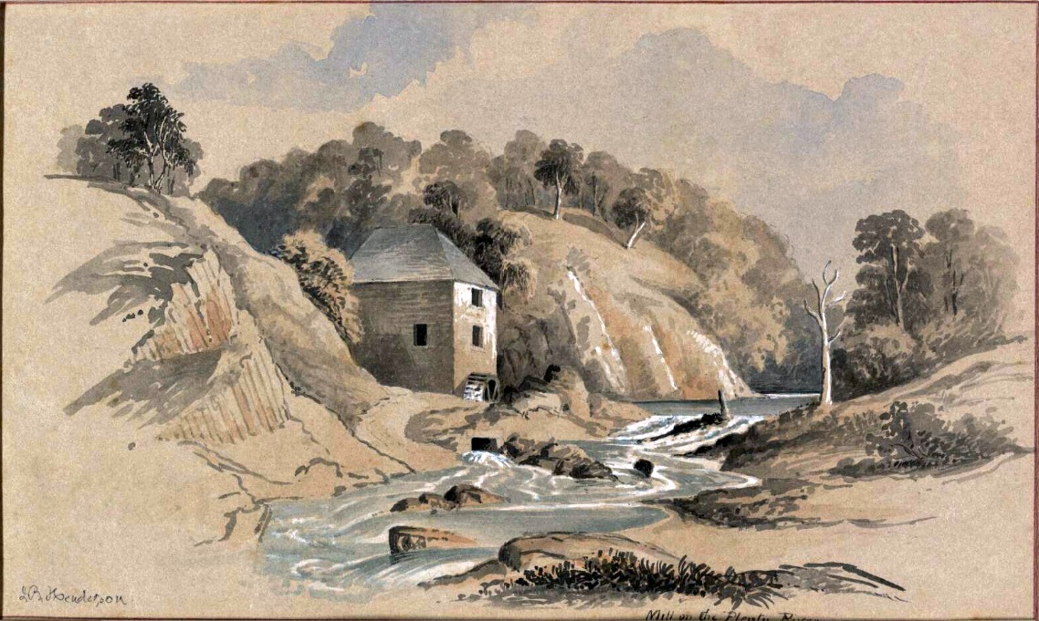

“Mill On The Plenty River, c 1860”. Painting by John Black Henderson. National Library of Australia.

Henry Brock also advertised the Janefield Flour Mill for lease, with 20 acres of grass land, during 1858 and up until 7 Mar 1959 (Argus), after which the advertisements ceased. By a curious coincidence, George Durrant Starling, master miller, had arrived in Melbourne two months earlier, in Jan 1859, by assisted passage, looking for work, a place to live and land to farm, and was joined by his wife in Feb 1869. Nothing more can be made of this without a reliable date for their move to Janefield, which so far is lacking, but the existence of a mill at Janefield, working or not, could explain their interest in moving there.

It is notable that Janefield Mill evidently was working during 1859. It stopped in December due to lack of water flow, which “Mr Brock, a miller on the Plenty Road” blamed on the Yan Yean Reservoir taking water from the Plenty River and so requested compensation from the Sewerage and Water Board. However the claim was rejected when it was proved that water had not been taken from the Plenty River during December, as the reservoir was adequately filled (Argus, 1859, Dec 29, p 5). Henry Brock had previously hired experienced millers to run Janefield Mill, so it is unclear who carried out the actual milling operations during 1859, whether Brock himself, or someone else.

Therefore the question remains unresolved as to whether George Durrant Starling operated the Janefield Mill at some point, though the weight of evidence (or lack thereof) suggests that he probably did not. If he did, it was only for a year or three, at most.

Evidence that the Janefield Mill had stopped operating by 1861 or 1862 is from Mr A. Willis, a miller who testified in June 1866 (Vic Parliament, 1867, part 22) that Mr Brock’s Mill had not worked “for the last four or five years”, but had worked since the Yan Yean Reservoir was built (c 1857). Hence the mill might have operated up until 1861, but had closed by 1862. This is consistent with evidence that Alfred Hurlstone purchased and removed the mill-stones and equipment from the Janefield Mill, for installation in a new steam powered mill in Wood St, Preston, which opened in 1864 (Jones, 1990, pp 40, 41, 96, 98).

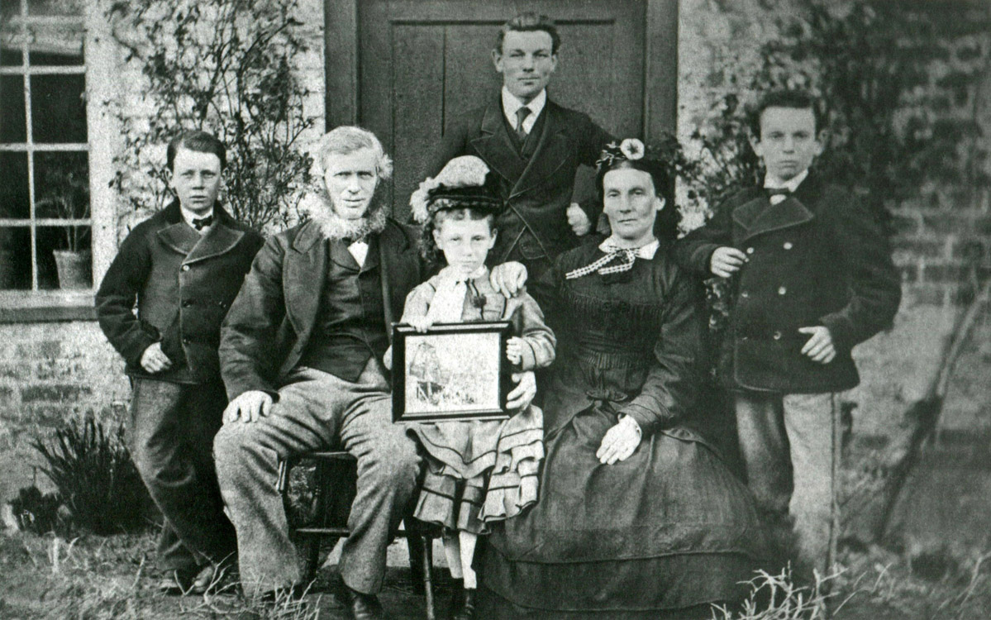

George Davey Starling Senior & family, Winterton Mill Cottage, Norfolk, England, in about 1873. From left: Julius, George Davey Starling Senior, Nora (Leonora, b 1865), Austic, Tryphena Maria Starling (nee Thurtle), Oliver. Other children: George Davey Junior (b Feb 1847), Jane Tryphena, Adrian (b 1850), Alpheus, Ambrose (b 1851). (Photo: R. M. Neumann).

The Starling's were a family of millers and farmers in Norfolk, England. George Durrant Starling managed three wind-powered mills in eastern Norfolk: at Fleggburgh, Ormesby and the brick tower-mill at Hemsby, which he built in about 1836 and where he was a miller, farmer and wheelwright. His wife Clementia ran a shop on site (Neville, 2014, Hemsby Towermill, Winterton Postmill).

His son George Davey Starling Senior (see photo above) was born at Hemsby Mill and later bought and ran the Winterton Mill. Due to tough economic conditions, the son became insolvent in 1857, which possibly led to his father George Durrant Starling selling up to help his family, before leaving for Australia in 1858. George Davey Starling Sr recovered and went on milling for four decades more with his son Austic, until the Winterton Mill was destroyed by a storm in 1902, after which Austic continued milling by steam power in a nearby barn.

The above family photo was sent from Norfolk, England in about 1873, by George Davey Starling Senior, to his parents George and Clementia Starling and eldest son George Davey Starling Junior in Australia, by then farming in Nillumbik (Diamond Creek). The framed picture held by Nora (centre) is thought to be a sketch (or photo) of the poppet head and mullock heap of the Union Gold Mine at Diamond Creek, the picture evidently having being sent to England from Australia, along with news of the family’s welfare.

In Nov 1886, two years after his wife had died, George Davey Starling Senior and his daughter Leonora made the journey to Melbourne by ship (‘Lusitania’), to visit George's elderly parents George and Clementia and son George Davey Junior at Diamond Creek, as well as sons Adrian and Ambrose, all of whom were by then well established in their new home of Australia.

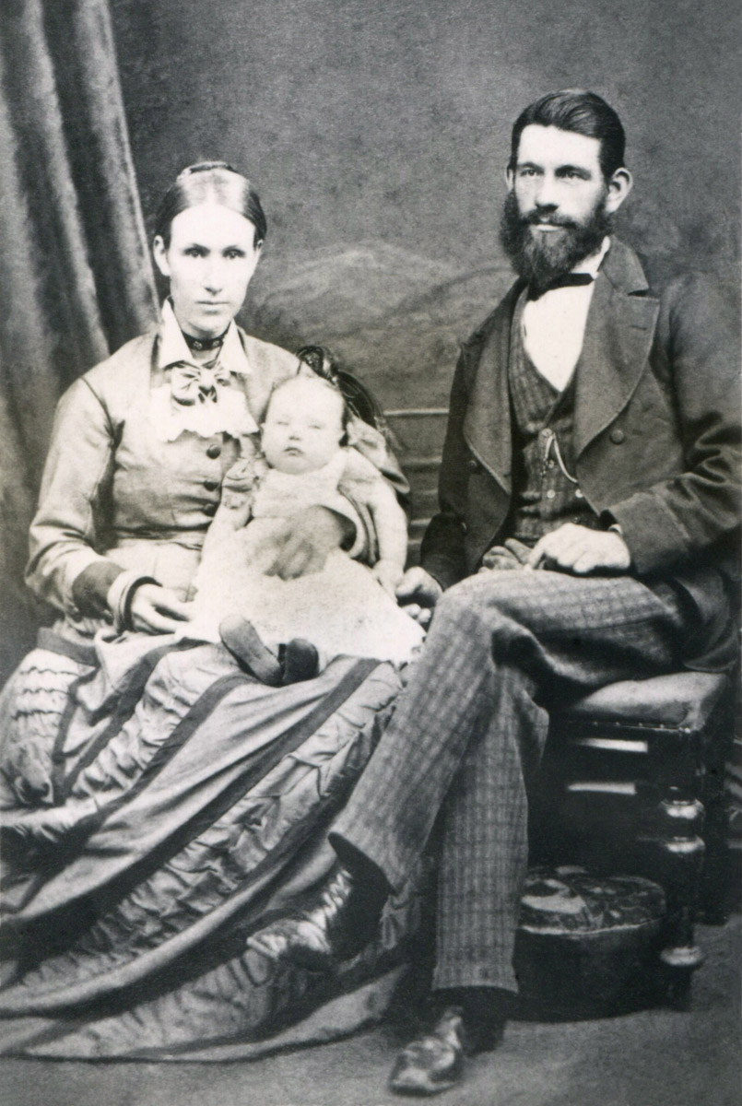

Margaret and George Davey Starling Jr, with daughter Maud. Studio photograph taken in Melbourne in about 1879. (Photo: R. M. Neumann).

In 1877 (Sep 26), George Davey Starling Junior, age 30, married Margaret Stewart, age 23, at Janefield Presbyterian Church, in Plenty Rd (Mill Park). They had their first child Maud (Beatrice Maud) at the Starling family farm in Diamond Creek (Plenty) in 1878.

Soon there followed: Blanche Barbara (1880-1890), Gertrude Elizabeth (1882), Frederick George (1883), Ida Tryphena Jane (1886), Leonora Margaret (1888), Walter David (1890), Mary Evelyn (1893), Isa Ruth (1895) and Esther Valerie (1899) (see following p 8 for photo).

The second youngest child, Isa, was not quite five years of age when she started attending school for three days each week at Diamond Creek School, which had two rooms. It was a mile and a half walk from the farm, so Isa’s sister ‘Dot’ (Ida) often gave her a ‘piggy-back’ part of the way home (Neumann, 1979).

When Isa was a little older, she attended Greensborough School, which was a long three mile walk. Later when Isa was old enough, she rode a horse to school. Walter and Nora attended school at Tanck’s Corner (Yarrambat). Other members of the family went to school at Plenty and Diamond Creek.

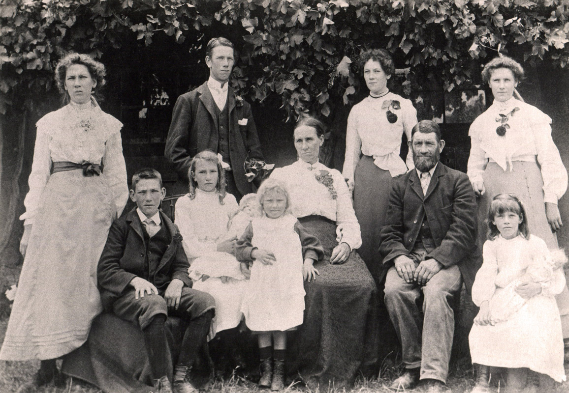

George and Margaret Starling and family at home at ‘The Firs’, Yan Yean Rd, Diamond Creek (Plenty), in about 1904.

Left to right, back: Nora, Fred, Gert, ‘Dot’ (Ida).

Front & middle: Walter, Mary, ‘Essie’ (Esther), Margaret, George Davey Starling Junior and Isa (lower right). (Photo: R. M. Neumann)

George Davey Starling was an orchardist and member of the Nillumbik Horticultural Society. As a respected member of the community, he also served on the Heidelberg Council for a number of years.

His wife, Margaret, kept a beautiful garden of roses, chrysanthemums, stocks, carnations, violets and other flowering plants. Grapevines grew along the front of the verandah. When the grapes were ripe, the children liked to sit on the verandah seat to eat them and sometimes have a contest to see who could spit the skins the furthest.

There was a great deal of work to be done on the farm, which had large orchards with three big areas of gooseberry bushes. Old stockings had to be tied to the fruit trees to attract codlin moth grubs, which crawled into them, after which the stockings were taken off and burnt.

Then there was ploughing, pruning, harvesting, chaff-cutting, milking, collecting of cream, butter-making, feeding the animals and so on.

It was too dangerous for the younger children to feed the chaff-cutter, so Isa had the job of turning the handle, while Fred, the eldest son, fed hay into the chaff-cutter. Fred often ploughed fields for various people in the area as well (Neumann, 1979).

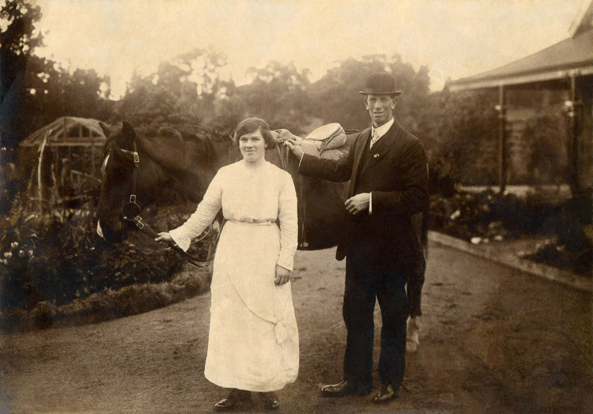

Isa Starling with her brother Fred Starling, in about 1915, outside ‘The Firs’ (‘Hazeldene’), Yan Yean Rd, Diamond Creek (Plenty). (Photo: R. M. Neumann).

In 1915, the ‘Great War’ was raging and Fred Starling enlisted in the A.I.F. in July. He was sent overseas to Egypt, then France, where he survived the devastation at Pozières, in the Somme, and received a Military Medal (M.M.) for gallant conduct as a runner, though subsequently hospitalised for shell shock. He was sent back to France and endured further shelling and enemy fire as Company Scout, for which he received the Distinguished Conduct Medal (D.C.M.) for bravery, but was later wounded and hospitalised in England (Durance, 2016).

Fred Starling returned from the ‘Great War’, but his younger brother Walter, and many others from the district, did not. Walter was severely wounded in France while serving in the A.I.F and died in England in 1918. This left Walter’s wife, Evelyn, to bring up their baby son, Raymond, near Terang, Vic.

Isa Starling trained and served as a nurse, during both the First and Second World Wars. During WWI, one of the injured soldiers she nursed was Albert Victor Neumann (returned to Australia, June 1916). They became friends in 1917 and married in July 1921, moving to Thornbury (‘Lothian’, 91 Smith St) where they brought up two sons, Stewart (b 1923) and Max (Ronald Maxwell, b 1925).

Fred Starling married Eleanor Sims in 1922 and lived with the Sims family at Greensborough, in Simms Rd (correct 1914 spelling) at ‘Camelot’ (Nos 2-18), where daughters Margaret (b 1923) and Sheila (b 1926) were raised.

Margaret Starling served in the Australian Women’s Army Service during the Second World War and in 1944 married Ray Murphy, a soldier in the A.I.F. They raised their children, Jennifer, Diana, Rodney and Jeremy, at Yarroweyah, near Cobram, on their dairy farm, which was also named ‘Camelot’.

Sheila Starling married Richard Cornish (after whom Cornish College is named) and they had three children: Christine, Richard and Keir.

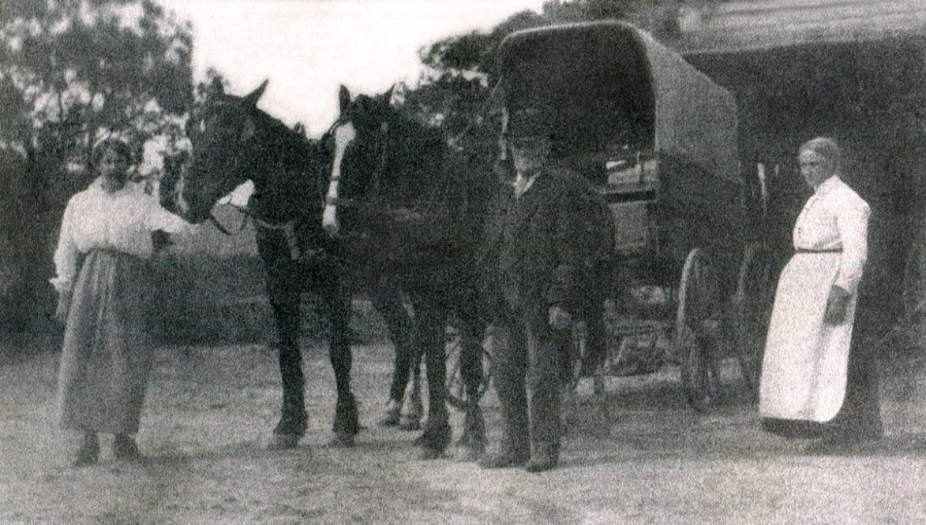

The Starling family wagon. George Davey Starling (centre), wife Margaret (right) and youngest daughter Esther (left). Photographed at ‘The Firs’ (‘Hazeldene’), Diamond Creek (Plenty), in about 1917. (Photo: R. M. Neumann).

Up until the 1930s, George Starling would harness the horses and travel in this wagon at a leisurely pace, ‘clip-clop’, ‘clip-clop’, all the way from Plenty to High Street Northcote, where he shopped each Friday at Robert Reid’s grocery store; except for bread, which he bought in Diamond Creek, at Jim Rose’s Bakery.

Esther Starling married Charles Davis in 1923 and they lived at East Preston with their two daughters, Holly (b 1924) and Joyce (b 1928).

The Starlings knew many families living near Plenty early in the 20th century: the Lines, Partington, Poulter, Laidlow and Godber families, to name just a few. The Starlings’ nearest neighbours were the Fieldings, to the north, and to the east the DeFredericks, who owned Larch Farm (now called Larch Hill) on the eastern corner of Hillmartin Rd and Sutherland Rd, near Larch Cres (see map, p 14).

Maud DeFrederick married Margaret Starling’s brother, James Stewart, in 1890, and they had four daughters and a son, Jim, who was killed at Lone Pine in the First World War.

North of the DeFrederick’s was Mr. Goodall’s farm ‘Hillmartin’, after which Hillmartin Rd was named. At the top of Hillmartin Rd was ‘Brown’s Lookout’, which gave a commanding view of the area.

The young Isa Starling and her sister Mary liked to go up Hillmartin Rd to Brown’s lookout, then across Bawley’s Gully to the old Pioneer mine (Dunn’s Gully), where they would drop rocks down the shafts and listen to the clatter as the rocks bounced off the walls.

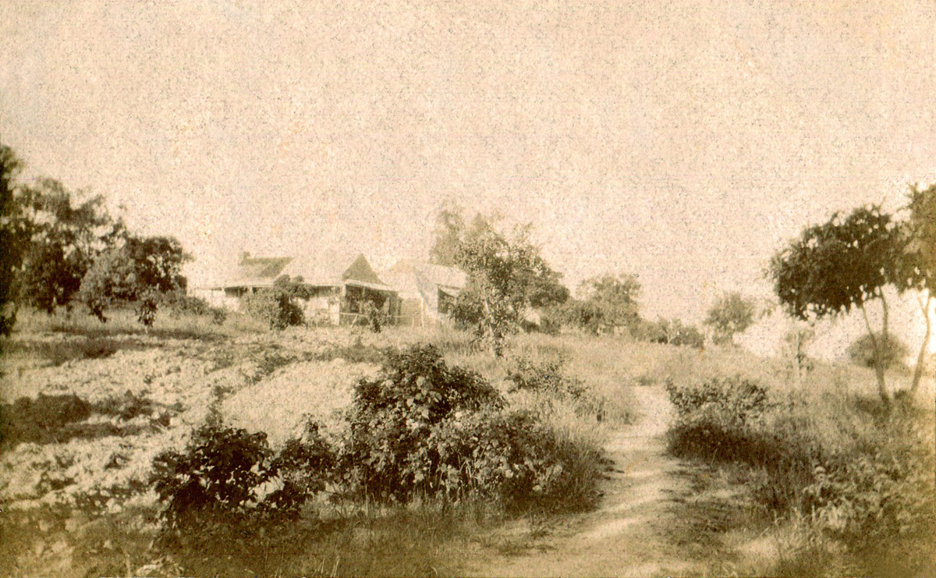

The Starling family home, ‘Hazeldene’ (previously known as ‘The Firs’), YanYean Rd, Plenty, in about 1920. Viewed from Heard Ave, originally part of Yan Yean Rd. (Photo: R. M. Neumann).

On the left side of the photo is the original four-roomed ‘adobe’ (clay) cottage built by George Durrant Starling in about 1870. Beside it to the right is the four-roomed timber house added by grandson George Davey Starling Junior, in about 1890.

The above photograph was taken in about 1920 by Albert Neumann, who married Isa Starling in 1921.

Several years earlier (c 1917), Isa had suggested naming the Starling family home ‘Hazeldene’, after the town on the Flowerdale Road, where there was a favourite picnic spot on the King Parrot Creek, beside the bridge leading to Hazeldene township. So they did. Albert Neumann was an engraver and sign-maker and made up a brass name-plate for the front gate of ‘The Firs’, which then became known as ‘Hazeldene’.

Living at ‘Hazeldene’ in the 1930s in the older adobe house were Maud Fineran and Coralie (b 1917, West Melbourne) and in the newer wooden house, Maud’s sister Mary, with husband James Harris and children: Reginald (b 1923), Margery, Fred and Evelyn.

Fred Starling travelled up from Simms Rd, Greensborough, for regular visits, pruning the fruit trees when they needed it.

Not far from ‘Hazeldene’ was the Plenty Store. Maud and her husband George Fineran lived near the Plenty School, but George was killed in the First World War, in July 1916 at Pozières. So George Davey Starling Jr helped Maud start a shop at her home and that became the original Plenty store.

Later, Maud’s sister Nora and Nora’s husband Frank Winsor took over running the store and used logs as rollers to move the house down the hill, close to where the present shop is, in Yan Yean Rd (cnr of Howell Rd). The Winsors had two children: Ida and Don.

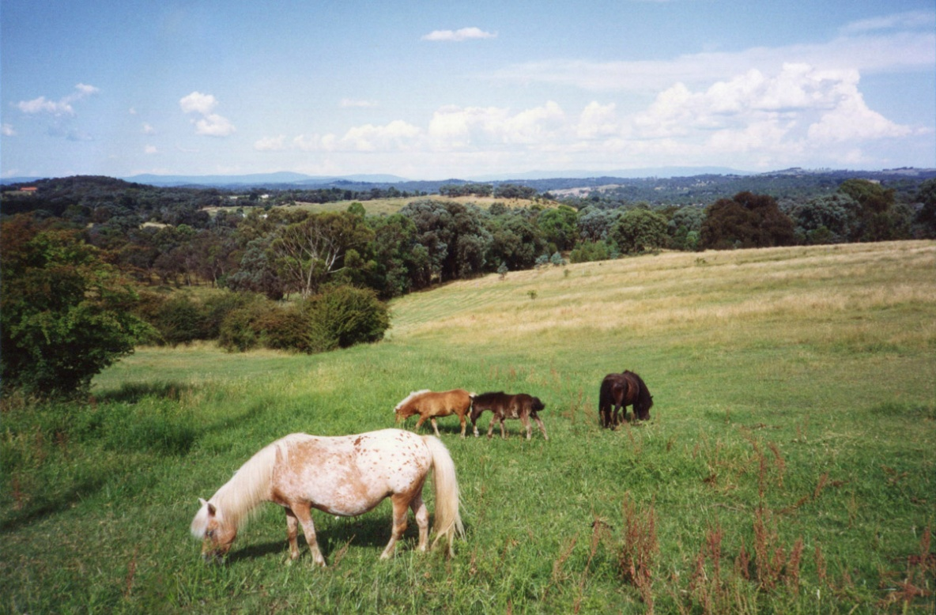

December 1992 view from Yan Yean Rd, Plenty, near the corner of Sutherland Rd, looking east toward Diamond Creek and Kangaroo Ground. Mr Edward’s miniature ponies in foreground. (Photo: G. M. Neumann).

Regarding the similar view from the Starling home ‘Hazeldene’, which was a little further north and more elevated, Isa Neumann wrote: “There was a lovely view from our home across to Kangaroo Grounds and Doncaster, where there was a tower which we could see on sunny days.” (Neumann, 1979). (The observation tower at Doncaster was 285 feet or 87m high, built in 1879 and popular with sight-seers, until it was dismantled in 1914 due to safety concerns).

Not far from where the above photo was taken, there was, until 2014, the cement-rendered brick dome of an old well, on the eastern side of Yan Yean Rd, half way between Sutherland Rd and Mackelroy Rd. On trips to Yarrambat, this landmark would be pointed out as the place where Ida (‘Dot’) Starling lived, after marrying Francis McLaughlin (in 1907).

Their daughter Vida Mclaughlin (b 1908) married Ray Stuchbery and lived near the Plenty river at Yarrambat, in the Stuchbery homestead, which was built in the 1880’s. The frame consisted of bush timber nailed together, with walls made from local stone and clay packed between boards until the clay had set (Hooper, 1978, p 70). Ray and Vida’s son Walter was born and raised there and Vida’s mother Dot later lived there also.

Walter Stuchbery married Violet Upton and built a house nearby, where they raised their children, Carol and Rosalie, while running the farm with Vida. Walter was also Yarrambat Postmaster and headed the local fire brigade. Walter’s extensive model railways fascinated young visitors and grew into a museum run by the Stuchbery family, who also helped restore and run full-size steam trains.

Isa Neumann and her sister Mary Harris regularly enjoyed visiting the Stuchbery’s at their farm in Yarrambat, as did many others, including my family, admiring the countryside along the way, especially the view in the above photo.

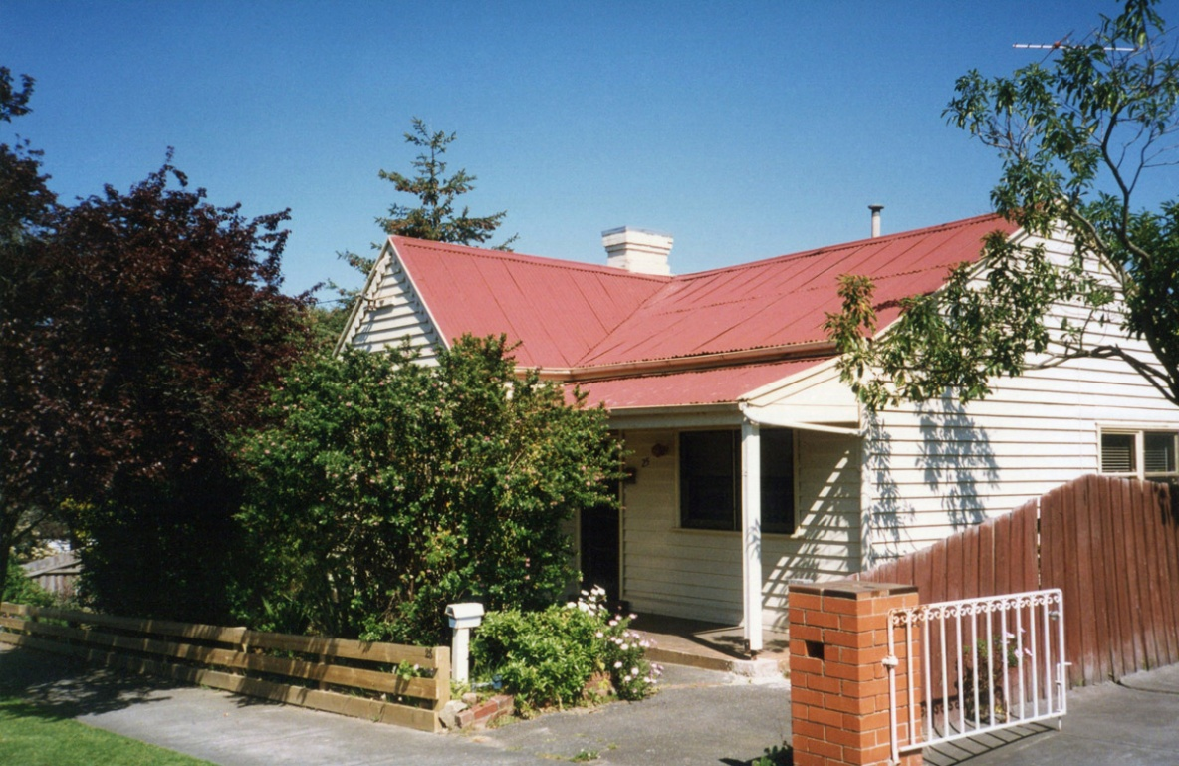

House at 25 Collins St, Diamond Creek, in September 1995, built by Mr. Percy Collins in the 1890s and home to David and Gertrude Iredale and family in the early 1900s. (Photo: G. M. Neumann).

Dave Iredale married Gert Starling in 1909 and from about 1916 they lived at 25 Collins St, Diamond Creek. They had six children: Margaret (b 1909), Alec (b 1912), Dulcie (b 1914), Ronald (b 1916), Norman (b 1920) and Victor (b 1923). The family later moved to Preston.

At Diamond Creek, Alec delivered bread from the nearby bakery, while Ron and Norman delivered milk from the Dairy, which was a few doors further up Collins St, on the corner of Clyde St. They carried milk and cream on their bicycles to Plenty Store to fill a row of waiting billies left there by customers, then loaded up again and made deliveries around Diamond Creek.

Further down Collins St, on the corner of Main St, was the Diamond Creek Literary Institute Hall, a wooden building completed in 1905 and incorporating an earlier hall dating from the 1870s. The Hall gave its name to the hill on which it stood: ‘Institute Hill’, and was a popular place for social events such as weddings and dances, until it was destroyed in the 1969 bushfires (Edwards, 1969, p 53). Fortunately, many of the numerous older homes in Collins St and elsewhere in Diamond Creek were saved.

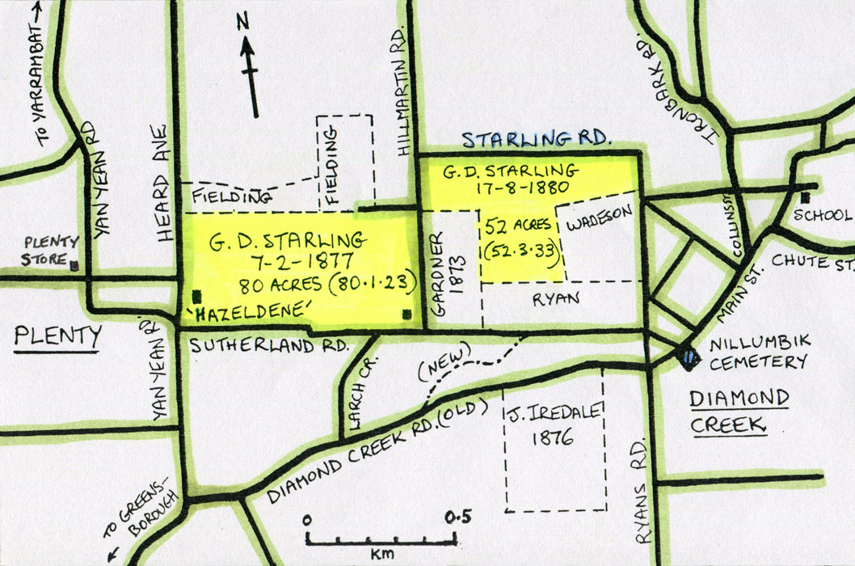

Map of land in the Diamond Creek area owned by George Durrant Starling and George Davey Starling Junior, based on an early survey map of Nillumbik.

The Starling homestead was built by George Durrant Starling in about 1870 on 80 acres selected in Dec 1866 (title obtained 1877) and was originally known as ‘The Firs’ (‘Hazeldene’ by 1918, see map above). George’s grandson, George Davey Starling Jr and family initially lived at the eastern end of this property, on the corner of Sutherland Rd and Hillmartin Rd (see map).

An additional 52 acres of land on the south side of Starling Rd (evidently named after the family) was purchased in 1880 for orchards: apple, pear, gooseberry and stone fruits. This helped support the family, including George’s elderly grandparents.

George Durrant Starling died in 1888, aged 83 and Clementia in 1890, also aged 83.

Around that time, George Davey Starling Jr built a wooden house adjoining the old adobe homestead at ‘The Firs’ and the Starling family moved up the hill to their new home, where four more children were born and grew up. The two youngest, Isa and Esther, were in their early twenties and helping Fred with the farm when their mother Margaret died in 1920.

In May 1921, George Davey Starling decided to retire and return to Norfolk to live, so he travelled by ship back to England, intending to live with the Norfolk Starlings. However, six months later, with winter approaching, he decided the climate was too harsh for him and so returned home to Australia. Then in 1925, at the age of 78, he married Clair Wainman and built a new house in Larch Crescent, Plenty and lived there until he died in 1938 (age 91). This led to the homestead and properties passing out of the Starling family’s hands.

George was buried in Diamond Creek (Nillumbik) Cemetery, with his great-grandparents and his wife Margaret and daughter Blanche (d 1890, age 10). Beside them rest Margaret’s sister Jane (‘Jinny’) and brother David Stewart and their parents Alexander and Mary-Jane Stewart (see following pages).

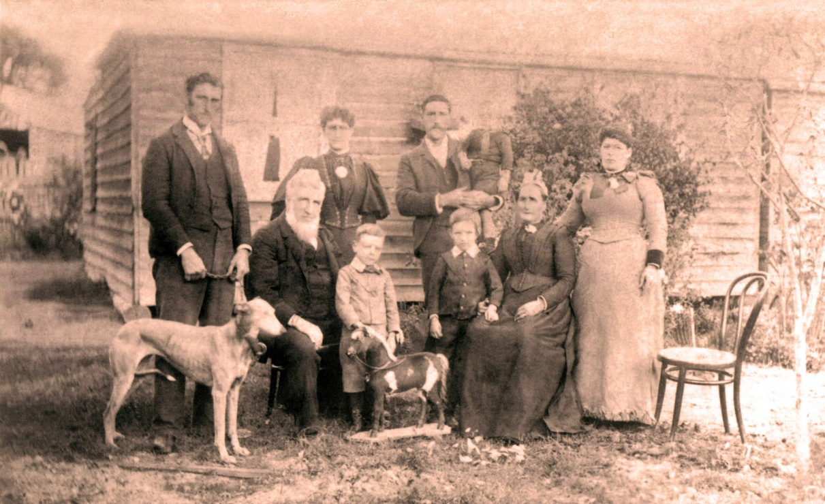

Alexander and Mary-Jane Stewart and family in about 1895, at the home of their son, Robert Stewart, in Pioneer Rd, Tanck’s Corner (Yarrambat).

Left to right, back row: David, Jaen (Jane, ‘Jinny’) and Robert Stewart, holding nephew Allan Hewitt (b 1892); front row: Alexander Stewart (seated) with grandson’s Murdoch Hewitt (b 1889) and Alec Bayliss (b 1889), Mary-Jane Stewart (seated) and Elizabeth Hewitt (nee Stewart).

Alec’s mother was Barbara Bayliss (nee Stewart), who had died a few years earlier. Elizabeth’s husband was Jonathan Hewitt. The Hewitt’s lived on the Hurstbridge Rd at Diamond Creek. (Photo: R. M. Neumann).

Alexander Stewart, the son of John & Margaret Stewart (nee Robertson) from Edinburgh, married Mary-Jane Short in 1854. They had nine children: Margaret Anne (b 1855 Aug 28), Mary Jane (b 1857), Barbara (b 1858), John (b 1860), Elizabeth (b 1862), Jane Forsythe (b 1865), James (b 1866), David (b 1868) and Robert Alexander (b 1870).

Initially the Stewart family lived at Yan Yean and Morang (Mernda), then later at Janefield and Greensborough (see p 16 for details). By that time the family attended the Presbyterian Church in Plenty Rd, Janefield (built 1861). Alex Stewart served as a Presbyterian Elder.

In the early 1870s, the family moved from Greensborough to Tanck’s Corner (Yarrambat), where they lived in a ‘wattle and daub’ cottage in the middle of their property, on a small hill. The homestead was named ‘Lothian Hills’, after the hills of Lothian in Alex Stewart’s home country, near Edinburgh, Scotland.

Nearby was Robert Stewart’s wooden house, as seen in the above photo, on an adjoining property in Pioneer Rd (140 Pioneer Rd, see map, p 16). Robert Stewart married Lilian Laslett in 1905 and they lived in this house with their two children Eva and Archie, who attended Yarrambat School.

In about 1948, this house and 60 acres, including apple and pear orchards, as well as the original Stewart family cottage at the back of the property, were purchased by the newly-married Mr. and Mrs. Bill Hackett, who added more rooms and raised their family there, at 140 Pioneer Rd (see following map, p 16).

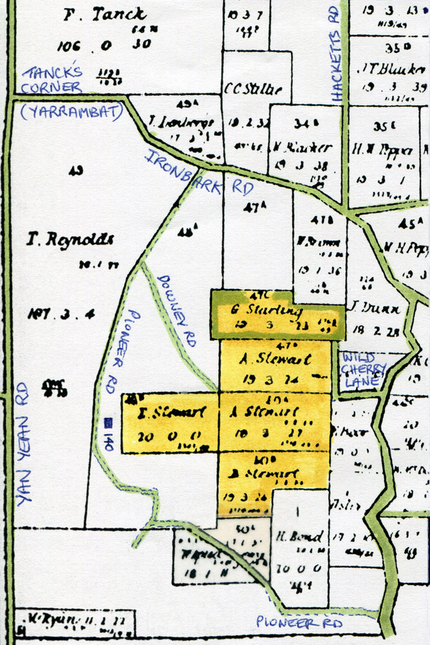

1893 survey map of land in the Tanck’s Corner (Yarrambat) area owned by Alexander and Mary-Jane Stewart (nee Short), their daughters Barbara and Elizabeth (later by their son Robert), and George Davey Starling Jr, who married Margaret Stewart in 1877. The Stewart family lived at the end of Downey Rd, with access originally from Wild Cherry Lane, before Pioneer Rd was made.

Mary-Jane Short was from a farm in Northern Ireland, near Newry, County Armagh. At 20 years of age, she travelled to Melbourne on the ship ‘Charles’, arriving in Oct 1853. According to her granddaughter Isa, Mary-Jane’s younger sister Margaret had run away with the horse groom and then got married (when barely old enough). The parents blamed Mary-Jane, that she knew what was going on and hadn’t told them. So when the sister and her husband (Thomas Sleeth) decided to leave Ireland and come to Australia, Mary-Jane came with them.

Mary-Jane Short married Alexander Stewart, from Edinburgh, Scotland, on 16th November 1854, at Morang (Mernda). Their first child Margaret was born in 1855 at Yan Yean (‘Plenty’), where Alexander worked on construction of the Yan Yean Reservoir, completed in 1857. Alexander then took up farming at Morang (Mernda) and in the mid-1860’s the family were living at Janefield, then moved to Greensborough. By 1868 the Stewart family were living near the sand quarry on Sand Hill (Flintoff’s Hill), the high hill north of Greensborough township. By 1874 they had moved to Tanck’s Corner (Yarrambat).

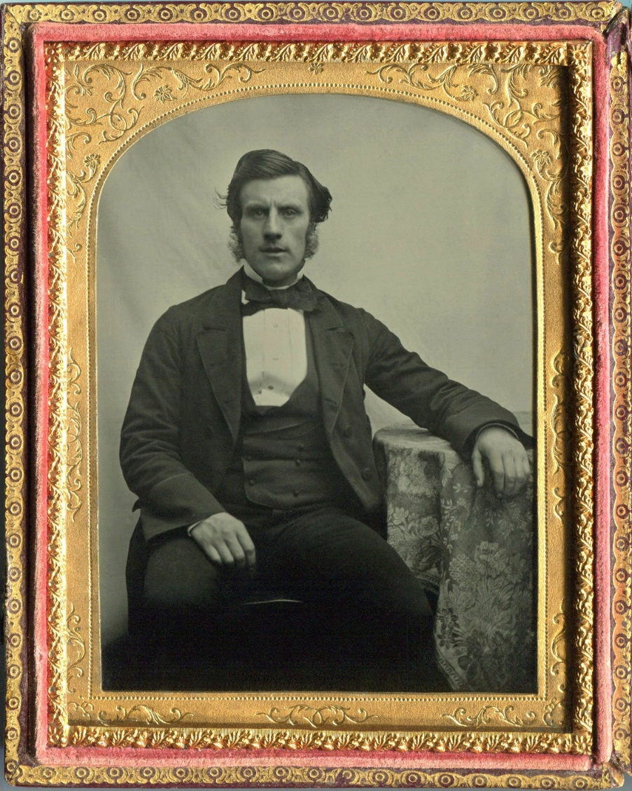

Alexander Stewart, in Melbourne, mid-to-late 1850’s. Glass-plate ambrotype or collodion positive image (digitally reversed to produce a non-mirror image). From the estate of Isa Neumann (nee Starling).

This treasured photo-portrait of Alexander Stewart, Isa Neumann’s grandfather, was passed down to Isa from her mother, Margaret (Alex's eldest child) and subsequently passed down to my father from his mother (Isa).

Alexander Stewart was from Edinburgh, Scotland and arrived in Melbourne in 1852 (probably Sep 1852, on the ship ‘Marco Polo’). The collodion photographic process was invented the previous year.

Ambrotypes or collodion positives are thought to have been introduced to Melbourne in early 1854 by Thomas Glaister, who set up a studio for Meade Bros at 5 Great Collins St, then moved to Sydney in April 1855. So 1854 is probably the earliest the above portrait could have been made in Melbourne.

The ambrotype above consists of a glass plate (‘quarter plate’ size) with black laquer on the back and the collodion photo-image on the front, protected by a glass plate front cover and with a brass mat in between. This assembly is encased in a gold-plated brass ‘preserver’ and mounted in an embossed, leather-covered wooden case that opens like a book. The designs on the case, elliptical brass mat and preserver are consistent with the mid-to-late 1850s, as are the clothing, hair-style and apparent age of the subject.

Alex Stewart was married on 16th November 1854 (age 27) and it is possible the ambrotype was made around that time, or perhaps later.

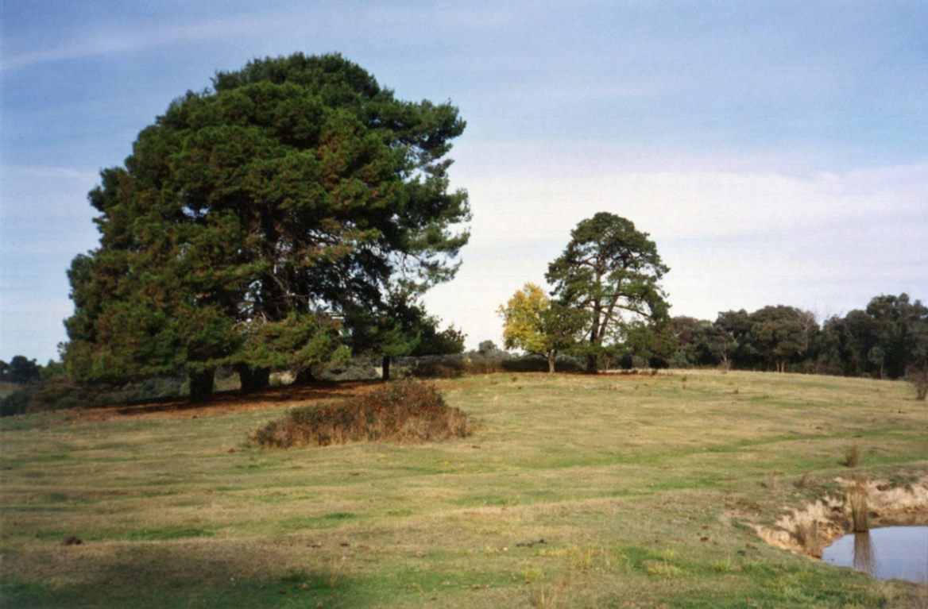

May 1993 view from the end of Downey Rd, off Pioneer Rd, Yarrambat, looking at the site of the Stewart family’s pioneer cottage, now grazing land for cattle. (Photo: G. M. Neumann).

The Stewart family cottage was built in the 1870s using a frame of wattle saplings packed with mud (‘wattle and daub’). The walls were papered inside with old newspapers dated in the 1860s and the roof was originally of wooden shingles, later covered with galvanised iron from Scotland (Hooper, 1978, p 71).

Alex Stewart died in 1900, age 73, when granddaughter Isa Starling was about 5 years old. When Isa was older (about 10), she and her sister Mary liked to walk across the fields to visit their grandmother, Mary-Jane, in her old cottage. Sometimes they would stay there on Saturday night and come home on Sunday.

Mary-Jane Stewart passed away at Diamond Creek in 1913, age 81. The Stewart cottage was then looked after by Robert Stewart and family, and after that by the Hackett family, from about 1948. Eventually the old cottage was blown over by a severe storm in the mid 1950s, having stood for about 80 years. The site is marked by elms and shady pine trees, which include several Scots pines that may have come from trees originally planted by the Stewarts.

This particular location can be seen from the opposite side of the hill, when travelling from Diamond Creek to Yarrambat along Ironbark Rd, on the left, between Murray Rd and Wild Cherry Lane (see map, p 16).

In years gone by, my grandmother, father and others who knew about the Stewart family, liked to stop along the way to view this location and think about the lives of the Stewarts and Starlings and other pioneering families of the district who were here before us.

Selected Bibliography & References (with Internet Links):

Argus Newspaper, Melbourne, Vic, 1848-1957. (https://trove.nla.gov.au/)

Bailliere, F F. (1868-1881). Official Post Office Directory of Victoria, (‘Post Office Towns’ section), Melb, Vic.

Durance, Jillian. (2016). One of the Most Reliable and Courageous Men, in ‘Fine Spirit and Pluck: World War One Stories from Banyule, Nillumbik and Whittlesea’, Yarra Plenty Regional Library, Melb, Vic.

(https://wikinorthia.net.au/one-of-the-most-reliable-and-courageous-men/)

Edwards, Dianne H. (1979). The Diamond Valley Story, Shire of Diamond Valley, Melb, Vic.

Hooper, Eileen. (1978). History of Yarrambat (Tanck’s Corner) School, 1878-1978, Yarrambat Primary School, Melb, Vic.

Jones, Lewis and Jones, Peggy. (1990). Flour Mills of Victoria: 1840-1990 - A Historical Record, Flour Millers Council of Victoria, Melb, Vic.

Kenna, Len. (1988). In the Beginning there was only the Land (History of Bundoora), Lions Club of Bundoora, Melb, Vic.

Neumann, Isa R. (1979). Looking Back (Recollections of life in the Plenty area in the early 1900s), in ‘Plenty News & Views’, Vol 1, No 2 Feb 2003 & No 3 May 2003, Plenty Historical Society, Melb, Vic.

Neville, Jonathan. (2014). Norfolk Mills, UK (http://www.norfolkmills.co.uk)

(http://www.norfolkmills.co.uk/Windmills/hemsby-towermill.html)

(http://www.norfolkmills.co.uk/Windmills/winterton-postmill.html)

Payne, John W. (1975). The Plenty. A Centenary History of the Whittlesea Shire, John W Lowden Publ Co, Kilmore, Vic.

Victorian Parliament. (1867). Claim of Mr A Willis. Report of the Board of Land and Works (June 1866 enquiry), Victorian Parliamentary Papers, 1867, Melb, Vic.

(https://www.parliament.vic.gov.au/papers/govpub/VPARL1867No77.pdf)

Victorian Pioneers Index, 1837-1888. (1994). Royal Melbourne Institute of Technology and Victorian Registry of Births, Deaths & Marriages, Melb, Vic.

(https://www.bdm.vic.gov.au/research-and-family-history)

Vines, Gary*. (2017). Mills of the Plenty, 19th Australasian Engineering Heritage Conference, Mildura, Vic. *(La Trobe University, Dept of Archaeology).

(https://www.researchgate.net/publication/322737311_Mills_of_the_Plenty)

Wuchatsch, Robert and Hawke, Gwen. (1988). Historic Views of the City of Whittlesea, Whittlesea Historical Society, Epping, Vic.