**GETTING IT RIGHT – WRITING FAMILY HISTORY**

*Sue Ballantyne 2022*

*We* can find interesting information on genealogy and hints on researching and writing family history in magazines. I have used some of the ideas found in these articles from Ancestor and *The Genealogist* in my own family history research and writing.

*Article 1:*

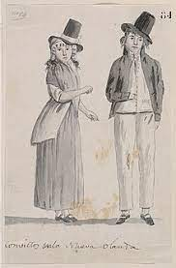**Hobson, John. How information is not always what it seems. *The Genealogist* June 2014, p17.**

The premise of the article is that information on BDM certificates is not always as it seems – in this article, the author finds that his paternal great grandfather’s death certificate claims he was born in Staffordshire, England and had been in Victoria for 24 years, married in Geelong aged 44 and had 7 children, 2 of whom predeceased him. His wife was the informant on the death certificate, so you’d think she would be a reliable source.

Further research revealed that great grandpa, also John Hobson, was convicted in Chester, England, in 1829 and sentenced to 14 years transportation, arriving in Tasmania in 1830. He received a conditional pardon in 1841 and a Free Certificate in 1843. He arrived in Victoria about 1847.

The writer goes on to mention his paternal great grandmother Ann Baynton, widowed with 2 children before marrying great grandpa John. There is no official record of this previous marriage. The author calls it a “personal arrangement” – in those days, a common law marriage?

Let’s look at the “CONVICT” first.

The “shame” of being a convict was very real in those times. How times have changed and we now relish finding a convict in the branches of our family tree.

During the Covid lockdowns in 2020 and 21, I filled some of my time looking at my husband’s Ballantyne ancestors, which his father had started in the early 1980s and our niece had continued before she had her family. So, I didn’t have to start from scratch – and was rewarded early on with a convict or 2! And an early family who were quite free and easy with the use of names.

Anne Birnes was born about 1809 in Queens County Ireland (now renamed County **Laois,** pronounced Leesh). A baptism record for an Ann Bern (father James Bern, mother Anne Callan) is recorded at Salterstown County Louth on 05/05/1809.

She married Anthony Carroll, although I am not able to find a record of this. (There is a record of an Anthony Carroll marrying an Ann Cullen on 03/08/1837 in Galway, but cannot confirm that this is our Ann. However, considering other name changes, it is possible this is our Ann using her mother’s maiden name. A mystery! Ann and Anthony had 3 children: Ann (1832-1897), Anthony (1838-?) and Henry (1839-?)

It appears that husband Anthony died in about 1844. In 1848, Ann Birnes was prosecuted for sheep stealing. She had one prior conviction for stealing potatoes. (Feeding her family??) She was transported to Van Diemen’s Land for 10 years. We have some idea of what Ann looked like from 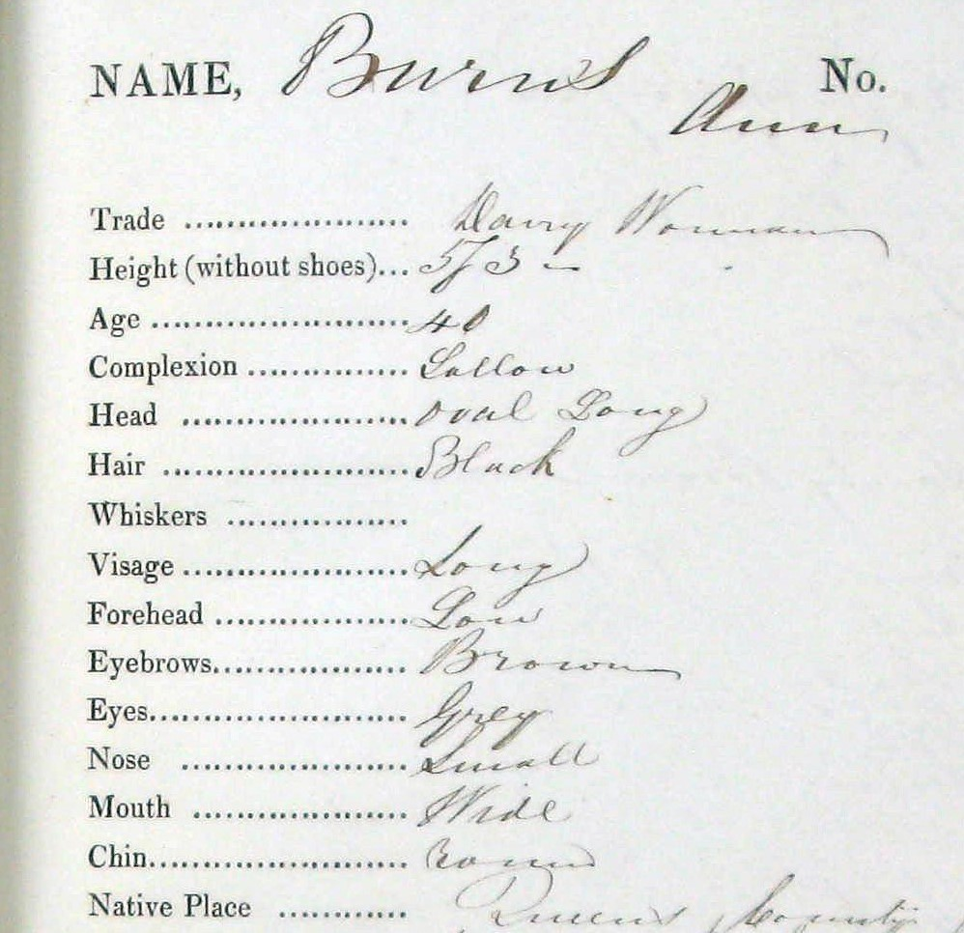her convict muster description:

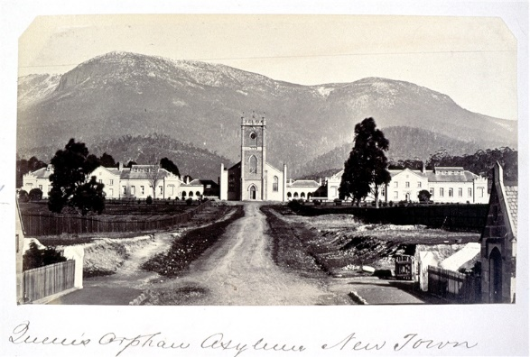Ann’s 3 Carroll children accompanied her to Australia on the *Maria II*. They were sent to the Queen’s Orphan School Hobart. Records for this school are online.

Eventually the children were discharged to employers. The daughter Ann Carroll also married a former convict, Charles Ainsworth, who promptly left her to seek his fortune on the Victorian goldfields. Her 2nd marriage was to James Ballantyne, although she used her mother’s name Ann Birnes, on this marriage as her first husband was still alive.

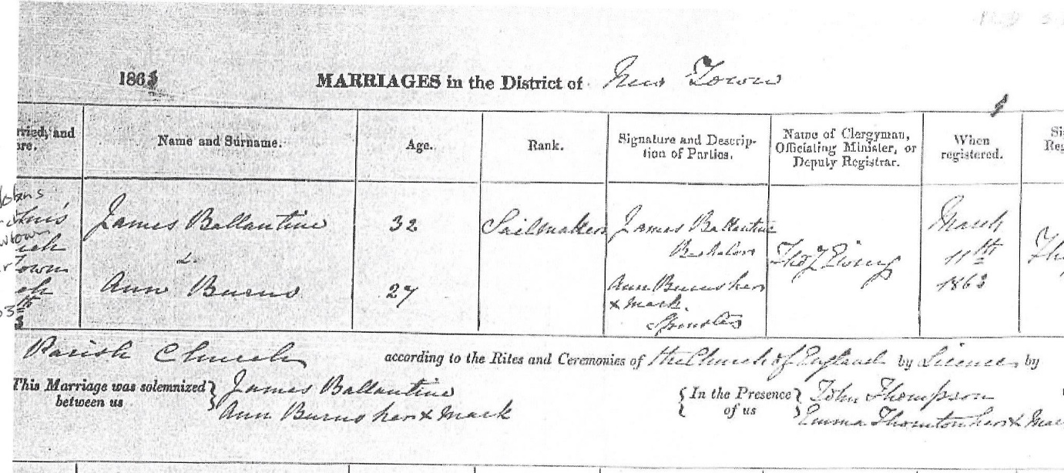

Interesting that Ann and James officially ‘married’ even though she was still married to the absent Charles Ainsworth.

**SURPRISES IN A BDM CERTIFICATE**

But back to common law marriages or as Hobson says “personal arrangements”. A common law marriage is described as a relationship between two people who decide to cohabitate and present themselves as a married couple without the benefit of a legal ceremony and marriage certificate.

My own great grandmother, Mary Ellen Wilde, from age 17 was known as Mrs Slocombe. Born in 1883, she “married” Henry Victor Slocombe, known as Harry, in 1900 and my grandfather John was born in 1901.

I have been researching my family for close to 40 years, on and off. My first look was in about 1986 when I was studying at university. One subject gave us about 12 weeks to find information on an ancestor using Birth, Death and Marriage certificates. Nothing online in those days, you applied to BDM, paid your money, and waited up to 6 weeks for your certificates to arrive in the mail. But time was short and my mother offered me some family documents she had, that had belonged to her grandmother – Mary Ellen. Nana’s copy was blotchy but clearly stated she was 21 and Henry 27 when 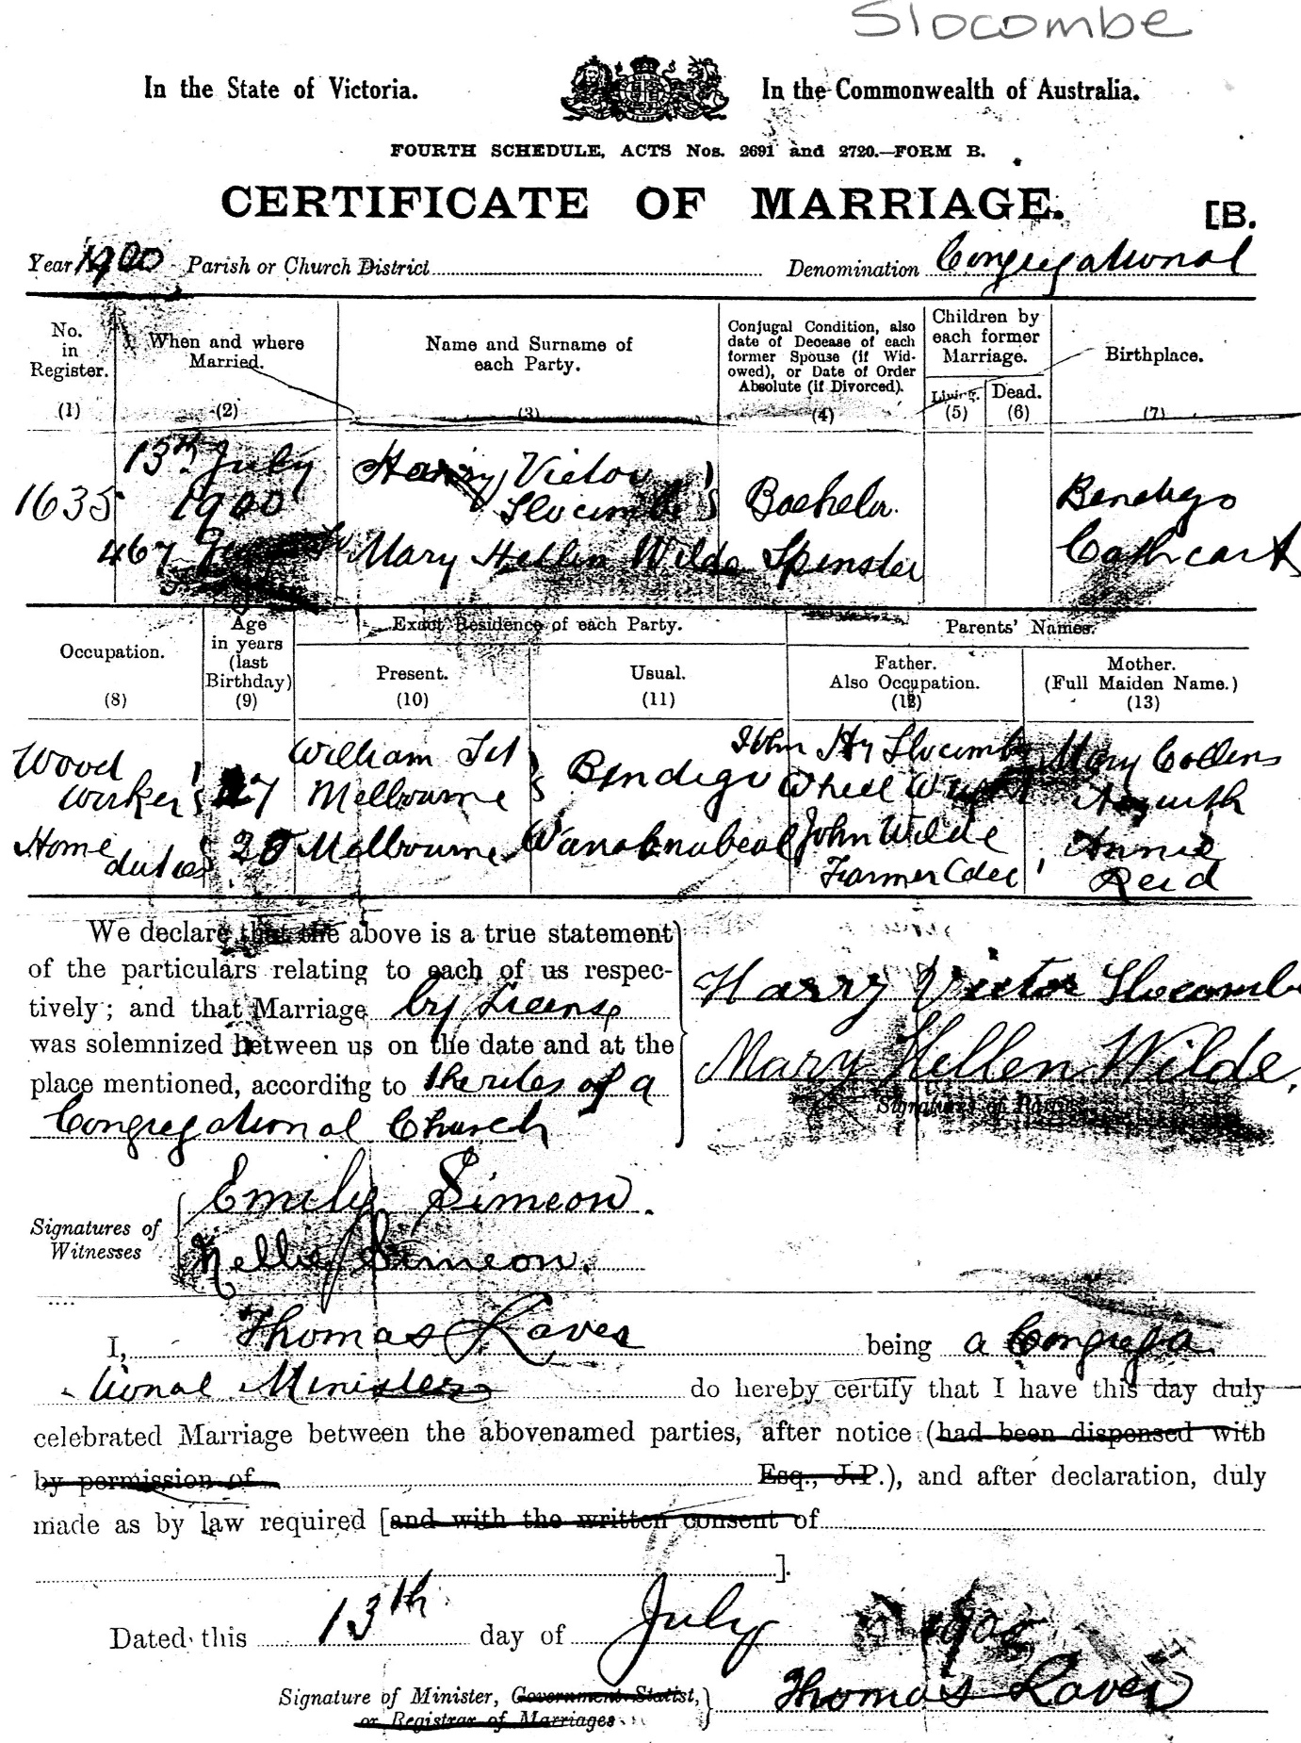they married in 1900.

The copy I eventually received from BDM Vic was clear with a marriage date of 1920. By the time I received this certificate, Nana had been dead for 20 years but her 2 surviving children and 2 grand daughters were horrified! It all made for a very interesting project for Uni, and I have been trying to put it into context ever since.

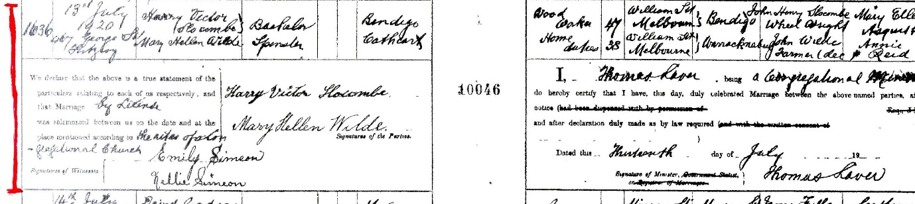

*Article 2:*

**Barlow, Bill. Writing family history or making it up? *Ancestor.* Vol 32 Issue 2 June 2014**

Bill Barlow opens with “Are our family histories interesting to read? What if our family is not interesting?”

He goes on to say: “We should include historical background, add colour, use story telling techniques”.

“It is just a life. It starts. It goes on and it ends.” “Like a story, it has a beginning, a middle and an end”.

Avoid a catalogue of events. Selection of facts and insights are the writer’s most important contribution.

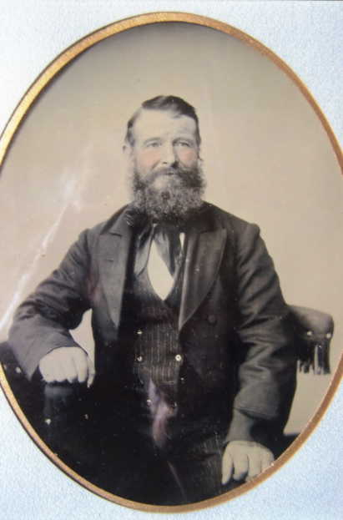**Emmanuel Wilde** 1822-1904 (my 3 x great grandfather) was the first of the clan to migrate to Australia. His obituary, published in the Ararat Advertiser in 1904 tells his life story in detail; a transcript is held at the Ararat Genealogical Society. He and wife Sarah had 8 children, and 95 descendants (grandchildren and great grandchildren) at the time of his death.

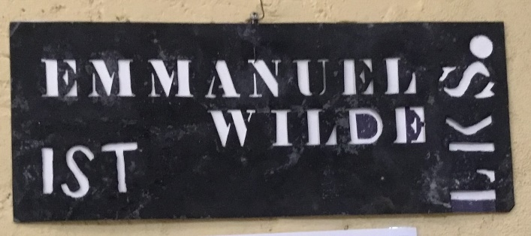Emanuel’s life story was published in the *Ararat Advertiser* following his death in 1904, and tells the story of his application to be an assisted emigrant: Twice he and Sarah applied and twice were rejected. There was no use for factory workers in the colonies. During his third application, he heard the man in front say he was a farmer and was immediately accepted. Good enough for Emanuel and Sarah – they too became farmers and were off to Port Phillip. They became successful pioneers in the Wimmera district of Victoria.

Wool bale stencil. From the collection of the Langi Morgala Museum, Ararat.

Emmanuel Wilde. Photo from the Langi Morgala Museum, Ararat.

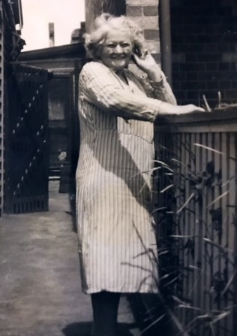**The first selection of facts is what is recorded – BDM, electoral rolls etc**.

Electoral Rolls show that Mary Ellen spent over 40 years at one address, except for a few years in the late 1920s.

Photo left: Mary chatting over the fence at 24 Park Street, North Fitzroy.

She and her family lived in this house from the 1920s until 1967, when she moved with my parents to their first home in Preston. I was 14 when she died in 1968.

**Add some handed down stories to give interest and colour to your story**… Back to my Nana Mary Ellen, but this time when she was a young girl.

She often told us of her step-mother Hannah Brown, who married Mary’s father less than a year after the death of his first wife Annie Reid, leaving him with 12 children. Nana was age 11, child #7 and 4th daughter when her mother died. Her brother Benjamin was 7 years younger.

Did Hannah cope with her ready-made family of Annie’s children? Mary Ellen told a story of her “wicked” step-mother – that’s how she referred to Hannah Brown – when Hannah “beat” little Ben for some misdemeanour. Mary intervened and chased Hannah with a bullwhip, threatening to give her (Hannah) what she had given Ben. How I would love to have been there to see the consequences of this. Mary never did tell what happened next… Was it a true story? I don’t know but it makes the idea of a ‘wicked stepmother’ quite appealing in the story of Nana’s life and a reason why she fought to keep my mother (her granddaughter) with her when my grandfather remarried.

After adding a further 5 children to the family in just over 5 years, Hannah died in 1901, a result of childbirth. The Coroner’s Report into her death was reported in the *Horsham Times* newspaper and found on Trove, and tells a sad story of neglect and hardship. But Mary Ellen was in Melbourne by then, starting her own family with Harry Slocombe. She lived with her sister Alice Reed, who was one year older than Mary. My grandfather John was born at the Reed home.

**When making it up sounds good, but the facts tell a different story.**

I’d like to show you a short piece I wrote in 2017 when I completed a subject at the University of Tasmania titled “*Writing Family History.’* Over 3 months we had to write 4 short pieces about a person in our family tree. This is about my great grandfather Harry Slocombe, Mary Ellen’s husband. Family legend had it that Harry was away working as an itinerant worker or swaggie for at least 4 years after the death of his daughter Muriel in 1924.

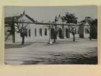The story takes place at the Ovens Valley Hospital in Beechworth (fiction) …

Ovens district hospital c1914 _slv-pic-aab47974

1928 - When Harry awoke, he was confused. The room had many beds and the beds had sheets. It certainly wasn’t the workers’ hut on the farm.

It made him think of home, of his wife Mary and his daughter Muriel, sitting around the kitchen table, talking and laughing.

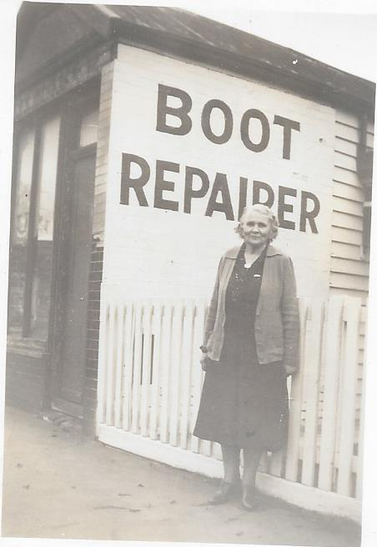It was a happy home, tucked behind the bootmaker’s shop. Big enough for their family, close to the shops and opposite the station. The kitchen was always warm and friendly, with Mary cooking for their brood, or doing laundry in the little wash-house off to the side.

Times were tough, money was tight, but they managed until Muriel became ill. After her death at just 22, things were never the same at home and Harry decided to go ‘on the road’, finding work where he could. Four long years humping his swag through Victoria’s central districts until he came to Beechworth just three weeks ago.

Farm work was hard, especially in the summer heat. The city had softened Harry - it was hardly an escape to the country. He thought about his kids and wondered what they were doing. He thought of Mary and hoped she was managing … perhaps it was time to go back.

Mary outside 24 Park Street, North Fitzroy

He was jolted from his reverie by a nurse, fussing and bossy.

Harry was in the Ovens Valley Hospital after collapsing at work on the farm. He died a few weeks later, alone and lost to his family.

Harry’s surname was misspelt on his death certificate and it took nearly 90 years to track him down. Harry Slocombe is buried in an unmarked grave at Beechworth Cemetery.

** Harry’s demise was nothing like my romanticised version. In 2021, I found the coroner’s report of his death online and with it, reports from the medical officers at Ovens Valley Hospital. It told a very different story to that I had heard from his children, my great aunt and uncle – that he abandoned Nana and left her to manage on her own.

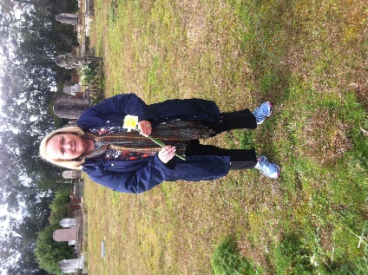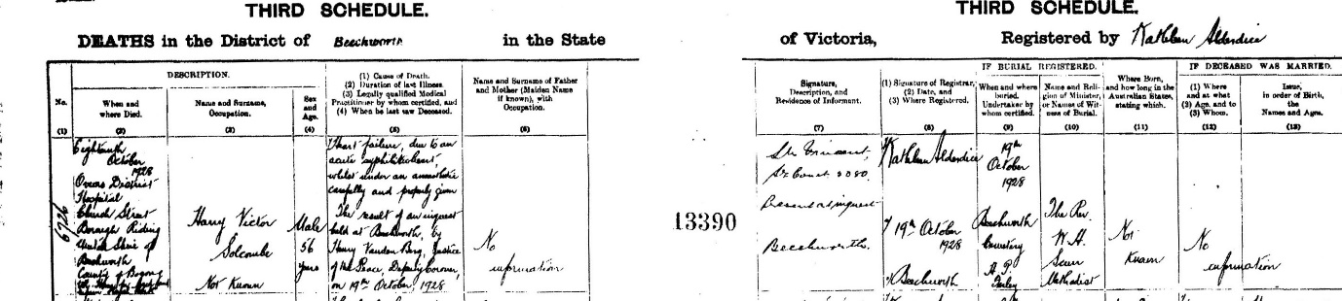Fact: he was in Beechworth for less than 3 weeks, having been in Melbourne Hospital for 5 weeks and before that in the Hospital for the Aged and Infirm at Royal Park for up to 5 years.

Death certificate for Harry Victor Solcombe (surname misspelled)

We visited Beechworth Cemetery in 2016 and found the approximate site of his burial.

As I write my version of our family history, I need to keep in mind that other family members might read it one day, and might not agree with my 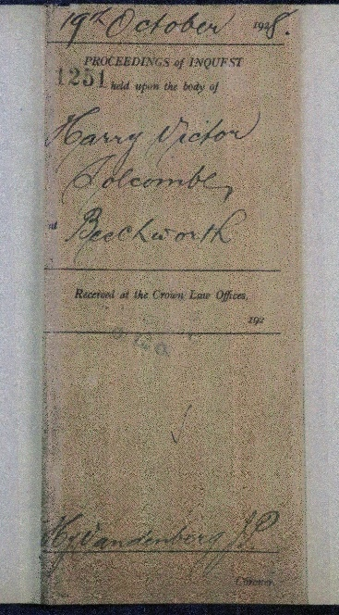interpretation of events. All I can do is collect what facts I can find and interpret them as best I can. … And rewrite when I find additional information.

How lucky are we to be tracing our family tree in the digital age? If I want a certificate, I can have it in my inbox within a few minutes. I can find a will or a coroner’s report through PROV and again save it to my laptop. I can search for family members via TROVE and find newspaper articles, police reports, personal notices. Or search the National Archives of Australia. Ancestry is another great source, but double check anything from another person’s tree.

Never take anything at face value though, and be prepared to correct mistakes once you find them – cross checking and rewriting are all part of the journey to trace your family tree.

Cover of Harry's Inquest report. His name is spelled correctly on 2 of the 4 documents inside. Downloaded from PROV.

*Article 3:*

**Beaumont, Barbara. What is good family history writing? *Ancestor.* Vol 32 Issue 5 Sept 2015.**

Beaumont’s article asks a few questions for us to think about:

* What to do with a huge amount of information?
* Facts and figures – mainly we have BDMs and electoral rolls – what do they tell us?
* Historical/social context – What is relevant to our ancestors? (Avoid writing a lot of history if it is not relevant to your ancestor)
* Who are we writing for? Our children and grandchildren, extended family or the public?

I am writing for:



* Her advice is to interview older members of the family – but what if you are the older member?
* How do we handle sensitive information? Is it a fact? I say include it.
* Are you lucky enough to have letters, diaries, newspaper articles? Or even a mention in a biographical dictionary (many of these bio dictionaries are online now)

Beaumont admits it is difficult to get started:

“Our family’s story is unique and deserves to be written. If we don’t do it, it may be lost forever.”

Once started, it’s also hard to know where to go next!

You can’t really find everyone on your tree, it’s an overwhelming task.

Be selective, start with what you (think) you know, and be prepared to be surprised!

Look at a family tree and see just how complex it can be (include genealogical charts where it helps to clarify relationships). This is just MY side of our family tree; the Ballantyne side is equally as big:



For my own family history research, I have concentrated on the Australian content, and that gives me at least 5 generations. For my husband’s side of our family, I have also gone back 5 generations.

I started with the “immigrants” (a lot of research) and worked my way to the present. The closer I get to the present the harder it is to write.

Beaumont goes on the suggest:

* Interview older members of the family – but what if you are the older member? I say start writing!
* How do we handle sensitive information? Is it a fact? I say include it.
* Are you lucky enough to have letters, diaries, newspaper articles? Or even a mention in a biographical dictionary (many of these bio dictionaries are online now)

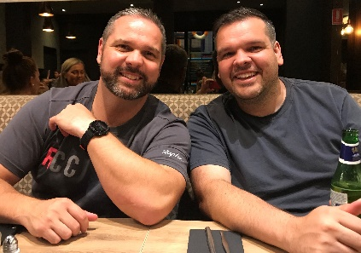Remember that I am writing for myself and also for my children and grandchildren. This is the third year that I told myself I’d publish the Ballantyne story to give my sons at Christmas… Maybe next year?

What do photos tell us? A look at this in detail another day, but here are 2 from our family:

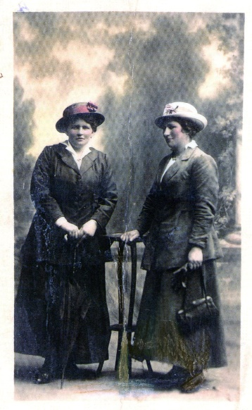

This is a studio photo of sisters Margaret (right) and Mary Ellen all dressed up for a day in town.

Legend has it that this photograph was taken to celebrate on the day Mag’s divorce came through in November 1917.

McGillivray family photo from *The Heritage of Lethbridge* by Eric A. McGillivray, 1996.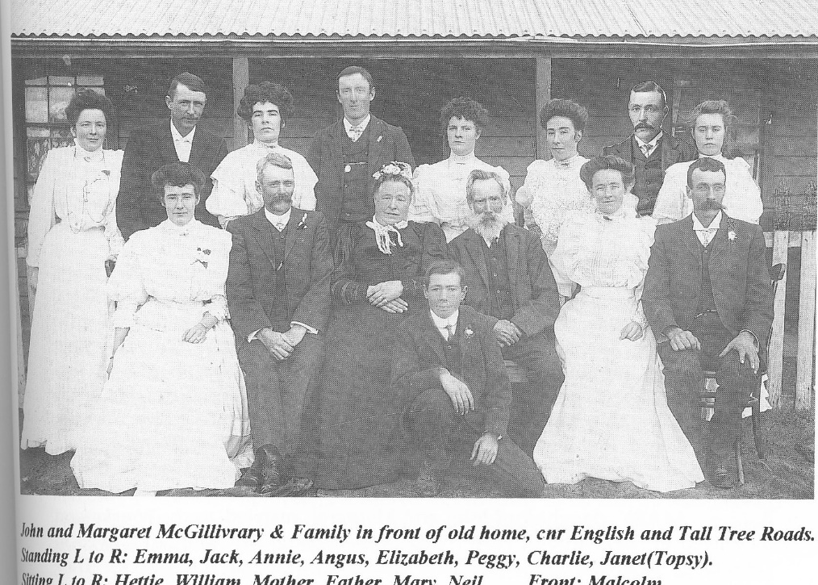

Reported to be a “Federation” photograph of James McGillivray and his family. (Ladies’ dress is consistent with this date)

Elizabeth (4th from left, back row) was my husband’s maternal grandmother. Note: son Charles (2nd from right back row) was absent on the day of photograph; his image has been cut and pasted – literally – into the group photo)

As Barbara Beaumont says:

“Perhaps the best gift we can give to future generations is to write our own memoirs.”

One day I will, but there’s plenty of history before I get to my story.