**YES – It DID snow in Greenhills!**

By Dawn Bennetts (nee Petts) – August 2024

*The area of ‘Greenhills’ has played a very important part in my life, because not only did I grow up there, but quite a number of family members also spent many years living in various properties in Greenhills. The following story shares some of the memories that my auntie Glenice Dyke (nee Bishop) has of growing up, which also includes time spent in Greenhills at three different properties*.

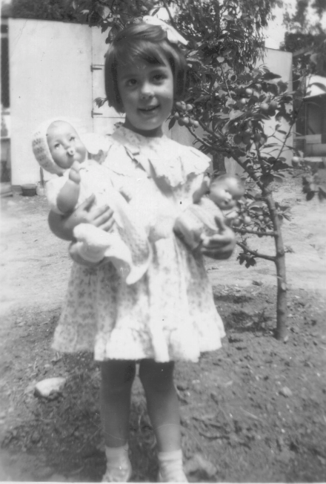Glenice’s story…. I was born in 1946, so unlike the rest of my family, I did not experience the really tough times of the depression in the 1930’s. I have wonderful memories of living in Greenhills for many years. Being the youngest of three children born to Ernest and Ada Myrtle Bishop, I had a very different childhood to that of my sister Norma, and brother Allan - who were 15 and 17 years older than me.

When I was born, the family was living at 30 Carnon Street Greensborough. They had previously lived for a few years at 61 Greenhills Road in the late 1930’s, and they eventually sold that house in 1949, to mum’s brother Hobart and his wife Olive. Our house in Carnon Street had been built in the late 1930’s by uncle Con, for my grandmother and her two daughters – Evelyn and Daphne. When grandma moved back to Northcote in the early 1940’s, mum and dad purchased the house for us to live in Greenhills once again. That house has now been replaced by three dwellings!

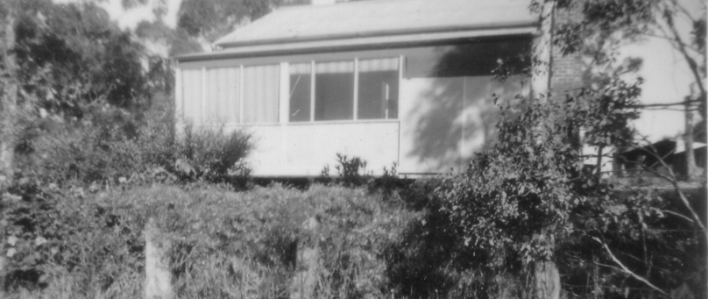

*30 Carnon Street, Greensborough c1950’s .... then around early 2000’s (below). The house had been extended and altered since Glenice lived there.*

*Glenice in the backyard at 30 Carnon Street, Greensborough*

*30 Carnon Street, Greensborough – 2021. Now there are three dwellings.*

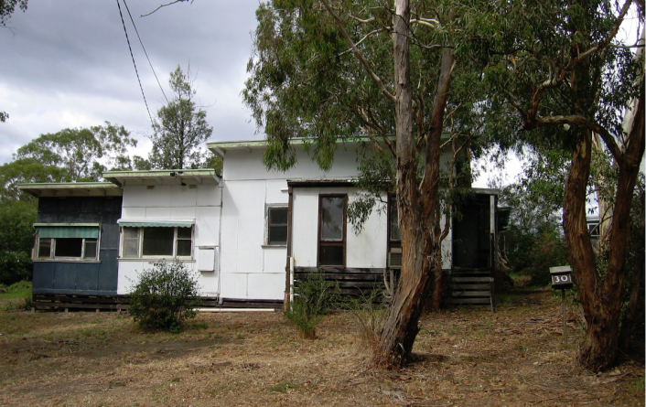

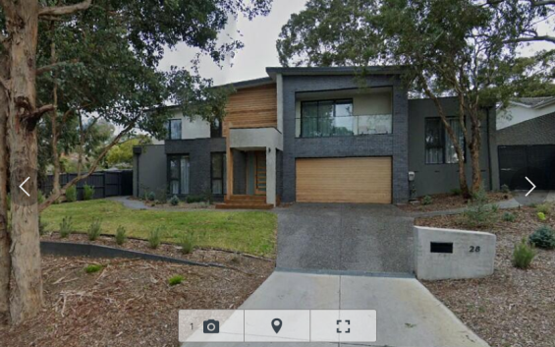

When I lived in the house in Carnon Street, there was a huge backyard with lots of gum trees, so I had lots of space to play, run around, ride my bicycles and have pets. We had an outside toilet then and water tanks. We also had a piano that Norma could play.

Dad was a plumber and we had several pens full of chooks in the backyard, which mum looked after and collected the eggs to sell to the Victorian Egg Board. Norma and Allan were working by the time I came along – so I had four grown up people to look after me.

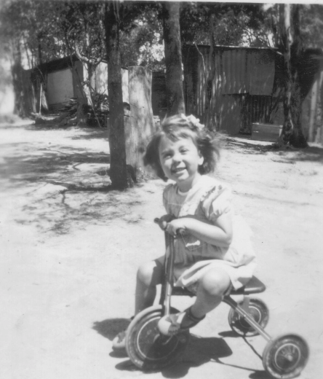

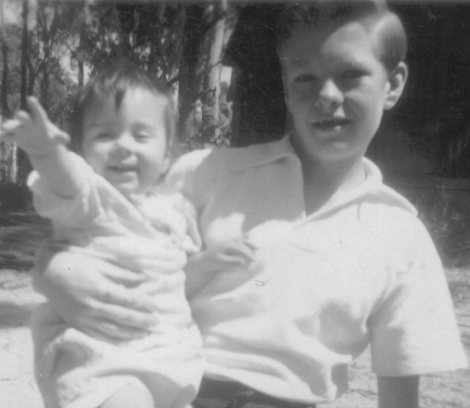

*Glenice with her brother Allan*

*Glenice at Carnon Street, around 1950*

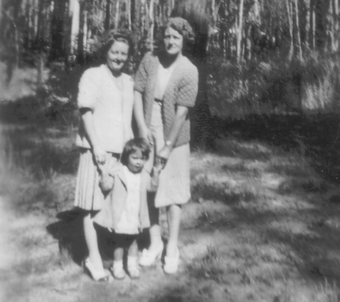

*Glenice with her mother Myrtle and sister, Norma.*

One of my first and very special memories of living in Greenhills, was when my uncle Ron (Bishop) came to visit us one day, and he said that he had something for me. In his pocket was the cutest, tiny little puppy! I called him Soxy. Uncle Ron lived nearby at Lot 7 Eltham Road, Briar Hill – now called 147 St Helena Road, Greensborough.

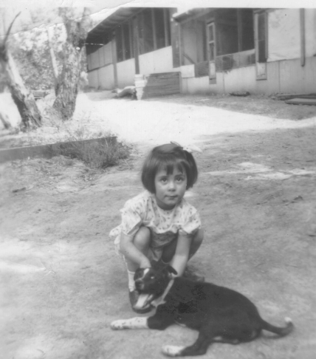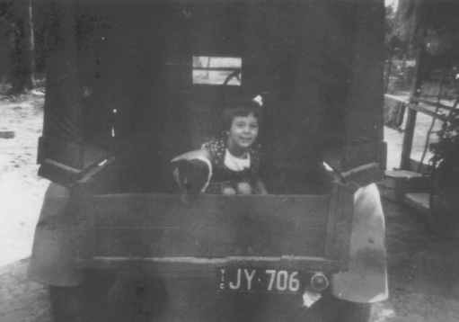

*Glenice in the back of Allan’s ‘Singer’ car, with her dog Soxy.*

*Glenice with Soxy. Chook pens in the background.*

By 1949, mum’s brother (Hobart Hart) and his wife Olive, had purchased 61 Greenhills Road from mum and dad. That property adjoined ours in Carnon Street at the rear boundary. My brother Allan purchased his block of land at 73 Greenhills Road around the same time and that also adjoined the rear corner of our property in Carnon Street.

My sister Norma, married Jim Petts in 1951. They purchased 72 Greenhills Road, Greensborough, from my uncle (Reuben) Con – so we were lucky to all still live very close to one another.

Another special memory is when I was with my dad inside the house in Carnon Street, and he lifted me up high enough so that I could see out of the kitchen window – it was **SNOWING**! I must have only been 5 years old at the time. That was something I had never seen before!......or since!

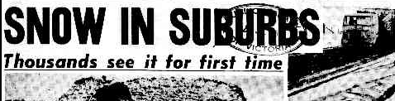

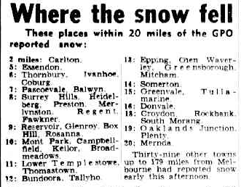

*The Herald - Thursday July 19, 1951 – Page 1 & 3*

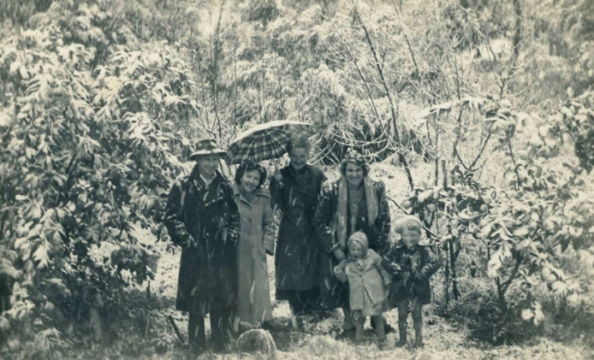

*Neighbour Mrs Laura Wightman with children Raymond and Laureen, together with friends in the snow at Greenhills July 1951.*

*(Photo - Greensborough Historical Society)*

I attended Briar Hill State School from February 1951, until 6th May 1955.

Around the middle of 1955, we moved to a house in River Avenue Plenty, where I then enrolled at the Plenty State School. I was able to ride my bike to school, but unfortunately that proved to be a little dangerous, when at one time I fell off my bike. In the next year or so, we moved again – to a house in Memorial Drive, Plenty. That house had a huge oak tree that I clearly remember. It was to the right-hand side of the driveway. That property was much closer to the school, so riding my bike to school was not as much of a worry to mum and dad. I remained at the Plenty School for the rest of my Primary School years.

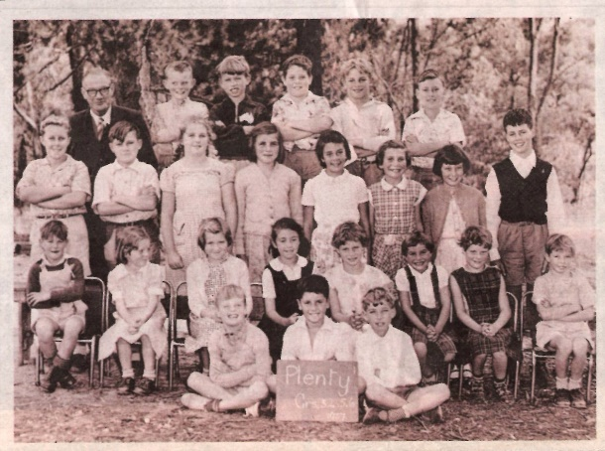

*Plenty State School photo 1957. Glenice 3rd row from bottom, 4 in from RHS.*

I then went to Eltham High School around 1958. I was able to catch the school bus at the Plenty Store, along with several other students. I left Eltham High at the finish of Grade 8 (Form 2), and went to Northcote Business College.

Around 1959/60, we moved again. This time, back to Greenhills! The house was Lot 51 Hebden Street - right on the corner of the lane (now number 10). We always accessed the property via the lane from Carnon Street… then, through the back door. I am not sure that the house even had a front door, and if it did, we never used it! The block was on quite a slope and the garage was at the back of the property.

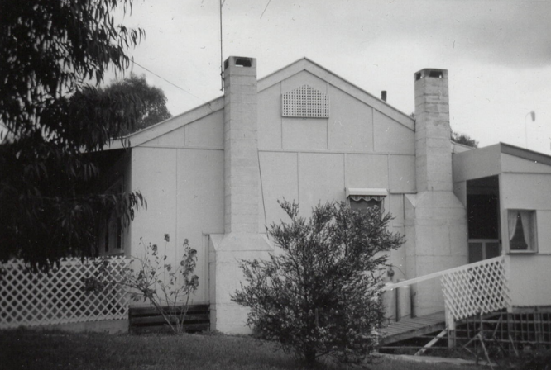We lived there until May 1961, when mum and dad purchased a property at Lot 10 Craig Road Plenty, from Mrs Jean McKay. Mrs McKay in turn, purchased our house in Hebden Street! This property in Craig Road had paddocks, a dam, several ducks, a couple of sheep, a goat, a calf and once again had chooks – 150 of them! So mum was very happy. There was even a small room for weighing and sorting the eggs.

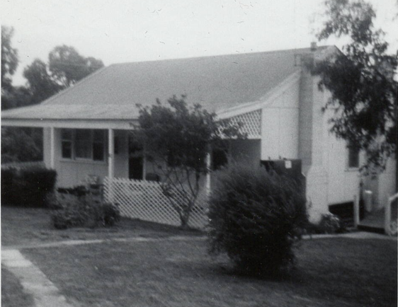

*Side view of Lot 10 Craig Road, Plenty*

*Lot 10 Craig Road, Plenty - 1960’s.*

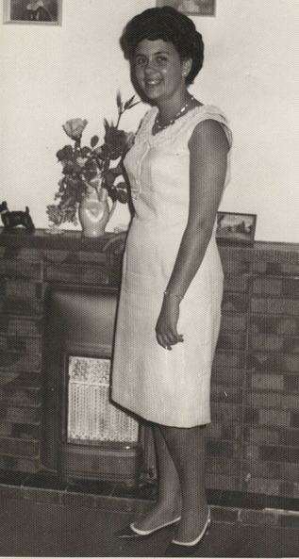There were very few houses around us at that time, and it was like living ‘in the bush’. We did at least have milk delivered in bottles to the front gate though – as can be seen in the photo of mum carrying them in one morning.

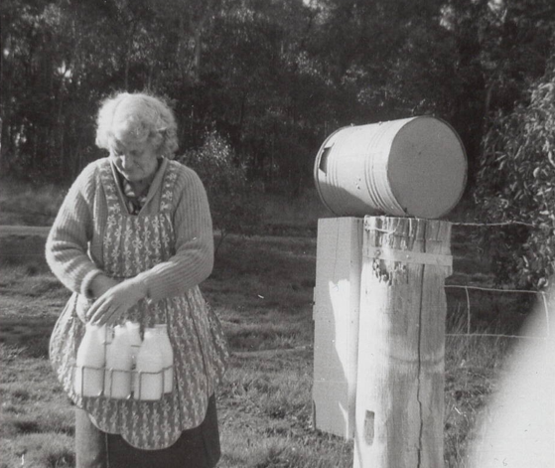

*Glenice at Craig Road, Plenty. Late 1960’s*

*Glenice’s mother Ada Myrtle Bishop, collecting the bottles of milk from the front gate one morning.*

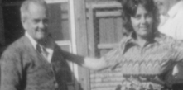In 1969 – yes, we moved again! This time it was back to Greenhills. Mum and dad purchased 72 Greenhill Road, from my sister and brother-in-law – Norma and Jim Petts, who were then living at 74 Greenhill Road. Mum and dad had the house renovated before we moved into it. We had my brother Allan, his wife Shirley and their children living directly across the road at number 73 Greenhill Road, mum’s brother Hobart and family living at 61 Greenhill Road and my dad’s younger brother Ron and his wife Ivy, living just around the corner at 147 St Helena Road. It was great!

*Glenice with her father Ern Bishop, at 72 Greenhill Road. 1970’s*

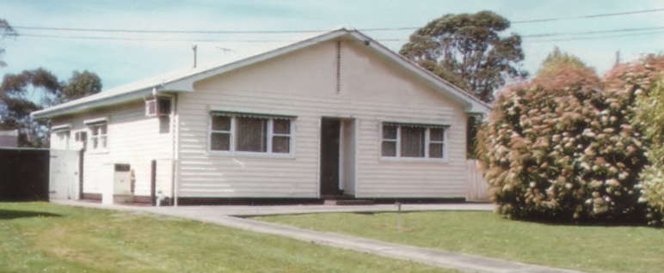I was also able to gain employment at Adams Cake Shop in Greensborough, and enjoyed my time working there. I lived there until 1972, when I married and went to live in Montmorency and am still living there today.

*72 Greenhill Road, Greensborough 1970’s.*