Friday August 12, 2016

Warrnambool's Flagstaff Hill Maritime Village welcome the return of artefacts
Rebecca Riddle 12 Aug 2016, 2:51 p.m.

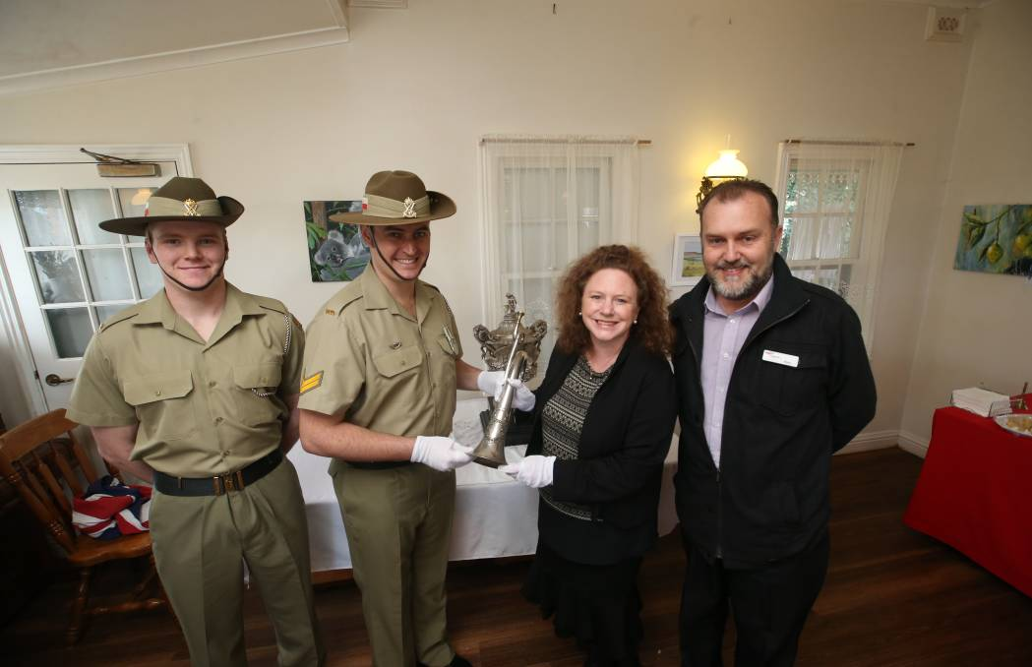
History: Private Wilson-Rea and Corporal Petering from the Australian Army handover artefacts to Mayor Gaston and Tourism Manager Peter Abbott. Picture: Amy Paton
Warrnambool’s history cabinet gained another two significant artefacts this week when a 1861 silver bugle and the Sir W. Clarkes trophy were displayed at Flagstaff Hill Maritime Village for the first time.
The Australian Army returned the Warrnambool Garrison artefacts from the 8th/7th Battalion to the maritime village during a handover ceremony on Thursday.
Tourism manager Peter Abbott said the ceremony was a long time in the making.
“I have been trying for five or six years to obtain these items for public display. This is a significant day for Warrnambool and for Flagstaff Hill Maritime Village,” he said.
The silver bugle was originally presented to the Rifle Volunteers in 1861 by the ladies of Warrnambool.
The second item is a large trophy awarded to various garrisons throughout the then Victorian colony as part of an annual target practice event. Warrnambool Garrison won the trophy on numerous occasions.
Both items have been in a display case at the Warrnambool Army Reserve Depot for close to 60 years.
This is a significant day for Warrnambool and for Flagstaff Hill Maritime Village. - Peter Abbott

