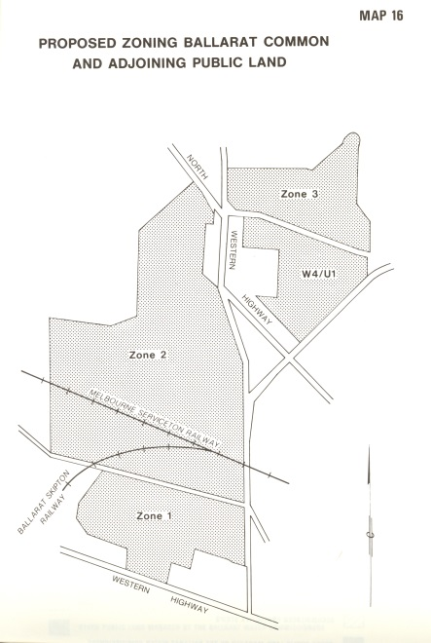

From Ballarat Study Area Final Recommendations, Land Conservation Council, Victoria, Melbourne. April 1982. Federation University Historical Collection (Cat. No. 10139)

The Ballarat Common originally covered a large area on the western outskirts of the City of Ballarat. Parts of the Common were alienated for urban and industrial development; and other parts developed from recreation and for the Ballarat airport. Some 680 ha of the original Ballarat Common and adjoining Crown land remains as public land. The bulk of this area is grazed under licence and supports very few trees or other native vegetation.

A tree-planting program has recently been carried out around the margins of Winter Swamp in this area and a number of islands have been constructed in the Swamp to improve its value for wildlife habitat. The Shire of ballarat plans to expand this tree-planting program; and Council believes that other parts of the existing Common and the adjacent Crown land could also be revegetated to make the area more attractive for open-space recreation, and to improve the amenity of the area. Part of the Common adjoins the Ballarat sewage treatment works and it may be possible to utilize the effluent from the treatment works for irrigation of some of the planted areas.

Public land close to Ballarat will be of increasing importance for a number of community uses – such as open-space recreation, and Council believes that provision should be made to meet present and future community needs. Part of the area, for instance, may be required for expansion of the Ballarat airport and its facilities, and provision for this must be made when planning future use of the area.

Recommendation

W3 – That on the area of approximately 620 acres shown on the map, current uses many continue; but the aims of future development be as outlined in the zones described below and shown on Map 16 and that the area be reserved as a common and be managed by the Department of Crown Lands and Survey.

*Zone 1 – Recreation and Conservation*

The land within this zone should be used for:

1. Open-space recreation
2. Development of habitat for wildlife conservation

Note: The Fisheries and Wildlife Division should continue to be involved in the development of habitat for wildlife conservation in this zone.

*Zone 2 – Airport Expansion and Recreation*

The land within this zone should be used for:

1. Expansion of the Ballarat airport and its facilities if and as required
2. Revegetation to enhance the value of the area for public recreation

Notes:

1. The Shire of Ballarat is hopeful that an aircraft museum may be established on part of this area in the future. Council would have no objection to part of the zone being used for this purpose.
2. If all of part of this area is not required for expansion of the airport or for an aircraft museum, then consideration could be given to adding those parts not required to Zone 1.

*Zone 3 – Revegetation and Recreation*

The land within this zone be used for:

1. Revegetation that may be able to utilize effluent fromt eh adjacent sewage treatment works
2. Open-space recreation to the extent that is is compatible with (a) above.

**Other Land in the Ballarat Common**

Freehold land east of the existing Ballarat Common has been developed for industrial uses, and some of the adjacent public land may be required to accommodate future expansion. Council therefore recommends that the portion of the existing Common adjoining the industrial area be uncommitted land.

Recommendation

W4/U1 That an area of 60 ha adjacent to allotment 19C of Section 4, parish of Dowling Forest, and shown on the map be excised from the existing Ballarat Common and be uncommitted land.

Pages 93-95